
CITES Non-detriment finding

Simple Evaluation Template

Text in italics is explanatory and should be deleted in completed documents. Please refer to the NDF Guidelines document for further explanation on how to complete this evaluation.

Species name | Diamondback Terrapin (Malaclemys terrapin)
Range state name | USA
Report compiled by | TEL & PPvD
Date compiled | 4/28/23
Section One: Summary
Please provide a short overview (1-2 paragraphs) of the trade in this species in the country of interest.
Diamondback Terrapin (DBT) was put on Appendix II at Cop16 in 2013.
A large breeder has several outdoor ponds with a mix of Diamondback Terrapin (DBT) subspecies. He can produce about 2500-3000 captive bred hatchling in a season. However, in one specific year his output of hatchlings suddenly jumped to 14,600 DBT. This raised a red flag. It turned out that that he had purchased 3500 DBT legally acquired wild mostly adult females (mostly gravid) from another State that allowed harvest. This NDF will examine the 3500 wild caught DBT.

Section Two: Simple Evaluation score
Please score each attribute listed within the table below and sum these to provide a total.
 | Number of points |  |  | Score
Criteria | 1 | 2 | 3 | Score
Annual Harvest level | Low (<500) | Medium (500 - 5,000) | High (>5,000) | 2
Area of distribution | Large (>20,000km²) | Medium (2,500 – 20,000km²) | Small (<2,500km²) | 3
Life-history | Fast | Medium | Slow | 3
Illegal trade and IUCN status | If levels of illegal trade are known, they should be included under “Annual harvest level”. If unknown, and suspected to be detrimental, give a maximum score of 1 point. Similarly, if the status of the species is is listed as VU, EN or CR in the IUCN Red List Of Threatened Species, give a maximum score of 1 point |  |  | 1
Section Three: Justification – Harvest level
Please provide an explanation with appropriate references to justify the score given.

Breeder purchased 3500 DBT legally acquired wild mostly adult females (mostly gravid) from another State that allowed harvest. Between Nov & Feb harvested by hand. This would give us an annual harvest rate value of 2.
Section Four: Justification – Area of distribution
Please provide an explanation with appropriate references to justify the score given.

Habitat destruction poses a serious and ongoing threat to Malaclemys terrapin populations. The range of Malaclemys terrapin is coincident with dense areas of human population. Coastal development, particularly salt marsh draining, increased use of coastal waterways for commercial and recreational purposes, and loss of sand dunes, an important habitat for nesting, contribute to the loss and degradation of this species’ habitat. This species is a habitat specialist to tidal marsh lands (brackish waters).

State coast line is 227 km out of a total range 1360 km (for this subspecies). The DBT live in saltmarshes in a ½ km wide band along the coast. Therefore, the entire area of suitable habitat in our target State is 114 km2. Although not know what percentage the turtles occupy, we know it is less than 114 km2. Therefore, we assign an area of occupancy of 3.

Section Five: Justification – Life history
Please provide an explanation with appropriate references to justify the score given.

Known population dynamics research has demonstrated that this is a slow reproducing and recovering species: Age at maturity at about 4-13 years, annual reproductive output 4-23 eggs/female (mean for NJ 9.7 eggs/clutch with 2-3 clutches/year), longevity potentially over 50 years, generation time estimated 15 years. Low recruitment due to high nest predation, juvenile and adult male mortality in crab pots and high adult female mortality from vehicle collisions and crab pots in southern populations are cause for alarm because population models suggest a stable population requires both modest recruitment and, most importantly, high adult survival
We therefore assign this species clearly to the ‘Slow’ category: 3 points.

Section Six: Illegal trade and IUCN Status
Please provide an explanation with appropriate references to justify the score given.

DBT have been seized from illegal international shipments in modest quantities (at the order of a dozen per shipment at most). Known to have been illegally harvested by fishermen. One point.
Section Seven: Conclusion, course of action, and determination on exports
Please provide an overall conclusion on the perceived threat of trade to the species and details on whether further course of action will be taken to complete an NDF for the species.

Our evaluation yields a final score of 9, therefore a thorough NDF is required.

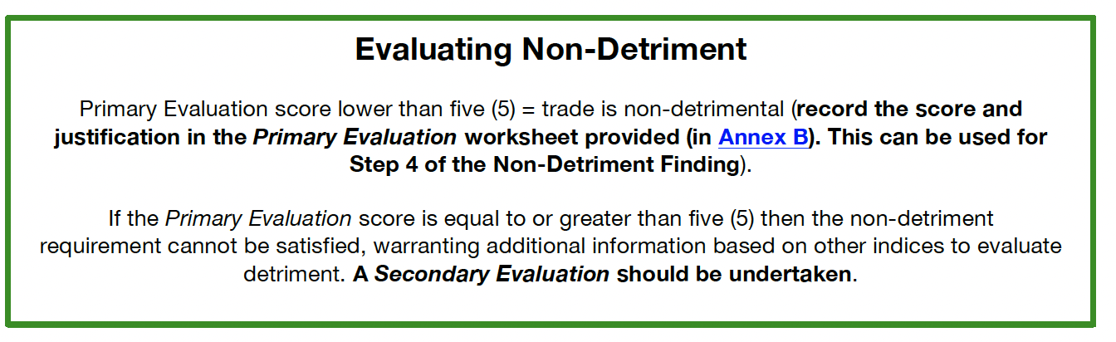
Turns out that DBT can be harvested in the winter by hand because females hibernate in communal underwater hibernacula of up to 200 animals.
Section Eight: Literature Cited
Please provide references to all the reports and literature cited in this evaluation.

CoP16 Prop31Inclusion of Malaclemys terrapin in Appendix II. https://cites.org/sites/default/files/eng/cop/16/prop/E-CoP16-Prop-31.pdf
IUCN Red List assessment https://www.iucnredlist.org/species/12695/507698
Turtles of the United States and Canada (Ernst & Lovich 2009)
TTWG Checklist and Atlas v9 2021
Russ Burke pers. Com. – area of occupancy info
Guidance document for NDFs for Tortoises and FW Turtles

