PC13 Doc. 24.1
CONVENTION ON INTERNATIONAL TRADE IN ENDANGERED SPECIES
OF WILD FAUNA AND FLORA
____________
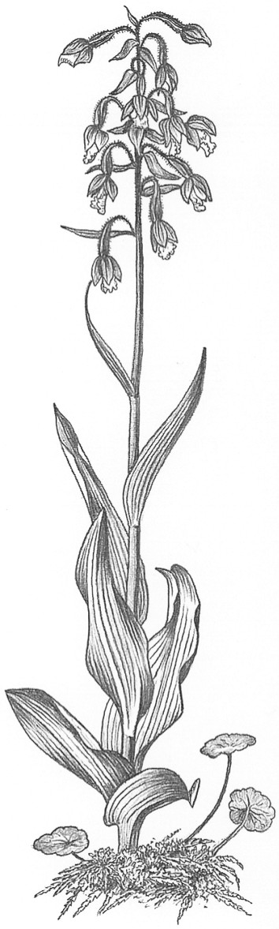
Thirteenth meeting of the Plants Committee
Geneva (Switzerland), 12-15 August 2003
Training initiatives
Standard slide package: progress report
1. This document has been prepared by the Scientific Authority for plants of the United Kingdom.
2. The development of a series of standard CITES presentation packs for plants, funded by the United Kingdom CITES Management Authority (Department for Environment, Food and Rural Affairs – Defra), has progressed from the original Version 1.0 of CITES and Plants: a User’s Guide produced by Marianne Syrylak Sandison, Margarita Clemente, Jan de Koning and Maurizio Sajeva. Since the first version was produced in 1999, PowerPoint has become the preferred means of presentation among the majority of CITES Parties. Production of these manuals has therefore changed from a hard copy set and accompanying set of slides to a hard copy text and accompanying PowerPoint presentation on CD-ROM. This new CD-based version allows for an increase in content, cheaper production costs and the facility to include a version on the Internet. Version 2.0 of CITES and Plants: a User’s Guide was produced in English, French and Spanish for the 12th meeting of the Conference of the Parties (CoP12) in November 2002, Santiago de Chile and distributed to interested parties. Updates from CoP12 have now been incorporated into Version 3.0, which is now available in English in hard copy and on CD-ROM. The pack is currently being translated into French and Spanish.
3. The latest addition to this series is CITES and Succulents, a guide to the use of and trade in succulent species listed under CITES. It is now available in English on CD-ROM and the French and Spanish versions are currently in translation. Preparation of CITES and the Genus Paphiopedilum has begun and will be completed next year. We have also produced some CD-based material directly targeted at aiding UK enforcement of key listings. We plan to produce, in cooperation with the German CITES Scientific Authority for Plants a title on CITES and medicinal plants, subject to available funding.
4. In addition, as part of a UK Darwin Initiative project (funded by Defra), the Royal Botanic Gardens, Kew has produced the CD-ROM entitled The CBD for Botanists. This is a presentation pack specifically designed to introduce people working with botanical collections to the Convention on Biological Diversity– in particular botanists, curators, horticulturists and technicians in botanic gardens, herbaria, museums and seed banks. Its genesis lies in the CITES training initiatives approved by the Plants Committee and, as the CITES manuals, it is available in English, French and Spanish. Copies of all the presentations mentioned in this paper are available on CD-ROM from members of the United Kingdom’s delegation.
5. Since 1999 the range of training material produced by and for CITES Parties has greatly expanded. The Capacity-Building Unit of the CITES Secretariat has produced ‘pocket’ CD-ROMs, and the Plants Committee has seen demonstrations of high quality material from, inter alia, Canada, Spain and Switzerland. It is now quite difficult for parties to keep track of all the material that is available and who is working in this field. We therefore suggest that it might be useful to set up an informal email contact group of all those who are working on producing CITES capacity-building material for plants. In addition we feel that it would be useful to produce a directory of such material to match the Plants Committee’s regional directories. The United Kingdom would be happy to put together a first draft of such a directory in collaboration with the Plants Committee and the CITES Secretariat.

Role of the Plants Committee
6. The comments of the Plants Committee would be welcome on:
a) whether it might be useful to set up an ‘informal’ email contact group of all those who are working on producing CITES capacity-building material for plants
b) whether, it might be useful to develop A directory of capacity-building materials to match the Plants Committee’s regional directories.

