PC13 Doc. 19
CONVENTION ON INTERNATIONAL TRADE IN ENDANGERED SPECIES
OF WILD FAUNA AND FLORA
____________
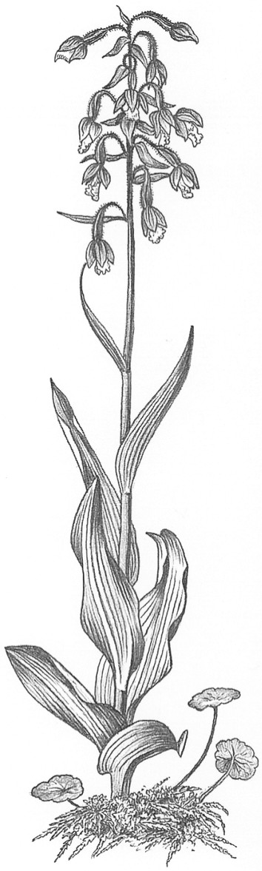
Thirteenth meeting of the Plants Committee
Geneva (Switzerland), 12-15 August 2003
Relationship between in situ conservation and
ex situ production of plants [Decision 12.11 l)]
1. This document has been prepared by the Secretariat.
2. The Plants Committee has been considering the relationship between in situ conservation and ex situ production of plants since its 10th meeting (Shepherdstown, December 2000) (see for further reference documents PC11 Doc. 9.1.a, PC11 Doc. 9.2, PC12 Doc. 20.3 and PC12 Doc. 23.1 and also AC16 Doc. 9.2, all available on the CITES website).
3. In Decision 12.11, paragraph l) the Plants Committee is directed to analyse the relationship between in situ conservation and ex situ production of plants in the period between the 12th and 13th meetings of the Conference of the Parties.
4 At the 12th meeting of the Plants Committee (Leiden, May 2002), the Secretariat reported that following Decision 11.102, Notification to the Parties No. 2001/091 of19 December 2001 had been sent out inviting all Parties and organizations to provide information on the relationship between ex situ production systems and in situ conservation programmes for any CITES-listed species. At the time of the meeting, no response to this Notification had been received.
5 The Committee endorsed the Secretariat’s suggestion to re-issue a Notification to the Parties, requesting information and comments on the issue and case studies examining the relationship between ex situ and in situ production.
6 To take this work forward the Secretariat invites comments on the draft Notification to the Parties contained in the Annex to the present document.
7. The Secretariat is aware that a discussion document on the relationship between ex situ production systems for plants and in situ conservation programmes may be presented for information to assist the Plants Committee in implementing the Decision. It also notes that agenda items 19 on the Relationship between in situ conservation and ex situ production of plants and 25.1 on Plant production systems (see document PC13 Doc. 25.1) are closely related. The Plants Committee may therefore wish to consider creating a working group to address both issues.

PC13 Doc. 19
Annex
DRAFT
NOTIFICATION TO THE PARTIES
CONCERNING:
The relationship between ex situ production and in situ conservation of plants
1. In Decision 12.11 paragraph l) the Plants Committee is directed to analyse the relationship between in situ conservation and ex situ production of plants in the period between the 12th and the 13th meetings of the Conference of the Parties.
2. As communicated in Notification to the Parties No. 2001/091 of 19 December 2001, a range of critical views and different perspectives appear to exist on this issue.
3. Some have argued that the artificial propagation of plants provides disincentives for conservation by de-linking the production from wild habitats and wild populations, and thus reducing opportunities for the sale of wild specimens to generate economic incentives for conservation. Indeed many ex situ production systems are situated outside range States.
4. The exemptions provided for in Article VII, paragraphs 4 and 5, of the Convention make it easier to trade in artificially propagated specimens than in specimens harvested from the wild: specimens of Appendix-I species that are artificially propagated for commercial purposes are deemed to be specimens of species included in Appendix II; and specimens of Appendix-I species produced for non-commercial purposes and specimens of Appendix-II and Appendix-III species produced through artificial propagation may be traded under an artificial propagation certificate, rather than the export and import permits normally required under the provisions of Articles III, IV and V. This has raised questions about the conservation impacts of such production.
5. In contrast, others argue that by producing specimens through artificial propagation, the pressure on the wild stocks may be reduced, and that this may be particularly important to the conservation of species for which the demand is higher than what can be sustainably harvested and traded, and where demand cannot be reduced or be met through the use of alternatives.
6. Parties and organizations are invited to provide any information and comments on the relationship between ex situ artificial propagation operations and in situ conservation programmes for plants, particularly in relation to:
a) evidence that artificial propagation has positive conservation impacts such as reducing off-take from the wild and can help wild populations grow;
b) examples of artificial propagation operations that support in situ conservation of the species they propagate or are involved in benefit-sharing to promote species conservation;
c) evidence that wild-collected specimens may be illegally traded as artificially propagated specimens, and suggestions or examples on how such problems might be prevented or addressed;
d) evidence that ex situ production for commercial trade may result in a shift in production and trade from range States to non-range States, giving consideration to the related questions of ownership of genetic resources (i.e. the extent to which the countries of origin should benefit from trade in CITES-listed species) and to whether CITES can contribute to addressing this issue in the forum of the Convention on Biological Diversity;
e) evidence that artificial propagation may have negative conservation impacts, such as reducing incentives for local conservation, possible introduction of diseases, hybridization between artificially propagated and wild stock; and introduction of alien invasive species, and examples of policies and management measures to contain these possible negative impacts;
f) measures in place to encourage artificial propagation operations to contribute to the conservation of the species in the wild.
7. Information received in response to this Notification will be presented to the Plants Committee to document their report for the 13th meeting of the Conference of the Parties on the implementation of Decision 12.11 l).

