PC13 Doc. 15.1
CONVENTION ON INTERNATIONAL TRADE IN ENDANGERED SPECIES
OF WILD FAUNA AND FLORA
____________
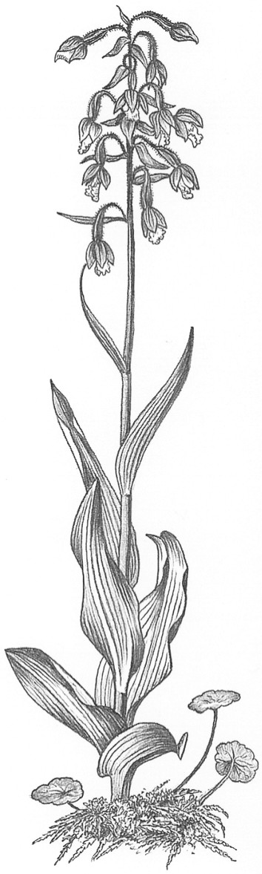
Thirteenth meeting of the Plants Committee
Geneva (Switzerland), 12-15 August 2003
Checklists and nomenclature
progress report
1. This document has been prepared by the botanist of the Nomenclature Committee.

Resolution Conf. 12.11
2. With Resolution Conf. 12.11, the Conference of the Parties adopted the Checklist of CITES species, compiled by the UNEP World Conservation Monitoring Centre, 2001 and its updates accepted by the Nomenclature Committee as the standard reference for species included in the Appendices.
3. The adoption of the Checklist of CITES species requires us to look again at the need for individual taxon-based checklists to compliment the UNEP-WCMC publication. A single volume checklist is a very useful tool for the CITES community. However the production of this condensed list necessitates the exclusion of some data which are included in the single-taxon checklists. The Checklist of CITES species does not contain the full lists of accepted species names and synonyms included in the core references adopted at meetings of the Conference of the Parties up to and including CoP12. It also does not include information on distribution, the separate listing of accepted names in current use and the country checklists. This abbreviated format is necessary to allow the production of a checklist of CITES plants and animals in a single volume of less than 400 pages. It would seem beneficial to CITES Parties for the Checklist of CITES species to be complimented by taxon-specific plant checklists.
4. The format of the taxon-specific checklists needs to be considered. The adoption of the Checklist of CITES species gives us the opportunity to look at the format of taxon-specific checklists and note where it is possible to add value to the traditional layout. On that basis it is proposed that the new checklists be amended to adopt the format of plant trade manuals. In addition to the information on accepted names, synonymy and distribution it is proposed that the introduction to the checklists should include an analysis of CITES trade in the group, key taxa in trade, the identification of wild versus propagated material and a summary list of key references for identification. The checklists would then incorporate key trade information and become plant trade manuals linked to other CITES capacity-building tools. This would support a more integrated approach to the implementation of the Convention.

Funds
5. The budget lines for Nomenclature studies were deleted in the budget for the triennium 2003-2005 adopted at the 12th meeting of the Conference of the Parties. Nomenclature issues are now included in the budget line ‘Assistance to Scientific Authorities’. This budget line is restricted and it is therefore essential that the Nomenclature programme be, if possible, totally funded by external sources.

Update on CITES Checklists
6. The CITES Orchid Checklists covers:
a) Cattleya, Cypripedium, Laelia, Paphiopedilum, Phalaenopsis, Phragmipedium, Pleione and Sophronitis (Volume 1);
b) Cymbidium, Dendrobium, Disa, Dracula and Encyclia (Volume 2);
c) Aerangis, Angraecum, Ascocentrum, Bletilla, Brassavola, Calanthe, Catasetum, Miltonia and Miltoniopsis, Renanthera, Rhynchostylis, Rossioglossum, Vanda and Vandopsis (Volume 3); and
d) Aerides, Coelogyne, Comparettia, Lycaste and Masdevallia (Volume 4).
Status: CITES Orchid Checklist Volume 1, 1995. CITES Orchid Checklist Volume 2, 1997. CITES Orchid Checklist Volume 3, 2001. Volume 4 in preparation – orchid experts urgently required to review drafts for each genus. Volume 4 will be published in time for the 13th meeting of the Conference of the Parties in October 2004.
A PDF file of combined CITES Orchid Checklist Volumes 1, 2 and 3 is now accessible on the website www.kew.org. Further checklists will be added as we obtain agreement from copyright holders.
UNEP-WCMC is working on producing checklists for a range of taxa for which CITES checklists are not available. This work is being funded by the Commission of the European Communities.
The Institute of Botany, Vienna, is preparing in cooperation with relevant international experts a checklist of the genus Bulbophyllum which it will submit to the Nomenclature Committee for approval. Funds are required from the CITES Trust Fund to support this project.
The Royal Botanic Gardens, Kew, United Kingdom, in cooperation with a global network of orchid experts is working on a world checklist of Orchidaceae as part of the Monocot Checklist Project. The database already includes some 25,000 accepted names and about 45,000 synonyms. Authorities, places of publication and distributions (using TDWGS standards) are also included. It is hoped that this global checklist will form an important reference source for CITES. It has the potential to form the scientific core on which future standard references could be based.
7. The CITES Cactaceae Checklist (1999) was adopted as the standard reference for Cactaceae. This volume is now effectively out of print with less than 200 copies remaining in stock. The cactus volume of the Lexicon is presently being updated and can form the basis of a revised cactus checklist. A new edition of the checklist will also provide the opportunity for the checklist to be made available on the web.
8. The CITES Euphorbia Checklist (1997), compiled by Städtische Sukkulenten-Sammlung, Zürich, Switzerland, and produced by the German Federal Agency for Nature Conservation was adopted as the standard reference for species of Euphorbia succulents. Since its publication a range of new species have been described. The Nomenclature Committee is in discussion with its sponsors to determine a method by which an addendum or update can be produced.
9. Tree-ferns. The revision of the listing of tree-ferns with the annotation 'Dicksonia spp., populations of the Americas' has lead to some confusion. Germany has produced the document Dicksonia species of the Americas, which indicates that Dicksonia berteriana, D. externa, D. sellowiana and D. stuebelii are the only species subject to control. To be accessible to the Parties this document now requires to be published and distributed or be made available in the Web. UNEP-WCMC is looking into the possibility of producing a comprehensive checklist of all tree-ferns covered by the Convention.

Role of the Plants Committee
10. The comments of the Plants Committee would be welcome on:
a) Whether, given the adoption of the Checklist of CITES species as the standard reference for species included in the Appendices, the production of taxon-specific checklists for plants should continue.
b) If taxon-specific checklist continue to be produced, should they include additional information on the species concerned – in effect form taxon-specific plant trade manuals
c) Suggested sources of funding for checklist production.

