PC13 Doc. 14.1
CONVENTION ON INTERNATIONAL TRADE IN ENDANGERED SPECIES
OF WILD FAUNA AND FLORA
____________
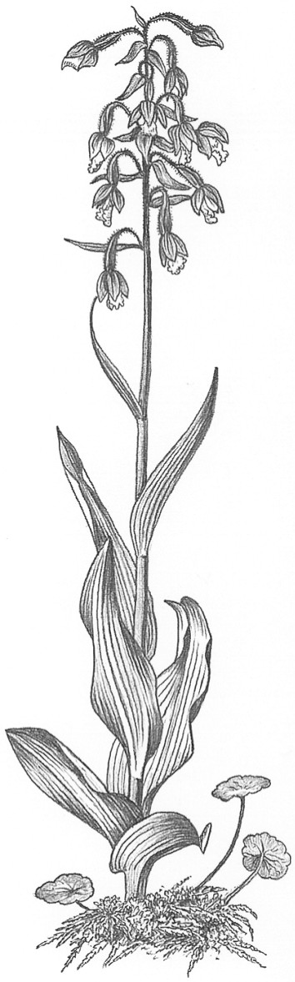
Thirteenth meeting of the Plants Committee
Geneva (Switzerland), 12-15 August 2003
Review of heavily traded non-CITES species
Review of heavily traded non-CITES species [Decision 12.9 a) iii)]
1. This document has been prepared by the Secretariat.
2. At its 12th meeting (CoP12, Santiago, 2002), the Conference of the Parties adopted the following Decisions directed to the Plants Committee.
Decision 12.9
a) The following topics shall continue to be given full attention and become high priorities for the Plants Committee:
i) the periodic review of the Appendices (action point 2.1.2 of the Action Plan of the Strategic Vision);
ii) the Review of Significant Trade (action point 2.1.3); and
iii) the review of heavily traded non-CITES species (action point 2.1.4).
b) For each of these priorities, specific activities shall be identified in order to determine the funding, resources and time-frame required to address them successfully. Furthermore, indicators should be identified to monitor the status and evolution of these activities closely.
Decision 12.10
The Plants Committee shall, during the period between the 12th and 13th meetings of the Conference of the Parties, develop proposals to amend the Appendices on the basis of the Contribution to an evaluation of tree species using the new CITES Listing Criteria, published by the Management Authority of the Netherlands in 1998.
3. This document refers specifically to paragraph a) iii) of Decision 12.9 concerning the review of heavily traded non-CITES species (action point 2.1.4 of the CITES Action Plan) and to Resolution Conf. 11.1 (Rev. CoP12) concerning the establishment of Committees. This action point directs the Animals and Plants Committees to “evaluate trade and biological information on currently unlisted species subject to significant international trade to determine whether they would qualify for and benefit from CITES listing”.
4. The Plants Committee has recently reviewed the following non-CITES-listed species under an informal process (updates are provided at this meeting in the Plants Committee documents listed below):
- Harpagophytum spp. (see documents PC13 Doc. 9.1.1 and Doc. 9.1.2)
- Guaiacum spp. (see document PC13 Doc. 9.2)
- Aquilaria spp. (see document PC13 Doc. 9.3)
- Tree species (see document PC13 Doc. 14.2; and for Dalbergia melanoxylon see document PC13 Doc. 14.3)
5. Additionally, in the past, the Plants Committee has reviewed other heavily traded non-CITES listed species through an informal process. A review of trade in South African succulent plants, for instance, undertaken by TRAFFIC and endorsed by the Plants Committee, was reported on at the 8th meeting of the Plants Committee (Pucón, November 1997).
6. It seems that attention paid by the Plants Committee to heavily traded non-CITES taxa under an informal process has usually benefited conservation efforts. It has resulted either in the inclusion of those species in the Appendices, or, when the species did not meet the criteria for inclusion in the Appendices, in further work, studies and management efforts by the range States.
7. However, it is not clear what criteria the Plants Committee has used in the past to determine which taxa should be considered for inclusion in the review of non-listed species. Furthermore, no definition of ‘heavily traded’ is provided in the Decisions or action points relating to this review. For some species ‘heavily traded’ could be characterized by trade in one or two specimens from a single very small population, whereas for more abundant and widespread species, it is likely to be characterized by a very high volume trade.
8. In order to maintain the benefits of the review process and to improve its efficiency by identifying those taxa that are most in need of review, the Plants Committee may wish to consider whether it is worthwhile formalizing a process for the review of heavily traded non-CITES species.
9. If the Plants Committee believes that formalizing the process would be useful, it could develop a review process to identify ‘heavily traded’ species. Such a process might involve regional representatives undertaking a consultation with national representatives on a cyclical basis. Any review should make use of readily available reliable information on trade quantities and species biology to identify which taxa may warrant further attention. Regional and national representatives may therefore consider consulting with organizations such as FAO, ITTO, IUCN and TRAFFIC.
10. In determining which non-CITES species might benefit from a formal review, the Plants Committee should also revisit some of the species identified as priorities through former informal reviews (for example Taxus spp. other than T. wallichiana and South African succulents), in addition to other information.
11. Any species determined to be ‘heavily traded’ resulting from such a process could then be assessed against the CITES listing criteria and consideration given as to whether they would benefit from inclusion in the Appendices. Proposals for inclusion of selected taxa in the Appendices could then be prepared and submitted by range States as appropriate.
12. The Secretariat recognizes the workload and cost implications to the Parties in dealing with implementing the Convention for species currently listed in the Appendices. When considering a more formalized process to review trade in non-CITES listed taxa, the Plants Committee should therefore be realistic and take into account the time-frame on which such a process might operate, the funds required to develop and implement any activities, and the number of taxa that could be reviewed.
13. Once a course of action has been determined, indicators should be developed to monitor the status and evolution of any activities proposed [as called for in paragraph b) of Decision 12.9].

