PC13 Doc. 13.2
CONVENTION ON INTERNATIONAL TRADE IN ENDANGERED SPECIES
OF WILD FAUNA AND FLORA
____________
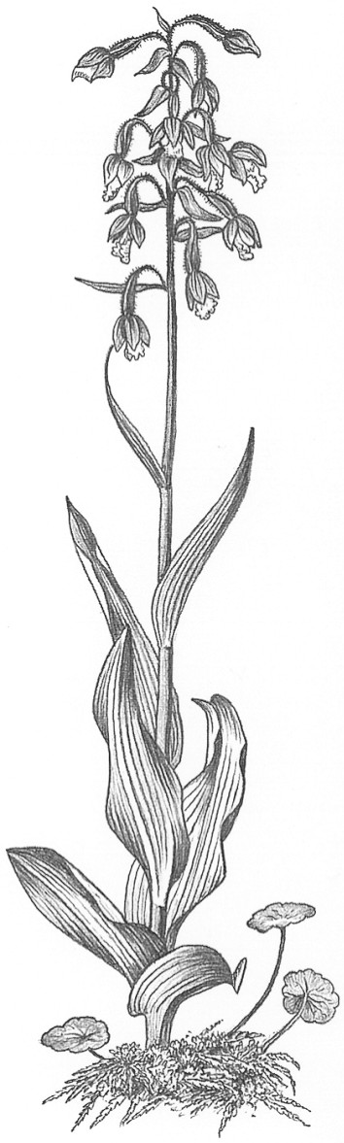
Thirteenth meeting of the Plants Committee
Geneva (Switzerland), 12-15 August 2003
Review of the Appendices
Artificially propagated plants traded in large quantities
1. This document has been prepared by the Secretariat.
2. Decision 12.9, adopted at the 12th meeting of the Conference of the Parties (CoP12, Santiago, 2002) and directed to the Plants Committee, states inter alia that:
a) The following topics shall continue to be given full attention and become high priorities for the Plants Committee:
i) the periodic review of the Appendices (action point 2.1.2 of the Action Plan of the Strategic Vision);
ii) the Review of Significant Trade (action point 2.1.3); and
iii) the review of heavily traded non-CITES species (action point 2.1.4).
b) For each of these priorities, specific activities shall be identified in order to determine the funding, resources and time-frame required to address them successfully. Furthermore, indicators should be identified to monitor the status and evolution of these activities closely.
3. Decision 12.11, directed to the Plants Committee, states that in the period between the 12th and 13th meetings of the Conference of the Parties, the Plants Committee shall inter alia:
c) continue the review of the Appendices with the following priorities: timbers, based on Contribution to an evaluation of tree species using the new CITES Listing Criteria, the review of tree species in trade by the Netherlands; and artificially propagated plants traded in large quantities.
4. The following taxa included in the CITES Appendices are known to contain or comprise taxa that are traded in large quantities as artificially propagated plants: the families Cactaceae, Cycadaceae and Orchidaceae (mostly Appendix II with some taxa in Appendix I); the genera Cyclamen, Galanthus and Sternbergia (ornamental bulbs or corms listed in Appendix II); the insectivorous plant genera Nepenthes and Sarracenia (mostly Appendix II with some taxa in Appendix I); the Venus fly-trap Dionaea muscipula (Appendix II); the succulent plant genera Aloe, Euphorbia (succulent species only) and Pachypodium (mostly Appendix II with some taxa in Appendix I). Depending on the precise definition of ‘traded in large quantities’, other taxa may also qualify (e.g. the family Didiereaceae and the succulent genus Anacampseros, Agave victoriae-reginae and possibly the newly-listed Swietenia macrophylla).
5. Of these, the working group on the review of the Appendices at the 9th meeting of the Plants Committee (Darwin, June 1999), recommended maintaining the listings of Cyclamen, Galanthus, Nepenthes and Sarracenia and recommended deletion of the Didiereaceae. It did not comment on the other taxa listed above.
6. A number of taxa have been exempt from the provisions of the Convention for some time when traded as artificially propagated specimens, namely cultivars of Euphorbia trigona and Cyclamen persicum and the following cactus hybrids or cultivars: Hatiora x graeseri; Schlumbergera x buckleyi; Schlumbergera russelliana x Schlumbergera truncata; Schlumbergera orssichiana x Schlumbergera truncata; Schlumbergera opuntioides x Schlumbergera truncata; Schlumbergera truncata (cultivars); Gymnocalycium mihanovichii (cultivars) forms lacking chlorophyll, grafted on the following grafting stocks: Harrisia 'Jusbertii', Hylocereus trigonus or Hylocereus undatus; Opuntia microdasys (cultivars). At the 12th meeting of the Conference of the Parties (CoP12, Santiago, 2002) the listing for Gymnocalycium mihanovichii was amended to cover all Cactaceae spp. colour mutants lacking chlorophyll.
7. In Resolution Conf. 11.11 regarding Regulation of trade in plants, the Conference of the Parties recommended that the then valid higher-taxon listings of plants in the Appendices, including the families Orchidaceae and Cactaceae, be maintained as they are essential for effective control of trade in the many species within those taxa that are threatened or potentially at risk. This Resolution is still in force.
8. The Plants Committee has continued to devote attention to consideration of the families Cactaceae and Orchidaceae, the former chiefly under the Review of Significant Trade. It has particularly focussed on the perceived burden placed on Management Authorities and nurseries by the need to implement the Convention for artificially propagated plants (in the case of orchids, mainly of hybrids) which are traded in very high volumes.
9. As a result of this, the United States of America submitted a proposal for consideration at CoP12 (Santiago, 2002) to exclude from the provisions of the Convention artificially propagated plants of interspecific hybrids in six genera of orchids, subject to a lengthy annotation. This proposal was amended to apply only to the genus Phalaenopsis with the following annotation:
Artificially propagated specimens of hybrids within the genus Phalaenopsis are not subject to the provisions of the Convention when: 1) specimens are traded in shipments consisting of individual containers (i.e. cartons, boxes, or crates) containing 100 or more plants each; 2) all plants within a container are of the same hybrid, with no mixing of different hybrids within a container; 3) plants within a container can be readily recognized as artificially propagated specimens by exhibiting a high degree of uniformity in size and stage of growth, cleanliness, intact root systems, and general absence of damage or injury that could be attributable to plants originating in the wild; 4) plants do not exhibit characteristics of wild origin, such as damage by insects or other animals, fungi or algae adhering to leaves, or mechanical damage to roots, leaves, or other parts resulting from collection; and 5) shipments are accompanied by documentation, such as an invoice, that clearly states the number of plants and is signed by the shipper. Plants not clearly qualifying for the exemption must be accompanied by appropriate CITES documents.
10. Concerns were raised in Committee I at CoP12 that implementation problems would be created if this proposal were to be adopted, particularly those of distinguishing non-flowering specimens of wild-collected species from artificially propagated hybrids. The proponents proposed a companion decision urging the Plants Committee to monitor the impact of the exclusion on any increased illegal trade and to report at the 13th meeting of the Conference of the Parties. However this proposal was not formally submitted as a Decision, and therefore agreed to by the Conference of Parties.
11. Although there is no formal decision, the Plants Committee may wish to review the impact of this amendment before considering further such amendments. As the amendment did not enter into force until March 2003, it is unclear whether any impact will be detectable by CoP13. In the meantime, and rather than adopting a taxon-by-taxon approach, the Committee may wish to recommend that a study be undertaken that attempts to determine exactly how onerous it is to have to report on artificially propagated plants included the Appendices that are traded in high quantities, and what conservation gains or concerns would be associated with the wider use of such amendments. Such a study could include a cost-benefit analysis of amending the Appendices to exclude some or all such plants, an assessment of the relevance to the conservation and management of wild populations of the species concerned, and recommendations to the Plants Committee.

