PC13 Doc. 13.1
CONVENTION ON INTERNATIONAL TRADE IN ENDANGERED SPECIES
OF WILD FAUNA AND FLORA
____________
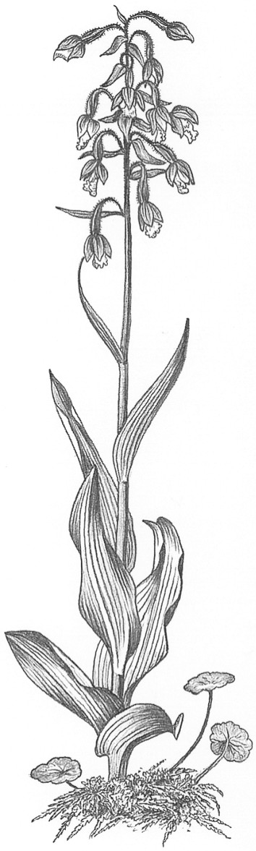
Thirteenth meeting of the Plants Committee
Geneva (Switzerland), 12-15 August 2003
Review of the Appendices
Timber species
1. This document has been prepared by the Secretariat.
2. The Plants Committee is directed in Decision 12.11 to:
c) continue the review of the Appendices with the following priorities: timbers, based on Contribution to an evaluation of tree species using the new CITES Listing Criteria, the review of tree species in trade produced by the Scientific Authority of the Netherlands; and artificially propagated plants traded in large quantities.
3. The Scientific Authority of the Netherlands presented document PC11 Doc. 13.3 at the 11th meeting of the Plants Committee (PC11, Langkawi, September 2001) which drew on information contained in Contribution to an evaluation of tree species using the new CITES Listing Criteria. The document contained information on 18 tree taxa: four included in Appendix I, 11 in Appendix II and three in Appendix III.
4. Of the Appendix-II species, Swietenia humilis was not evaluated and the status of Prunus africana was considered ambiguous. Of the remaining 13 Appendix-I or -II species, 10 were considered to be included in the appropriate Appendix, in accordance with the criteria set in Resolution Conf. 9.24. One Appendix-II species (Pterocarpus santalinus) was considered to meet the criteria for inclusion in Appendix I. Two other Appendix-II species (Caryocar costaricense and Oreomunnea pterocarpa) were thought possibly to meet the criteria for inclusion in Appendix I, although information was insufficient. Finally one of the Appendix-III taxa (Swietenia macrophylla) was included in Appendix II at the 12th meeting of the Conference of the Parties (Santiago, 2002).
5. Participants in PC11 were urged to provide feedback on the report from which the document had been drawn, which had been sent out to all Parties and was accessible on the UNEP-WCMC website. At the 12th meeting of the Plants Committee (Leiden, May 2002), it was noted that only four countries had provided feedback.
6. Of the taxa considered in document PC11 Doc. 13.3, Aquilaria malaccensis, Prunus africana and Pericopsis elata are currently included in the Review of Significant Trade pursuant to Resolution Conf 12.8, and will be discussed under that agenda item (12.2.3). The Plants Committee may therefore wish to focus its attention on the three Appendix-II species that, according to the report presented at PC11, may qualify for transfer to Appendix I. These are Caryocar costaricense, Oreomunnea pterocarpa and Pterocarpus santalinus. In particular, it may wish to investigate whether Caryocar costaricense and Oreomunnea pterocarpa occur at all in international trade. It may also wish to consult with range States to determine whether they believe that transfer to Appendix I is the most appropriate course of action, and may wish to consider other stratagems for ensuring that harvest for international trade does not pose a threat to the survival of the species concerned.

