PC13 Doc. 12.2.3.3
CONVENTION ON INTERNATIONAL TRADE IN ENDANGERED SPECIES
OF WILD FAUNA AND FLORA
____________
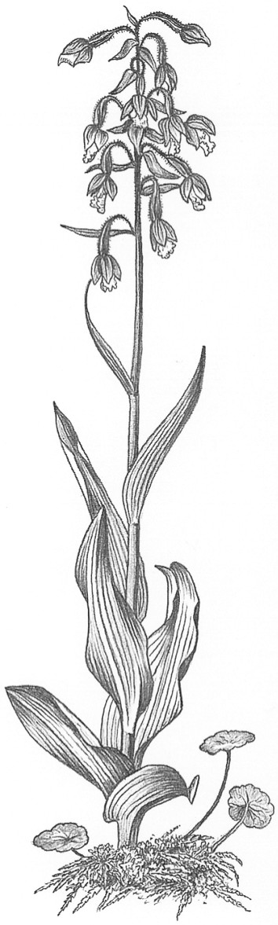
Thirteenth meeting of the Plants Committee
Geneva (Switzerland), 12-15 August 2003
Significant trade in plants
Implementation of Resolution Conf. 12.8
Taxa for review [Decision 12.74]
pericopsis elata
1. This document has been prepared by the Secretariat.
2. The Plants Committee is directed in Decision 12.74 to review Pericopsis elata (African teak) under the Review of Significant Trade (Resolution Conf. 12.8).
3. The Secretariat has contracted Fauna and Flora International to conduct the research phase of the review of P. elata. Research was initiated in January 2003 and will be completed in the second half of 2003. The final report will be presented for consideration by the Plants Committee at its 14th meeting.

