PC13 Doc. 12.2.3.2
CONVENTION ON INTERNATIONAL TRADE IN ENDANGERED SPECIES
OF WILD FAUNA AND FLORA
____________
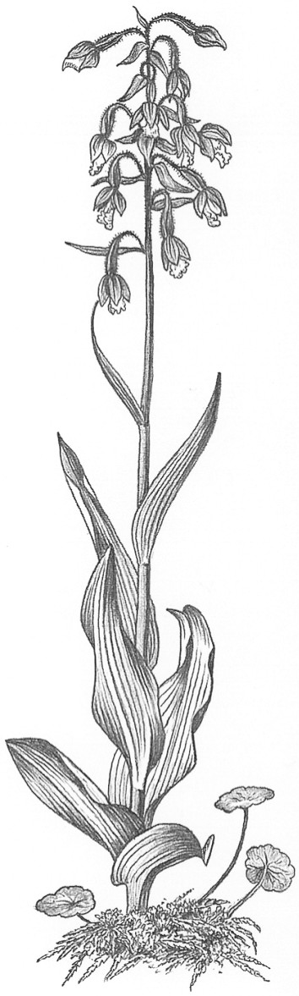
Thirteenth meeting of the Plants Committee
Geneva (Switzerland), 12-15 August 2003
Significant trade in plants
Implementation of Resolution Conf. 12.8
Taxa for review [Decision 12.74]
Aquilaria malaccensis
1. This document has been prepared by the Secretariat.
2. The Plants Committee is directed in Decision 12.74 to review Aquilaria malaccensis (agarwood) under the Review of Significant Trade (Resolution Conf. 12.8).
3. The Secretariat has contracted TRAFFIC Southeast Asia to conduct the research phase of the review of A. malaccensis. Research was initiated in December 2002 and will be completed in the second half of 2003. The final report will be presented for consideration by the Plants Committee at its 14th meeting.
4. Parties that are range States for A. malaccensis are particularly encouraged to respond as comprehensively as possible to requests for information under the Review of Significant Trade. Indeed information thus provided may also contribute to the implementation of several other Decisions related to agarwood-producing taxa (see document PC13 Doc. 9.3).

