PC13 Doc. 12.2.3.1
CONVENTION ON INTERNATIONAL TRADE IN ENDANGERED SPECIES
OF WILD FAUNA AND FLORA
____________
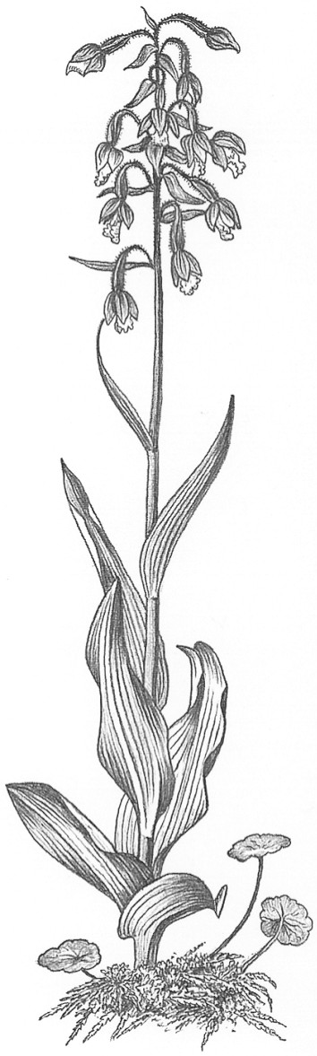
Thirteenth meeting of the Plants Committee
Geneva (Switzerland), 12-15 August 2003
Significant trade in plants
Implementation of Resolution Conf. 12.8
Taxa for review [Decision 12.74]
Prunus africana
1. This document has been prepared by the Secretariat.
2. The Plants Committee is directed in Decision 12.74 to review Prunus africana (red stinkwood) under the Review of Significant Trade (Resolution Conf. 12.8).
3. Until recently, the Secretariat has not been able to allocate sufficient funding to arrange for a consultant to undertake the research phase of the review, but a suitable consultant will be contracted to prepare the review in the near future. A report on progress with the review will made at the 14th meeting of the Plants Committee.

