PC13 Doc. 12.2.1
CONVENTION ON INTERNATIONAL TRADE IN ENDANGERED SPECIES
OF WILD FAUNA AND FLORA
____________
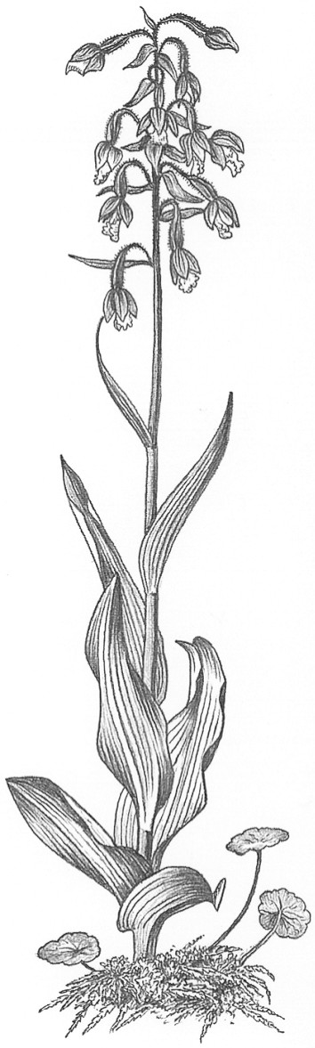
Thirteenth meeting of the Plants Committee
Geneva (Switzerland), 12-15 August 2003
Significant trade in plants
Implementation of Resolution Conf. 12.8
Trade in plants from Madagascar [Decision 12.73]
1. This document has been prepared by the Secretariat.
2. At its 11th meeting, the Plants Committee agreed to a proposal by the Secretariat to undertake a country-wide Review of Significant Trade for Madagascar. The Secretariat contracted the Royal Botanic Gardens, Kew to undertake the part of the review concerning Appendix-II listed plant species from Madagascar.
3. The country-wide Review of Significant Trade in Madagascar concerns all Appendix-II listed animal and plant species in the country. It basically follows the same sequence of events as laid out in Resolution Conf. 12.8: consultation with Madagascar concerning the implementations of Article IV; compilation and review of information on the implementation of Article IV; formulation of recommendations; implementation of the recommendations; and monitoring and evaluation of the implementation of the recommendations.
4. The programme of work should have been conducted throughout 2002, but was interrupted for some time owing to difficult working conditions in Madagascar.
5. At its 12th meeting (CoP12), the Conference of the Parties confirmed the earlier agreement by adopting Decision 12.73, directed to the Plants Committee, as follows:
The review of plants in Madagascar shall be conducted by the Royal Botanic Gardens, Kew (the Scientific Authority for plants of the United Kingdom). The Royal Botanic Gardens is recommended to undertake a workshop in Madagascar, if possible, to discuss the results of the review.
6. In consultation with representatives of the Malagasy Government and Management Authority that attended CoP12, it was decided that a high-level delegation from CITES would visit Madagascar as soon as possible after CoP12 to launch the process officially. In February 2003, the Secretary-General and the Senior Scientific Officer of the Secretariat, along with the Executive Director of TRAFFIC International visited Madagascar and met with senior government officials, including the Prime Minister, the Minister of the Environment, Water and Forests and the Head of the Division of Water and Forests (the CITES Management Authority). A representative of the Division of Water and Forests was appointed as counterpart to the consultants to work on the Review of Significant Trade. During the mission it was agreed that a workshop would be held at the end of May 2003.
7. In compliance with Decision 12.73, a review of Malagasy plants in trade has been conducted by the Royal Botanic Gardens, Kew to compile information on the implementation of Article IV for plants.
8. As part of the review, a database has been built to hold information on taxa recorded in CITES trade data (held by UNEP-WCMC) as having been exported or imported from Madagascar. Taxa not found in the CITES trade data but considered to be in trade according to an expert panel have also been included. There are currently 652 taxa in the database, of which 554 are native to Madagascar, and 399 are orchids. Information is included on: taxonomy, distribution, habitat, IUCN conservation status, previous recommendations of the Plants Committee, CITES trade data; availability in catalogues or nurseries, offer for sale on the Internet, illegal trade and artificial propagation within Madagascar and elsewhere. There are also assessments of whether CITES trade records are a true reflection of trade, whether trade is believed to affect the conservation status and whether conservation status is believed to be stable or declining.
9. A copy of the database has been provided to the Management Authority and the Scientific Authority for plants of Madagascar.
10. A preliminary analysis of the information in the database has classified the native taxa contained therein into five categories of conservation concern. Twenty-five taxa are identified as of highest conservation concern (category 5), and 43 of second-highest (category 4); 151 are regarded as of low concern (category 1) and 143 of unknown status, with the remainder of intermediary concern (categories 2 and 3).
11. A summary analysis of the trade data for endemic Malagasy species listed in Appendix II has been prepared along with a separate analysis of data for the red stinkwood [Prunus (Pygaeum) Africana].
12. A workshop was held in Antananarivo, Madagascar, from 26 to 28 May 2003, to assist in the development of a CITES programme for Madagascar to improve the implementation of Article IV in the country. This workshop was organized by the Secretariat, the Malagasy Management Authority and TRAFFIC International (the consultants undertaking the country-wide Review of Significant Trade for animals running in parallel with the review of plants). The workshop adopted a participatory, stakeholder-led approach to develop recommendations to reform the management system for both wild animals and wild plants exported from Madagascar, and specifically those included in Appendix II of CITES. The Royal Botanic Gardens, Kew participated in the workshop, as did the newly designated Malagasy Scientific Authority for Plants (the Department of Plant Biology of the University of Antananarivo). The summary reports from the database, supplemented by information provided by the Malagasy Management Authority on plant exports (including species not currently included in the Appendices) for the years 2001 and 2002, were used as background documents for the workshop.
13. The workshop agreed on the elements of an action plan covering the following areas: policy and legislation, information and operational needs of the Scientific Authority, administration and management, and enforcement. It also agreed on a provisional timetable for drafting, reviewing and finalizing the plan. It is intended that the plan will be ready for implementation in autumn 2003. In the meantime, and pending the review of individual species to be undertaken by the Scientific Authority in order to make non-detriment findings, the Malagasy Management Authority is not issuing CITES export permits for native plant or animal species.
14. A training workshop for CITES Authorities in the Western Indian Ocean region is to be held in Antananarivo, Madagascar, from 14 to 18 July 2003. Part of the workshop will address the roles and responsibilities of Scientific Authorities, including the making of non-detriment findings.
15. Informal feedback from a range of participants has indicated that the May workshop was considered a success, with widespread satisfaction expressed both with the process and the outcome. However, successful implementation of the resulting action plan will require continuing commitment on the part of the Malagasy Management and Scientific Authorities. Continuing external technical assistance, capacity-building and oversight as well as significant further financial resources are also likely to be necessary. Such needs will be specified in detail in the final version of the action plan.
16. The issues of the effective control of the fauna and flora export trade and the wider governance of the natural resource sector in Madagascar are currently of high priority for the Government and for the major donors active in the environmental field. The Review of Significant Trade has raised the profile both of the wildlife trade and of the role of the Convention in Madagascar at an important time. Provided that momentum can be maintained, this presents a major opportunity for a very significant improvement in the implementation of CITES in the country.
17. The action plan for effectively managing trade in Appendix-II species for Madagascar and implementing Article IV referred to in paragraph 13 above will be elaborated in a collaborative effort by the CITES Authorities of Madagascar, the Secretariat and, particularly where scientific aspects are concerned, the Animals and Plants Committees. It will need to address all aspects relating to the implementation of Article IV, including population status assessments, the process of making non-detriment findings, identification of information gaps, quota setting where appropriate, the supervision of different production systems and operations, the issuance of export documents, the monitoring of trade and production centres, the compilation of trade data, the production of annual and other CITES reports, enforcement, international collaborations, capacity building, and budgetary and operational needs.
18. The implementation of the agreed action plan will probably take several years. The different steps and recommendations will be monitored by the Secretariat in consultation with the Chairmen of the Animals and Plants Committees, and reported to the Standing Committee.

