PC13 Doc. 11.2
CONVENTION ON INTERNATIONAL TRADE IN ENDANGERED SPECIES
OF WILD FAUNA AND FLORA
____________
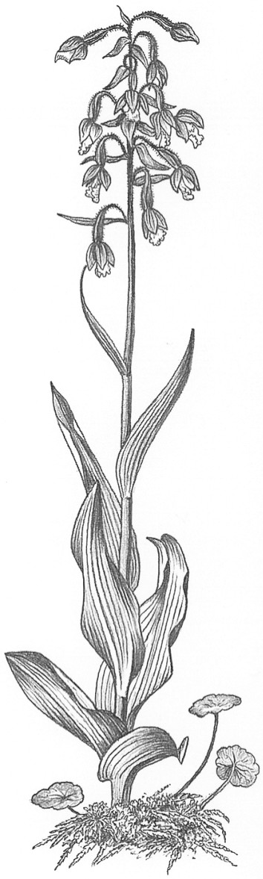
Thirteenth meeting of the Plants Committee
Geneva (Switzerland), 12-15 August 2003
Species proposals for the 13th meeting of the Conference of the Parties
Specimens in international trade under exemption
1. This document has been prepared by Management Authority of Switzerland.

Background
2. Several exemptions allow international trade without permits in live plant specimens of CITES-listed species that would otherwise have to be traded under the regulations of the Convention. Such specimens may be re-exported, but in certain cases they, at a certain point, may no longer qualify for the exemption under which they have been traded previously. After specimens no longer qualify for an exemption, it may be impossible to issue a re-export certificate in a proper way as there is no previous permit on which a re-export certificate could be based, even if there is evidence for the legal acquisition. This is specifically because an export permit of the country of origin is lacking. Examples of exemptions are given below.
a) In vitro specimens [annotations #1 b), 2 b), 4 b) and 8 b)]: as soon as specimens are taken from the sterile containers for further cultivation, the qualification for the exemption, under which they have been in international trade previously, no longer applies.
b) Orchidaceae spp. in Appendix II are annotated with a footnote that allows for an exemption of artificially propagated Phalaenopsis hybrids under certain conditions. Inter alia a minimum quantity of 100 specimens per hybrid is required. If such a shipment is divided up into smaller lots outside the country of origin, the specimens no longer qualify for the exemption in case of re-export.
c) Seeds [annotations #1 a), 2 a), 4 a) and 8 a)], stem joints [annotation #4 e)] and fruits [annotations #4 d) and 8 d)] allow production of live plants outside the country of origin and may thus lead to the creation of stocks that may enter international trade. The exporting country in this case would not be the country of origin of the propagules.
d) Live plant specimens traded under the exemption for exchange of scientific material between registered institutions [Article VII, paragraph 6] may be artificially propagated and eventually enter commercial trade.
e) Cultivars of Cyclamen persicum may be traded, if not dormant, but specimens may eventually become dormant after export from the country of origin.

Draft proposal
3. To avoid complications with re-export of specimens that legally entered international trade under exemptions from the provisions of the Convention, the following text is proposed to be included in the interpretation of the Appendices:
“The country of origin of specimens that are legally in international trade under exemptions from the prescriptions of the Convention shall be deemed to be the first country of destination in which the specimens no longer qualify for the exemption.”
or
“The re-export certificate shall state under “country of origin” and “provenance”: Legally imported under an exemption from the prescriptions of the Convention (or an abbreviation of this).”

