PC13 Doc. 11.1
CONVENTION ON INTERNATIONAL TRADE IN ENDANGERED SPECIES
OF WILD FAUNA AND FLORA
____________
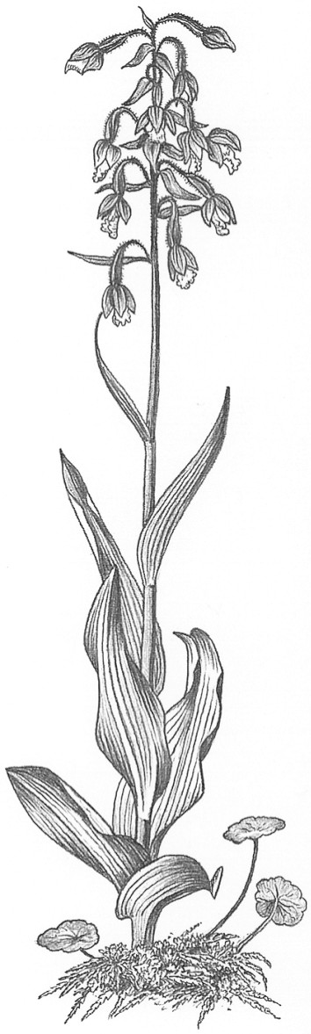
Thirteenth meeting of the Plants Committee
Geneva (Switzerland), 12-15 August 2003
Species proposals for the 13th meeting of the Conference of the Parties
annotations for certain artificially propagated orchid hybrids
1. This document has been prepared by the Management Authority of Switzerland.

Background
2. At the 12th meeting of the Conference of the Parties (CoP12), a proposal was submitted by the United States of America to annotate Orchidaceae in Appendix II with the aim to exempt certain artificially propagated orchid hybrids from the provisions of CITES under a number of conditions. The proposal that was adopted at CoP12 restricted the annotation to hybrids within the genus Phalaenopsis. The annotation reads as follows:
Artificially propagated specimens of hybrids within the genus Phalaenopsis are not subject to the provisions of the Convention when: 1) specimens are traded in shipments consisting of individual containers (i.e. cartons, boxes, or crates) containing 100 or more plants each; 2) all plants within a container are of the same hybrid, with no mixing of different hybrids within a container; 3) plants within a container can be readily recognized as artificially propagated specimens by exhibiting a high degree of uniformity in size and stage of growth, cleanliness, intact root systems, and general absence of damage or injury that could be attributable to plants originating in the wild; 4) plants do not exhibit characteristics of wild origin, such as damage by insects or other animals, fungi or algae adhering to leaves, or mechanical damage to roots, leaves, or other parts resulting from collection; and 5) shipments are accompanied by documentation, such as an invoice, which clearly states the number of plants and is signed by the shipper. Plants not clearly qualifying for the exemption must be accompanied by appropriate CITES documents.
3. The annotation should facilitate the international trade in such artificially propagated hybrids, which form an important part of the international orchid trade. The special conditions provided for in the annotation should prevent, illegal trade in wild-collected orchids under this exemption. Non-flowering and unlabelled specimens are allowed, but a minimum quantity of 100 separately packed specimens per hybrid shall allow checking for uniformity in order to exclude wild-collected specimens. As a result of this restriction, the exemption will only apply to international trade in wholesale quantities. The draft proposal below is aimed to complement the annotation adopted at CoP12.
4. Artificially propagated orchid hybrids are easy to distinguish from wild-collected specimens when they are ready for sale, i.e. flowering, individually potted orchids, labelled with printed labels, and sometimes individually packaged with printed packages. Orchid hybrids are much standardized mass products. Unnaturally big-sized hybrid-flowers, compact and regular growth, uniformity, printed labels and the undamaged leaves and inflorescence allow their identification even by laymen as artificially propagated specimens, and they can therefore be reliably distinguished from wild-collected specimens of botanical species. It is highly unlikely that wild-collected plants could be processed into a comparable standardized product in any profitable way.
5. It can however not be fully excluded that there could be attempts to smuggle flowering specimens of wild species amongst a shipment of exempted orchid hybrids. However, such wild specimens can be camouflaged and smuggled in any imaginable way. Furthermore, the probability is very low that specimens can be found in their natural habitat in flowering state to be collected undamaged, potted, labelled, packaged and transported to an airport or to another port of exit from the country of origin. It is much more likely that such specimens would be hidden in personal luggage in non-flowering state and not openly transported, as their identification is considerably facilitated when they are flowering. Hence it is unlikely that such illegal trade would rise by the adoption of the annotation proposed in paragraph 9.
6. It is possible that wild-collected orchids are cultivated in a nursery in their country of origin until they flower, to be prepared for retail sale in the manner proposed in the annotation. However such specimens would never resemble artificially propagated ones. Moreover, they could not compete in the market with mass-produced hybrids, as acclimatization of wild-collected orchids is time-consuming and their growth rate is low, whereas hybrids are fast growing and vigorous.
7. Commercially traded orchid hybrids are grown as potted plants, whereas a considerable proportion of the species that could be collected from the wild grow epiphytically and can not be potted in cultivation. They have therefore to be fixed on pieces of bark, stem segments of tree ferns and other comparable supports. It is therefore horticulturally not feasible to make them fit the conditions of the proposed exemption.
8. Artificially propagated flowering orchid hybrids are very common in international trade, at least in the European region. They are usually traded in lots of a dozen plants or a multiple of it in mixed shipments with other commonly traded ornamental indoor plants from horticultural production, which are not listed on the CITES Appendices. In international retail sale, such orchid hybrids are often not perceived as CITES specimens, even by professional traders, as they are highly artificial industrial products. In international tourist traffic, especially from Southeast Asia, small numbers of flowering orchid hybrids are often acquired as souvenirs. Tourists are not aware that plants that are for sale in flower shops in airports and other tourist places as souvenirs and that do not look like wild plants at all may need a CITES permit. No such information is usually provided to the consumer. This all leads to seizures that use up a lot of resources in enforcement and have little or no beneficial impact on wild species.
Draft proposal (CoP13)
9. To annotate all Orchidaceae spp. in Appendix II as follows:
“Artificially propagated Orchid hybrids are not subject to the provisions of the Convention, when specimens are:
a) flowering;
b) professionally processed for commercial retail sale, e.g. labelled with printed labels and packaged with printed packages; and
c) show no similarity to wild-collected specimens of botanical species.”

