PC13 Doc. 10.4
CONVENTION ON INTERNATIONAL TRADE IN ENDANGERED SPECIES
OF WILD FAUNA AND FLORA
____________
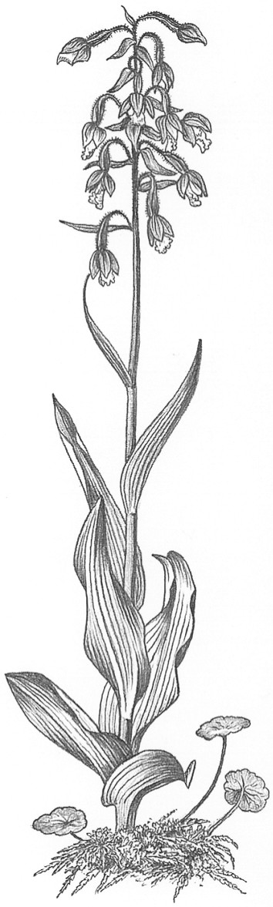
Thirteenth meeting of the Plants Committee
Geneva (Switzerland), 12-15 August 2003
Technical proposals from the 12th meeting of the Conference of the Parties
Determination of the Definition of Swietenia macrophylla Plywood
1. This document has been prepared by the United States of America.

Introduction
2. At the 12th meeting of the Conference of the Parties (CoP12) in November 2002, the Parties adopted a proposal to list the neotropical populations of Swietenia macrophylla (bigleaf mahogany) in CITES Appendix II. The listing applies to logs, sawn wood, veneer sheets, and plywood, but not any other parts or derivatives. The listing will become effective on 15 November 2003. The neotropical populations of Swietenia macrophylla have been listed in CITES Appendix III since 16 November 1995, with the listing annotated to apply to logs, sawn wood, and veneer sheets, but not any other parts or derivatives. Plywood is not included in the current Appendix-III listing.
3. Resolution Conf. 10.13 (Implementation of the Convention for timber species) includes specific definitions for logs, sawn wood, and veneer sheets, and recommends that the Parties apply these definitions with respect to the current annotations for CITES-listed timber species, including the Appendix-III Swietenia macrophylla annotation. This Resolution also provides specific World Customs Organization Harmonized System (HS) commodity codes to describe logs, sawn wood, and veneer sheets, and recommends that the Parties apply them. However, the Resolution does not include a specific definition for plywood, nor does it list any specific HS code(s) for this commodity.
4. The United States believes that, in order for the Parties to implement effectively the Appendix-II listing of Swietenia macrophylla with respect to plywood, it is important for CITES to determine a definition for this commodity, and to ascertain the appropriate HS code(s) for Parties to apply in describing the commodity. It is also important for CITES to decide on an appropriate unit of measure for Swietenia macrophylla plywood.
United States proposed interim determination of the definition of Swietenia macrophylla plywood
5. Although it does not include a specific definition for plywood, Resolution Conf. 10.13 does recommend that, “for the purpose of annotations in the Appendices for parts and derivatives of species traded as timber, definitions to be used should, to the extent possible, be based on the tariff classifications of the Harmonized System of the World Customs Organization”. The United States has followed this recommendation to determine an interim definition of plywood, which it proposes to use with regard to the Swietenia macrophylla Appendix-II listing.
6. HS code 44.12 of the Customs Harmonized Tariff Schedule applies to “plywood, veneered panels and similar laminated wood”. Within this HS code, plywood is defined as:
consisting of three or more sheets of wood glued and pressed one on the other and generally disposed so that the grains of successive layers are at an angle.
7. In accordance with Resolution Conf. 10.13, the United States has adopted this HS-recognized definition as its proposed interim CITES definition of the term ‘plywood’.
8. The United States has flagged those sub-codes under HS code 44.12 that it has determined will apply to plywood which includes Swietenia macrophylla as one or both of its outer plies. These sub-codes (and their HS descriptions), also recognized by the World Customs Organization’s HS, are provided below:
SUB-CODE | PRODUCT DESCRIPTION
4412.13 | Plywood consisting solely of sheets of wood, each ply not exceeding 6 mm in thickness, and with at least one outer ply of tropical wood specified in subheading note 1 to this chapter *
4412.14 | Plywood consisting solely of sheets of wood, each ply not exceeding 6 mm in thickness, and with at least one outer ply of non-coniferous wood
4412.22 | Other (meaning one ply, or more, that is greater than 6 mm in thickness), with at least one outer ply of non-coniferous wood, and with at least one ply of tropical wood specified in subheading note 1 to this chapter *

* Subheading Note 1: For the purposes of subheadings 4403.41 to 4403.49, 4407.24 to 4407.29, 4408.31 to 4408.39, and 4412.13 to 4412.99, the expression ‘tropical wood’ means one of the following types of wood:
Abura, Acajou d'Afrique, Afrormosia, Ako, Alan, Andiroba, Aningré, Avodiré, Azobé, Balau, Balsa, Bossé clair, Bossé foncé, Cativo, Cedro, Dabema, Dark Red Meranti, Dibétou, Doussié, Framiré, Freijo, Fromager, Fuma, Geronggang, Ilomba, Imbuia, Ipé, Iroko, Jaboty, Jelutong, Jequitiba, Jongkong, Kapur, Kempas, Keruing, Kosipo, Kotibé, Koto, Light Red Meranti, Limba, Louro, Maçaranduba, Mahogany, Makoré, Mandioqueira, Mansonia, Mengkulang, Meranti Bakau, Merawan, Merbau, Merpauh, Mersawa, Moabi, Niangon, Nyatoh, Obeche, Okoumé, Onzabili, Orey, Ovengkol, Ozigo, Padauk, Paldao, Palissandre de Guatemala, Palissandre de Para, Palissandre de Rio, Palissandre de Rose, Pau Amarelo, Pau Marfim, Pulai, Punah, Quaruba, Ramin, Sapelli, Saqui-Saqui, Sepetir, Sipo, Sucupira, Suren, Teak, Tauari, Tiama, Tola, Virola, White Lauan, White Meranti, White Seraya, Yellow Meranti.
9. The United States provides its proposed interim determination of the definition of Swietenia macrophylla plywood as a model for Parties to use in establishing a formal definition for this commodity, and in assigning the appropriate HS code(s) to describe the commodity.
United States proposed unit of measure for Swietenia macrophylla plywood
10. In order to monitor effectively the amounts of Swietenia macrophylla in trade as plies of plywood, it is important for CITES to decide on an appropriate unit of measure for this commodity. The United States Customs Service has noted that United States importers of plywood measure this commodity in square metres for the purposes of their market. The United States Customs Service requires that, in accordance with the HS, United States importers record plywood in cubic meters.
11. For any given piece of plywood containing Swietenia macrophylla, the species is most likely to occur as one ply of veneer, usually six millimetres or less in thickness. The United States therefore proposes that plywood containing Swietenia macrophylla be recorded in square metres, in the same manner as sliced veneer. This would, in most cases, give the most accurate measure of how much Swietenia macrophylla is in the plywood. A cubic meter measurement would give an accurate measure of how much total wood is in the plywood, but not how much of that total is actually Swietenia macrophylla.

