PC13 Doc. 9.4.1
CONVENTION ON INTERNATIONAL TRADE IN ENDANGERED SPECIES
OF WILD FAUNA AND FLORA
____________
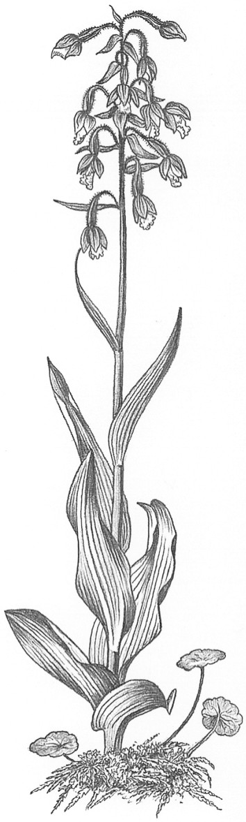
Thirteenth meeting of the Plants Committee
Geneva (Switzerland), 12-15 August 2003
Follow-up of CoP12 Decisions
Review of Resolution Conf. 9.24 (Rev. CoP12) [Decision 12.97]
Decision 12.97
1. This document has been submitted by the Chairman of the Plants Committee.

Review of the criteria for amendment of Appendices I and II
Directed to the Standing, Animals and Plants Committees
12.97 | The Conference of the Parties adopted the following terms of reference for the review of the criteria for amendment of Appendices I and II, to be completed by the 13th meeting of the Conference of the Parties.  a) The revised version of Annex 4 of document CoP12 Doc. 58 compiled by the Chairman of the Criteria Working Group (CWG) formed by Committee I during the 12th meeting of the Conference of the Parties (the CWG12 Chairman’s text) will form a basis for further discussion, in recognition of the substantial and constructive efforts contributed by the Parties, the intersessional Criteria Working Group set up at the 11th meeting of the Conference of the Parties, FAO, the Criteria Working Group formed during the 12th meeting of the Conference of the Parties, and others.  b) The Animals and Plants Committees shall coordinate an open, transparent and broadly consultative process involving all Parties to consider further revision of the CWG12 Chairman’s text.  c) The process should include reviews of selected taxa, to ensure that the applicability of the criteria and guidelines to a broad array of taxa is assessed, and results of these reviews should be made widely available.  d) The Animals and Plants Committees shall report to the Standing Committee before a date to be established by the Standing Committee.

