PC13 Doc. 9.3
CONVENTION ON INTERNATIONAL TRADE IN ENDANGERED SPECIES
OF WILD FAUNA AND FLORA
____________
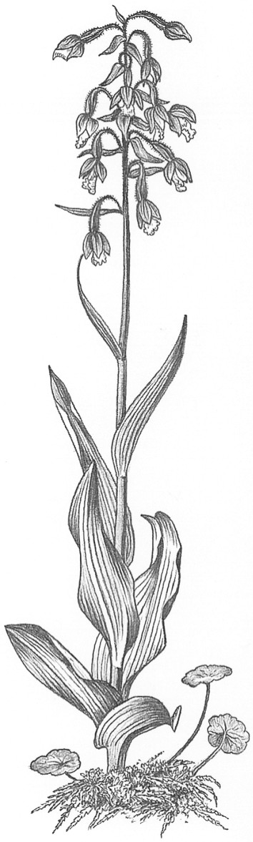
Thirteenth meeting of the Plants Committee
Geneva (Switzerland), 12-15 August 2003
Follow-up of CoP12 Decisions
Aquilaria spp. [Decisions 12.66-12.71]: progress report
1. This document has been prepared by the Secretariat.
2. Six Decisions concerning Aquilaria spp. were adopted by the Conference of the Parties at its 12th meeting (CoP12, Santiago, 2002). These Decisions, all of which are directed to the Plants Committee, are as follows:
12.66 The DNA work currently being undertaken by the National Herbarium of the Netherlands under contract with the Secretariat should continue and should be aimed at investigating the options for the development of identification tools based on molecular analysis.
12.67 More detailed information on the distribution of species should be compiled and assessed as an aid to better trade reporting, using point-of-origin data.
12.68 As the trade is in the readily identifiable product of agarwood, studies should include all known agarwood-producing taxa and not only the CITES-listed species A. malaccensis.
12.69 IUCN should be invited to re-evaluate the threatened status of all agarwood-producing taxa according to the 2000 IUCN criteria.
12.70 A standard method for determining the population status of CITES-listed agarwood-producing taxa should be developed to assist Scientific Authorities in advising that exports will not be detrimental to the survival of the species in compliance with Article IV of the Convention. Such a standard method could be used to verify populations across all agarwood-producing areas, and allow not only the setting of appropriate quotas but also the verification of species being harvested.
12.71 Further field research should be conducted on trade dynamics, including in the major import and re-exporting States and territories (Japan, Saudi Arabia, Singapore, Taiwan, province of China, and the United Arab Emirates).
3. Concerning decision 11.66, the Secretariat is working to secure funds so that the work initiated by the National Herbarium of the Netherlands can continue.
4. There are no activities being undertaken or planned specifically to implement Decision 12.67. However, it is possible that range States can provide such information as a result of national level activities (for example, through detailed forest inventories). The Secretariat would welcome updates from Parties that are range States for agarwood-producing taxa concerning any work they are undertaking or plan to initiate that may contribute towards implementation of this Decision.
5. The Secretariat will strive to ensure that, where appropriate, any work undertaken on behalf of the Plants Committee is sufficiently funded in order to incorporate research on all agarwood-producing taxa as required in Decision 12.68. With regard to work currently underway, it is worth noting that this Decision has been taken into consideration in the Review of Significant Trade questionnaire developed by TRAFFIC Southeast Asia for A. malaccensis. The questionnaire requests information on agarwood-producing taxa other than A. malaccensis.
6. Providing that funding is secured in sufficient time, IUCN intends to organize a further evaluation of the Red List categories for agarwood-producing taxa as a side event during the First International Agarwood Conference (Ho Chi Minh City and An Giang Province, Viet Nam, 10-15 November 2003), in compliance with Decision 12.69. The evaluation process will be coordinated by IUCN/SSC, with specific input from the recently formed IUCN/SSC Global Trees Specialist Group. Parties interested in supporting this initiative are encouraged to contact IUCN/SSC.
7. Concerning Decision 12.70, the Secretariat has contracted TRAFFIC Southeast Asia to contribute towards the development of methodology to make non-detriment findings for CITES-listed agarwood-producing taxa. A report of this work will be prepared for the 14th meeting of the Plants Committee. Initial discussions between TRAFFIC Southeast Asia and the CITES Management and Scientific Authorities of Indonesia (including the Asian representative for the Plants Committee) have resolved to work with the Indonesian Gaharu (agarwood) Traders’ Association (ASGARIN) to conduct field assessments in key harvesting areas and to work collaboratively towards the objectives of Decision 12.70. Further discussions between these collaborators are planned for later in 2003 to select a number of priority population sites in Indonesia in order to enable field-testing of appropriate methodologies for making non-detriment findings for agarwood producing-taxa. TRAFFIC Southeast Asia is also collaborating with the IUCN/SSC Wildlife Trade Programme and the Secretariat to secure additional funding to produce standard guidelines for monitoring the status of A. malaccensis. These will be used to assist in making non-detriment findings. Parties interested in supporting this initiative are encouraged to approach these organizations.
8. The Secretariat has contracted TRAFFIC Southeast Asia to begin implementing Decision 12.71. Trade dynamics have begun to be investigated in more detail in the major exporting countries of Indonesia and Malaysia. Further efforts in Singapore and Taiwan, province of China, are planned for the second half of 2003. These are expected to lead to a greater understanding of the dynamics in re-exporting and consuming countries and territories. A report will be provided at the 14th meeting of the Plants Committee on this work. Additional funding will be required to complete the work in the remaining importing countries identified in Decision 12.71 (Japan, Saudi Arabia and the United Arab Emirates). This work incorporates research on all agarwood-producing taxa, and therefore also contributes to the implementation of Decision 12.68.

