PC13 Doc. 9.2
CONVENTION ON INTERNATIONAL TRADE IN ENDANGERED SPECIES
OF WILD FAUNA AND FLORA
____________
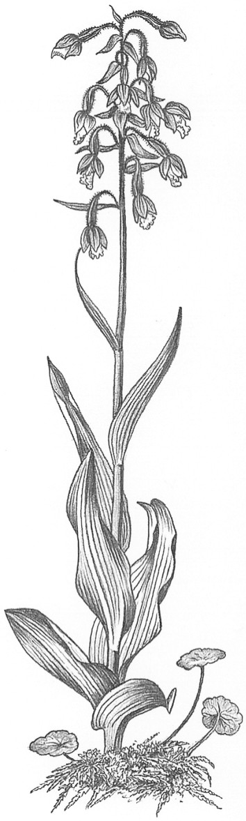
Thirteenth meeting of the Plants Committee
Geneva (Switzerland), 12-15 August 2003
Follow-up of CoP12 Decisions
Guaiacum spp. [Decision 11.114 (Rev. CoP12)]
1. This document has been prepared by the Secretariat.
2. At the 12th meeting the Conference of the Parties (CoP12, Santiago, 2002), the Parties adopted a proposal to include Guaiacum spp. in Appendix II of the Convention, and Decision 11.114 (Rev. CoP12) relating to Guaiacum spp. as follows:
Directed to the Plants Committee
The Plants Committee shall assess the status of Guaiacum species in the wild, the status in trade and threats to the species
3. The following information was provided in the report of the Chairman of the Plants Committee presented at CoP12 in document CoP12 Doc. 10.2, paragraph 22:
The results of the project that was undertaken by Mexico and the United States of America pursuant to Decision 11.114 were presented at PC11. During discussions at this meeting, it was recognized that Guaiacum sanctum, G. coulteri, G. coulteri var. palmeri and G. unijugum are distinguishable based on morphological features, but not their wood, which is the chief commodity in trade. The results also pointed out that further research on Guaiacum spp. should explore different approaches to assess the relationships in the genus more definitively. Though not practical for monitoring purposes, analysis of molecular evidence could prove to be the simplest way of identifying the species. Though the phylogenetics of the Zygophyllaceae has been examined previously, the phylogeny of the genus Guaiacum remains unexplored. Such a study may provide explanations for the morphological variation of Guaiacum in areas such as Mexico, Oaxaca, and Guatemala. The PC considered that the project should be continued by way of a survey of the population status of the Mexican species only.
4. In its considerations about the most appropriate manner to implement Decision 11.114 (Rev. CoP12), the Plants Committee may wish to take into consideration the discussions at its 10th and 11th meetings on Guaiacum sanctum and other Guaiacum species (see documents Doc. PC 10.7.3 and PC11 Doc. 8.2), and at its 12th meeting concerning the status of Guaiacum research in Mexico [see document PC12 Doc. 8.2 (Rev.1)]. The Scientific Authority of Mexico has informed the Secretariat that it would provide an update on these research activities at the present meeting.
5. Germany has stated that it was prepared to contribute financially towards the implementation of Decision 11.114 (Rev. CoP12).

