PC13 Doc. 9.1.2
CONVENTION ON INTERNATIONAL TRADE IN ENDANGERED SPECIES
OF WILD FAUNA AND FLORA
____________
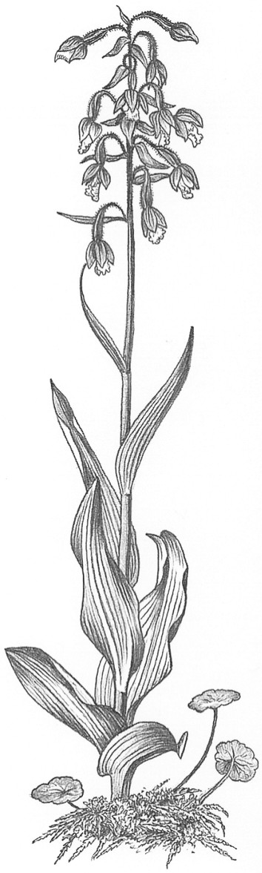
Thirteenth meeting of the Plants Committee
Geneva (Switzerland), 12-15 August 2003
Follow-up of CoP12 Decisions
Harpagophytum spp. [Decisions 12.63-12.65]
Implementation of decisions in namibia
1. This document has been prepared by the Management Authority of Namibia, in compliance with Decisions 12.63, 12.64 and 12.65 (see document PC13 Doc. 9.1.1).
2. As part of the ongoing management and trade of Harpagophytum, Namibia undertook a national devil’s claw situation analysis. The main objectives of the situation analysis were as follows:
a) To identify the critical features of the occurrence, harvesting of and trade in Devil’s claw to enable the Namibian Government to develop appropriate policy and take legislative decisions that would contribute to improve resource management and benefit those involved in the harvesting of and trade in Harpagophytum in Namibia; and
b) To put in place mechanisms to ensure that Namibia’s trade in devil’s claw on the international market was sustainable and that it received fair payment.
3. To meet the main objectives of the national situation analysis, the following interrelated surveys were carried out in 2002:
a) Resource survey;
b) Socio-economic survey; and
c) Market survey.
4. The level of Harpagophytum exports from Namibia continues to increase annually, and its sustainability remains of concern. In 2001, 726, 333 kg were exported from Namibia against 1,038,205 kg in 2002.
5. The resource survey has provided some preliminary baseline information on the status of Harpagophytum in Namibia, i.e. the distribution and density of Harpagophytum. This information will enable Namibia to set national harvesting quotas.
6. It is proposed that national harvesting quotas be set and implemented on the following basis:
a) That the Harpagophytum range in Namibia is divided into 2 to 3 categories, for example low, medium and high density with a standard sustainable annual off-take rate per square kilometre.
b) That communities/harvesters are given the opportunity to organize themselves into simplified conservancies (where there is none yet) and apply as a group for a quota to be determined based on the size of the area and the Harpagophytum density class.
c) The community is then supplied with a certain number of Ministry of Environment and Tourism bag labels with unique numbers/bar codes valid for a harvesting season in relation to the area under their control. The aim is to have individual groups of harvesters being solely responsible for harvesting in certain areas and have exclusive harvesting rights through the formation of the conservancies.
7. The Ministry of Environment and Tourism will communicate with all Harpagophytum dealers (exporters and importers) before putting the system in place. A benefit for dealers could be that product quality could be linked to certain harvesters and hopefully to material that is sustainably harvested, and would thereby attract a better price for the harvesters themselves.
8. When additional information is obtained on the density and distribution of Harpagophytum in Namibia, the harvesting rates for the 2 to 3 proposed density categories can be revised and the distribution of these categories can be alternatively delineated. Through this adaptive management the national harvesting quota will be fine-tuned.

