PC13 Doc. 9.1.1
CONVENTION ON INTERNATIONAL TRADE IN ENDANGERED SPECIES
OF WILD FAUNA AND FLORA
____________
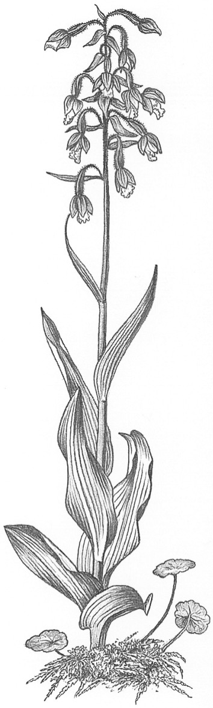
Thirteenth meeting of the Plants Committee
Geneva (Switzerland), 12-15 August 2003
Follow-up of CoP12 Decisions
Harpagophytum spp. [Decisions 12.63-65]
Implementation of Decisions
1. This document has been prepared by the Secretariat.

Background
2. At the 12th meeting the Conference of the Parties (Santiago, 2002), the Parties adopted three Decisions relating to Harpagophytum spp. as follows:
Directed to Parties
12.63 Range States of Harpagophytum species that authorize the export of specimens of these species should provide an update on implementation of the policies and management programmes mentioned in the reports submitted in fulfilment of Decision 11.63 (cf. document PC12 Doc. 8.1) for consideration by the Plants Committee at its 14th meeting. Reports on progress with the implementation of this decision should be provided to the Secretariat 90 days before the 14th meeting of the Plants Committee for inclusion by the Secretariat in a report to that meeting.
12.64 Range States and importing States should negotiate with the devil’s claw industry to obtain support for management programmes that promote sustainable use and the development of communities that are managing the resource. Assistance in this regard could, if necessary, be requested from the Plants Committee and the Secretariat. Reports on progress with the implementation of this decision should be provided to the Secretariat 90 days before the 14th meeting of the Plants Committee for inclusion by the Secretariat in a report to that meeting.
12.65 Range States should explore how processes and mechanisms in other international treaties can be used to provide support for sustainable resource use and fair trade, and should request the CITES Secretariat to provide assistance if required. Reports on progress with the implementation of this decision should be provided to the Secretariat 90 days before the 14th meeting of the Plants Committee for inclusion by the Secretariat in a report to that meeting.
3. All three Decisions require range States of Harpagophytum spp., and in the case of Decision 12.64, importing States, to provide progress reports to the Secretariat regarding implementation of these Decisions for discussion at the 14th meeting of the Plants Committee.

Progress with implementation of the Decisions
4. The Government of Namibia has provided an update concerning implementation of the Decisions, and specifically Decision 12.63 (see document PC13 Doc 9.1.2).
5. With regard to Decisions 12.63 and 12.64, the Secretariat is aware that the Government of South Africa is in the process of developing a strategic plan for the sustainable harvest and management of Harpagophytum spp. in South Africa, which already forms the official strategy of the South Africa Devil’s Claw Working Group. The formulation of the strategy has involved thorough consultation with traders in South Africa. The strategy encompasses all aspects of conservation of the species, from the harvesting community to administration and law enforcement of the trade, and will be available to the Plants Committee at its 14th meeting.
6. The Secretariat is aware that South Africa is also currently completing a report documenting the findings of scientific and socio-economic research carried out by the National Botanical Institute and Resource Africa between June 2002 and February 2003 on devil’s claw. The objectives of this study were to:
a) Determine as accurately as feasible the distribution of devil’s claw in South Africa and identify areas of resource concentration;
b) Determine the amount of devil’s claw currently harvested in South Africa;
c) Gather socio-economic information pertaining to devil’s claw harvesting and trade in South Africa;
d) Determine as far as possible whether the devil’s claw trade in South Africa is being conducted in a sustainable manner; and
e) Develop policy recommendations aimed at helping to ensure the sustainable use of devil’s claw in South Africa.
7. The Plants Committee may wish to consider at this meeting whether the development of a methodology to review the reports is required in order to increase the efficiency of the review. With reference to Decisions 12.64 and 12.65, any Parties requiring assistance from the Secretariat are urged to approach the Secretariat as soon as possible.

