PC13 Doc. 3.2
CONVENTION ON INTERNATIONAL TRADE IN ENDANGERED SPECIES
OF WILD FAUNA AND FLORA
____________
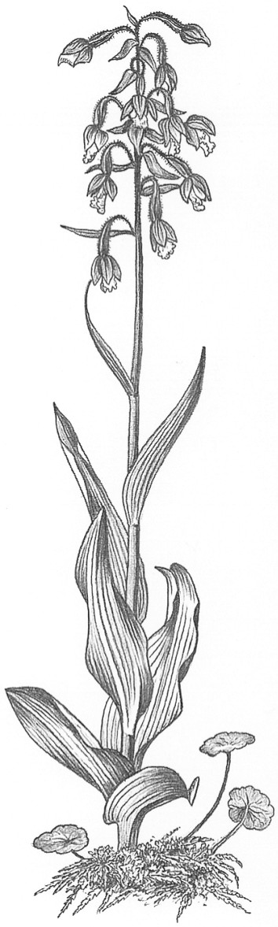
Thirteenth meeting of the Plants Committee
Geneva (Switzerland), 12-15 August 2003
Adoption of the Agenda and working programme
Working programme

Tuesday 12 August
09h00 – 10h30 Closed session (Committee members and Parties only)
10h30 – 11h00 Coffee break
11h00 – 12h30 Work session
12h30 – 14h30 Lunch
14h30 – 16h00 Work session
16h00 – 16h30 Tea break
16h30 – 18h00 Work session

Wednesday 13 August
09h00 – 10h30 Work session
10h30 – 11h00 Coffee break
11h00 – 12h30 Work session
12h30 – 14h30 Lunch
14h30 – 16h00 Work session
16h00 – 16h30 Tea break
16h30 – 18h00 Work session

Thursday 14 August
09h00 – 10h30 Work session
10h30 – 11h00 Coffee break
11h00 – 12h30 Work session
12h30 – 14h30 Lunch
14h30 – 16h00 Work session
16h00 – 16h30 Tea break
16h30 – 18h00 Work session

Friday 15 August
09h00 – 10h30 Work session
10h30 – 11h00 Coffee break
11h00 – 12h30 Work session
12h30 – 14h30 Lunch
14h30 – 16h00 Work session
16h00 – 16h30 Tea break
16h30 – 18h00 Work session

