PC13 Doc. 3.1 (Rev. 7)
CONVENTION ON INTERNATIONAL TRADE IN ENDANGERED SPECIES
OF WILD FAUNA AND FLORA
____________
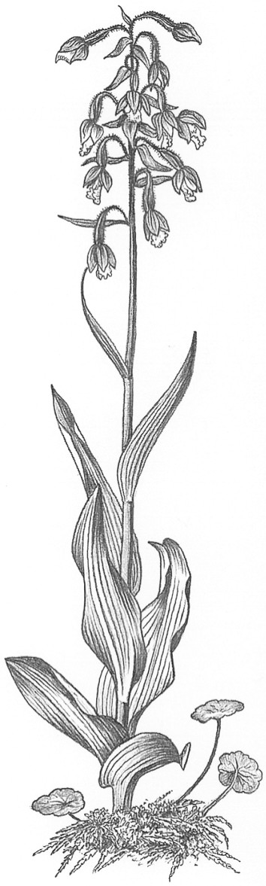
Thirteenth meeting of the Plants Committee
Geneva (Switzerland), 12-15 August 2003
Adoption of the Agenda and working programme
agenda
Agenda item | Document No. | Language
1. Opening of the meeting | No document
2. Adoption of the Rules of Procedure | PC13 Doc. 2 (Rev. 1) | E, F, S
3. Adoption of the Agenda and working programme
3.1 Agenda | PC13 Doc. 3.1 (Rev. 7) | E, F, S
3.2 Working programme | PC13 Doc. 3.2 | E, F, S
4. Admission of observers | PC13 Doc. 4 | E, F, S
5. General introduction on the operation of the Plants Committee [Decision 12.16] | No document
6. Regional reports and updated regional directories [Decisions 12.14 and 12.15]
6.1 Africa
6.1.1 Regional report | PC13 Doc. 6.1.1 | E
6.1.2 Regional directory | No document
6.2 Asia
6.2.1 Regional report | PC13 Doc. 6.2.1 (Rev. 1) | E
6.2.2 Regional directory | No document
6.3 Central and South America and the Caribbean
6.3.1 Regional report | PC13 Doc. 6.3.1 | S
6.3.2 Regional directory | No document
6.4 Europe
6.4.1 Regional report | PC13 Doc. 6.4.1 | E
6.4.2 Regional directory | No document
6.5 North America
6.5.1 Regional report | PC13 Doc. 6.5.1 | E, F, S
6.5.2 Regional directory | PC13 Doc. 6.5.2 | E
6.6 Oceania
6.6.1 Regional report | PC13 Doc. 6.6.1 | E
6.6.2 Regional directory | PC13 Doc. 6.6.2 | E
7. Report on the 49th meeting of the Standing Committee | No document
8. Working programme for the Plants Committee until the 13th meeting of the Conference of the Parties
8.1 Resolutions and Decisions directed or related to the Plants Committee | PC13 Doc. 8.1 | E, F, S
9. Follow-up of CoP12 Decisions
9.1 Harpagophytum spp. [Decisions 12.63-12.65]
9.1.1 Implementation of Decisions | PC13 Doc. 9.1.1 | E, F, S
9.1.2 Implementation of Decisions in Namibia | PC13 Doc. 9.1.2 | E, F, S
9.2 Guaiacum spp. [Decision 11.114 (Rev. CoP12)] | PC13 Doc. 9.2 | E, F, S
9.3 Aquilaria spp. [Decisions 12.66-12.71]: progress report | PC13 Doc. 9.3 | E, F, S
9.4 Review of Resolution Conf. 9.24 (Rev. CoP12) [Decision 12.97]
9.4.1 Decision 12.97 | PC13 Doc. 9.4.1 | E, F, S
9.4.2 Chair’s text – Committee I Working Group on Criteria (document CoP12 Com. I. 3) | PC13 Doc. 9.4.2 | E, F, S
9.4.3 Proposal of terms of reference and schedule | PC13 Doc. 9.4.3 (Rev. 1) | E, S
10. Technical proposals from the 12th meeting of the Conference of the Parties
10.1 Definitions of the technical terms used in the annotations of medicinal plants [Decisions 12.23 and 11.118 (Rev.CoP12)] | No document
10.2 Artificially propagated orchid hybrids | No document
10.3 Review of Resolutions on plants and plant trade [Decision 12.11 e)] | No document
10.4 Determination of the definition of Swietenia macrophylla plywood | PC13 Doc. 10.4 | E, F, S
11. Species proposals for the 13th meeting of the Conference of the Parties
11.1 Annotations for certain artificially propagated orchid hybrids | PC13 Doc. 11.1 | E, F, S
11.2 Specimens in international trade under exemption | PC13 Doc. 11.2 | E, F, S
11.3 Proposal to include Caesalpinia echinata in the Appendices | No document
12. Significant trade in plants
12.1 Evaluation of the Review of Significant Trade [Decision 12.75] | PC13 Doc. 12.1 | E, F, S
12.2 Implementation of Resolution Conf. 12.8
12.2.1 Trade in plants from Madagascar [Decision 12.73] | PC13 Doc. 12.2.1 | E, F, S
12.2.2 Cycads | PC13 Doc. 12.2.2 | E, F, S
12.2.3 Taxa for review [Decision 12.74]
12.2.3.1 Prunus africana | PC13 Doc. 12.2.3.1 | E, F, S
12.2.3.2 Aquilaria malaccensis | PC13 Doc. 12.2.3.2 | E, F, S
12.2.3.3 Pericopsis elata | PC13 Doc. 12.2.3.3 | E, F, S
12.2.3.4 Aloe species from East Africa used as extracts | PC13 Doc. 12.2.3.4 | E, F, S
13. Review of the Appendices
13.1 Timber species | PC13 Doc. 13.1 | E, F, S
13.2 Artificially propagated plants traded in large quantities | PC13 Doc. 13.2 | E, F, S
13.3 Periodic review of animal and plant taxa in the Appendices [Resolution Conf. 11.1 (Rev.), Decision 12.96 and document SC49 Doc. 20.1] | PC13 Doc. 13.3 | E
14. Review of heavily traded non-CITES species
14.1 Review of heavily traded non-CITES species [Decision 12.9 a) iii)] | PC13 Doc. 14.1 | E, F, S
14.2 Evaluation of tree species (Decision 12.10) | PC13 Doc. 14.2 (Rev. 1) | E, F, S
14.3 Project report on Dalbergia melanoxylon | No document
15. Checklists and nomenclature
15.1 Progress report | PC13 Doc. 15.1 | E, F, S
15.2 Checklist of Succulent Euphorbia, new edition | No document
15.3 Checklist of medicinal and aromatic plants, new edition | No document
15.4 Preparation of CITES checklist for Bulbophyllum (Orchidaceae) | No document
16. Strategic planning (PC): Action Plan of the Plants Committee [Decisions 12.9 b) and 12.11 a)] | No document
17. ID Manual: progress report | PC13 Doc. 17 | E
18. Guidelines for transport of live plants | No document
19. Relationship between in situ conservation and ex situ production of plants [Decision 12.11 l)] | PC13 Doc. 19 | E, F, S
20. Links with industry and traders to promote projects on sustainable use [Decision 12.11 k)] | No document
21. Role of Appendix II [Decision 12.11 m)] | No document
22. Global Strategy for Plant Conservation (CBD): Analysis and links with CBD [Decisions 12.12 and 10.86] | No document
23. Other issues resulting from PC12 | No document
24. Training initiatives
24.1 Standard slide package: progress report | PC13 Doc. 24.1 | E, F, S
24.2 Master's Course in Baeza, Spain, 2003 | No document
25. Production systems involving CITES-listed species and their impact on wild populations – source code designations
25.1 Plant production systems | PC13 Doc. 25.1 | E, F, S
26. Time and venue of the 14th Plants Committee meeting | No document
27. Any other business
27.1 Annotations of parts and derivatives | No document
27.2 Artificially propagated Tillandsia xerographyca from Guatemala and the Philippines | No document

Information documents
Document title | Document No. | Language
Response from Association Technique Internationale des Bois Tropicaux (ATIBT) to document PC13 Doc. 10.14 | PC13 Inf. 1 | E
Guaiacum sanctum in Mexico: progress in the study of population status, recent management and enforcement actions and other related issues | PC13 Inf. 2 | E, S
Status assessment of Agarwood producing species for improved conservation and non detrimental use | PC13 Inf. 3 | E
Proposal to include Caesalpinia echinata in the Appendices. Presentation of the international pernambuco conservation initiative | PC13 Inf. 4 | E, F, S
Artificially propagated Tillandsia xerographyca from Guatemala and the Philippines | PC13 Inf. 5 | E
Production systems involving CITES-listed species and their impact on wild populations | PC13 Inf. 6 | E
Carta de la Autoridad Administrativa CITES de Cuba dirigida a la Secretaría CITES (17.06.03) | PC13 Inf. 7 | S
Madagascar Significant Trade – Plants  Report for CITES Secretariat  RBG Kew (July 2003) Andrew Newman | PC13 Inf. 8 | E
Document prepared by the Scientific Authority of Austria for PC13 (Agenda item 15.4)  Preparation of CITES checklist for Bulbophyllum (Orchidaceae) | PC13 Inf. 9 | E
cancelled | PC13 Inf. 10
Convention on Biological Diversity (CBD) Global Strategy for Plant Conservation (IUCN, TRAFFIC) | PC13 Inf. 11 | E
Correspondence from the Executive Secretary of CBD  to the Chairman of the Plants Committee | PC13 Inf. 12 | E

