PC13 Doc. 2 (Rev. 1)
CONVENTION ON INTERNATIONAL TRADE IN ENDANGERED SPECIES
OF WILD FAUNA AND FLORA
____________
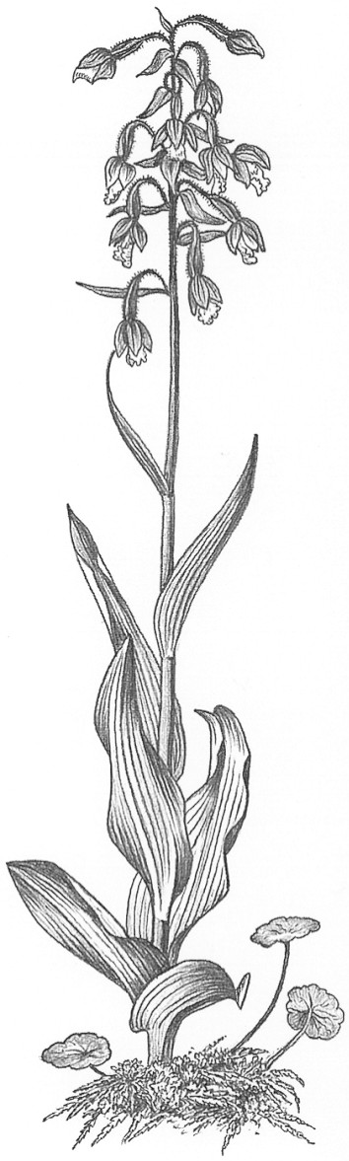
Thirteenth meeting of the Plants Committee
Geneva (Switzerland), 12-15 August 2003
Rules of Procedure
for meetings of the Plants Committee

Representation and attendance

Rule 1
The membership of the Committee shall consist of the regional representatives elected at each meeting of the Conference of the Parties.

Rule 2
If a member is not present at a meeting, his/her alternate shall be entitled to represent the region as a member and to vote in his/her place.

Rule 3
Only members of the Committee have the right to vote.

Rule 4
Parties shall be entitled to be represented at meetings of the Committee by observers who shall have the right to participate but not to vote. Alternate members shall be entitled to participate at meetings of the Committee as observers.

Rule 5
All observers shall normally inform the Secretariat of their intention to participate in a meeting at least four weeks in advance.

Rule 6
The Chairman may invite any other person or a representative of any country or organization to participate in meetings of the Committee as an observer without the right to vote.

Officers

Rule 7
After election of the members at each regular meeting of the Conference of the Parties or at the beginning of the first meeting of the Committee thereafter, the members of each Committee shall elect their Chairman and Vice-Chairman.

Rule 8
The Chairman shall preside at meetings of the Committee, approve the provisional agenda prepared by the Secretariat and maintain liaison with other Committees between meetings of the Committee. He/she shall represent the Committee and the Parties as required within the limits of the Committee's mandate, and shall carry out such other functions as may be entrusted to him/her by the Committee and the Standing Committee.

Rule 9
The Vice-Chairman shall assist the Chairman in his/her functions, and shall act on his/her behalf at meetings in the absence of the Chairman.

Rule 10
The Secretariat of the Convention shall service and act as secretary for meetings of the Committee. However, in the event of a closed session, the meeting shall provide for its own rapporteur, if needed.

Meetings

Rule 11
The Committee shall normally meet at least once every year.

Rule 12
Meetings of the Committee shall be called at the request of the Chairman or of a simple majority of the members.

Rule 13
The time and place of meetings shall be determined by the Chairman.

Rule 14
Notice of meetings shall normally be given by the Secretariat at least 105 days, and in case of emergency meetings at least 14 days, in advance of the meeting.

Rule 15
Documents to be considered at a meeting shall normally be provided to the Secretariat by Parties only, or by members of the Committee. These documents should also be submitted to the Chairman and the Regional Representative(s) of the Party concerned.

Rule 16
Non-governmental organizations may provide documents through the CITES Authorities of the Party where they are located. However, international non-governmental organizations, as recognized under the provisions as applied at the meeting of the Conference of the Parties, may send documents to the CITES Secretariat. In both cases the decision to distribute these documents shall be taken by the Secretariat in consultation with the Chairman. These documents shall also be submitted to the Chairman and the Regional Representative(s) of the Party concerned where applicable.

Rule 17
Documents to be considered by the Committee shall normally be provided to the Secretariat at least 60 days before the meeting where they are to be discussed.

Rule 18
All documents submitted by the Secretariat or to the Secretariat by a Party, or submitted by an observer at the request of the Chairman, shall be placed on the Secretariat’s website as soon as possible after they are received in the original language in which they have been submitted. The Secretariat shall distribute printed documents for any meeting at least 40 days before the proposed date of the meeting where they are to be discussed. The documents shall be provided to all members and alternate members of the Committee, to all Parties that may be directly affected by any discussion of the documents and to all Parties that have informed the Secretariat of their intention to be represented at the meeting.

Rule 19
A quorum for a meeting shall consist of six members from at least four regions. No decision shall be taken at a meeting in the absence of a quorum.

Rule 20
Decisions of the Committee shall be taken by consensus unless a vote is requested by the Chairman or by members from two regions.
Rule 21
In the case of a vote, the decision of the Committee shall be taken by a simple majority of the members voting. In the case of a tie, the vote of the Chairman shall be decisive.

Rule 22
At the request of the Chairman, or of any member, the Committee shall decide by a vote whether the discussion of any particular subject shall be held in closed session; any such vote shall be decided by a simple majority. Alternate members, Parties and intergovernmental organizations present at the meeting as observers shall be entitled to be present at closed sessions.

Rule 23
A concise executive summary of the decisions of the Committee shall be prepared by the Secretary before the closure of each meeting of the Committee.

Rule 24
A summary record of each meeting shall be prepared by the Secretary and sent to the Parties represented at the meeting within 60 days. The Secretary shall take into account the comments received within 20 days of the circulation and shall communicate the final summary record to all Parties after it is approved by the Chairman, preferably at least one month before the next meeting.

Rule 25
The working languages of the meetings of the Committee shall be English, French and Spanish.

Communication procedure

Rule 26
Any member may submit a proposal to the Chairman for a decision by postal procedure. The Chairman shall send the proposal to the Secretariat for communication to the members, who shall comment within 40 days of the communication of the proposal; any comments received by the Secretariat within this time limit shall also be so communicated to the members.

Rule 27
If no objection from a member to a proposal is received by the Secretariat within 25 days of the date when the results of the consultation on the proposal were communicated to the members, the proposal shall be considered as adopted, and notice of the adoption shall be given to all members.

Rule 28
If any member objects to a proposal within the applicable time limit, the proposal shall be put to a vote. The proposal shall be considered as decided by a simple majority of the members. If no majority is achieved, the proposal shall be referred to the next meeting of the Committee.

Final provisions

Rule 29
Any working document submitted for consideration by the Committee may be marked as “Restricted” or “Confidential” by the Secretariat, in consultation with the Chairman, when it determines that the document contains information that might be detrimental if disclosed to non-Parties or to organizations; Parties should use their best efforts to maintain such restriction or confidentiality unless the classification has been removed by the Secretariat or the Committee.

Rule 30
In matters not covered by the present Rules, the Rules of Procedure as adopted at the last regular meeting of the Conference of the Parties shall be applied mutatis mutandis.

Rule 31
These Rules shall come into force on adoption by the Committee, and may be amended by the Committee as required.

