PC12 Doc. 25.1
CONVENTION ON INTERNATIONAL TRADE IN ENDANGERED SPECIES
OF WILD FAUNA AND FLORA
____________
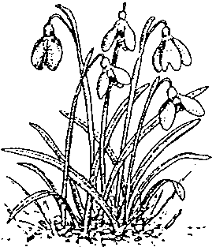
Twelfth meeting of the Plants Committee
Leiden (The Netherlands), 13-17 May 2002
Any other business
PROGRESS report OF THE CITES MANAGEMENT AUTHORITY OF CHINA
IN PLANT PROTECTION AND MANAGEMENT IN 2001
1. This document has been prepared by the Plant Division of the Management Authority of China.
2. The Project of Wild Animal and Plant Protection and Nature Reserve Construction has been launched after approval by the Chinese Government. It aims at improving the protection of wild animals and plants and at developing the sustainable use of wild animal and plant resources. This project has been integrated into the 10th five-year National Plan. Orchids and cycads are amongst the species protected under this project.
3. An export quota was established for Tricholoma matsutake and Cibotium barometz in order to improve their protection and ensure their sustainable use.
4. Nostoc flagelliforme was uplisted from the second to the first category of State-protected plants, thereby prohibiting its collection, purchase, sale and export. Furthermore, the Harmonized Commodity Description and Coding System for animals and plants was revised to include more items and put into force on 1 January 2002. Ramin (Gonystylus spp.) and the products thereof, of which there are over 20 sorts, was listed in this new HS code.
5. A strict management mechanism was implemented for the export of Paclitaxel (a natural extract of Taxus spp.). The companies that exported Paclitaxel illegally were prosecuted.
6. In January 2001, a training on plant import and export management and on CITES enforcement was organized in Grangzhoug for Hong Kong CITES officers. In April 2001, more than 50 Chinese Customs officers were also trained on plant import and export and ICTES enforcement, in order to improve their identification skill.
7. An annual meeting was organized by the CITES Authorities in Beijing, Hong Kong and Macao. The participants looked at mechanisms and measures to strengthen cooperation and combat illegal trade.
8. In order to strengthen the border control of wild animals and plants in trade, we visited the CITES Management Authorities of the Lao People’s Democratic Republic and of Myanmar to share information with them. We reached an agreement to cooperate closely in CITES enforcement.

