PC12 Doc. 21.1
CONVENTION ON INTERNATIONAL TRADE IN ENDANGERED SPECIES
OF WILD FAUNA AND FLORA
____________
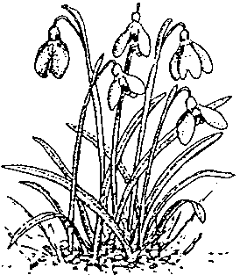
Twelfth meeting of the Plants Committee
Leiden (The Netherlands), 13-17 May 2002
Training initiatives
Standard slide package: progress report
1. This document has been prepared by the Scientific Authority for plants of the United Kingdom.

Background
2. To date, over 600 copies of ‘CITES and Plants: a User’s Guide’, by Marianne Syrylak Sandison, Margarita Clemente, Jan de Koning and Maurizio Sajeva, have been distributed by the CITES Secretariat and the United Kingdom Scientific Authority.
3. This pack has proved to be a very useful training tool for a wide range of CITES stakeholders.

Update
4. This initial pack is now in the process of being updated. Amendments after CoP11 have been made and the new updated pack will be made available from April 2002 in the form of a PowerPoint presentation that can be downloaded from the Internet. Additional amendments will be made after CoP12 in November 2002.
5. As reported at the last Plants Committee meeting there are three new titles in preparation:
a) The CITES and Orchids pack is being developed in collaboration with Kadoorie Botanical Gardens in Hong Kong, China.
b) The CITES and Succulents pack is being developed in collaboration with Maurizio Sajeva from Palermo Botanical Gardens in Sicily.
c) The Training exercises pack will be developed by the Royal Botanic Gardens Kew. This pack is due for publication in 2003.

Request for help
6. The United Kingdom Scientific Authority would like to ask for co-operation from all Parties with the development and production of the slide packs and would welcome and information/images/ideas that could be used in the future packs.

