PC12 Doc. 20.1
CONVENTION ON INTERNATIONAL TRADE IN ENDANGERED SPECIES
OF WILD FAUNA AND FLORA
____________
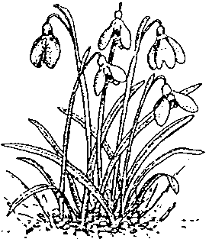
Twelfth meeting of the Plants Committee
Leiden (The Netherlands), 13-17 May 2002
Issues resulting from PC11, not included elsewhere in the Agenda
Review on the genus Taxus
1. This document has been prepared by the United States of America.
Background
2. The Scientific Authority of the United States of America submitted documents PC10 Doc. 13.3 and PC11 Doc. 22 on Taxus at the 10th and 11th meetings of the Plants Committee (PC10 and PC11), respectively. At PC11, it was decided that China, France, India, and the United States of America should collaborate on a review of the trade in yew and produce a document to address recommendations 20 and 21 contained in document PC11 Doc. 22, which are:
20. The Plants Committee should examine the trade in all species of Taxus, to determine if additional species should be included in Appendix II.2(a), or whether effective control of trade in Taxus wallichiana would be improved through the listing of additional species in Appendix II under the provisions of Article II.2(b) due to similarity of appearance.
21. The Plants Committee should examine whether traded commodities derived from Taxus species are readily recognizable, and whether they should be subject to CITES control, including through annotation of listings.
3. The Scientific Authority of the United States of America has not completed consultations with the other countries, but will report on any further progress at the 12th meeting of the Plants Committee. However, we have this information to provide at this time:
a) Initial consultation has occurred between the U.S. Scientific Authority and the Management Authority of China. The Management Authority of China has notified the U.S. Scientific Authority that the Government of the People's Republic of China would support listing additional species of Taxus in Appendix II of CITES, and would consider co-sponsoring a proposal for such a listing for the 12th meeting of the Conference of the Parties (CoP12).
b) The U.S. Scientific Authority is still consulting internally with other U.S. Federal and State agencies responsible for the management and harvest of Taxus, but has included this taxon in its public and inter-agency consultation process for potential listing actions to be considered for CoP12. This process was actually begun prior to PC11, with a public notice published on 12 June 2001, which specifically requested additional information on certain Taxus species.
c) There is little doubt that additional species of Taxus are being impacted by trade, but the primary commodity in trade from all of these species is the chemical derivative, not unprocessed plant parts. Plant parts present unique problems of identification in a genus beset by taxonomic uncertainty. However, these difficulties are compounded by the failure of the current listing of Taxus wallichiana, and the potential failure of additional listings, to capture and control the majority of specimens actually traded. Therefore, the United States of America recommends that the Plants Committee focus on recommendation 21 above (from document PC11 Doc. 22) to determine whether any listing of additional Taxus species would be effective.

