PC12 Doc. 11.2.1
CONVENTION ON INTERNATIONAL TRADE IN ENDANGERED SPECIES
OF WILD FAUNA AND FLORA
____________
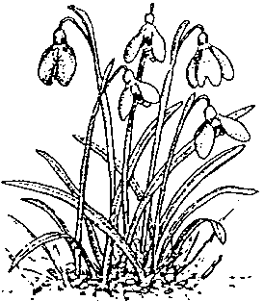
Twelfth meeting of the Plants Committee
Leiden (The Netherlands), 13-17 May 2002
Significant trade in plants
Implementation of Resolution Conf. 8.9 (Rev.) (cf. Decision 11.117)
Trade in plants from Madagascar
1. The objective of this project is to review the trade in plant species from Madagascar included Appendix II, concentrating on Orchids and Succulents. The project will assist the Malagasy Management and Scientific Authorities by providing recommendations on the sustainable trade in wild-collected plants and on the commercial propagation of species of horticultural interest or those used for their derivatives.
2. The trade review work is being carried out by the Royal Botanic Gardens, Kew, UK (RBG Kew) and the CITES Management and Scientific Authority of Madagascar.
3. The trade data available in the CITES database (held by UNEP-WCMC) has been reviewed and transferred to a database, created and maintained by RBG Kew. Further information on taxonomy, distribution, conservation and ease of cultivation status, has been gathered from literature and two mini workshops held at RBG Kew. This information has also been added to the database. On completion a copy of this database will be given to the CITES Authorities of Madagascar.
4. A review has also been undertaken of the availability of Malagasy orchids and succulents on the Internet. Websites have been analysed and information gathered on the source (wild or artificially propagated) and price of each taxa has been added to the database.
5. The extensive information from this trade review is presently in draft form. This data will be summarised and translated into French and given to the CITES partners in Madagascar. A project workshop consisting of national and international experts on the plants concerned, representatives of the Malagasy Authorities and institutions and the CITES Secretariat will be held in-country, subject to the agreement of the Malagasy partners. The workshop will consider all the information collected and make recommendations in order to facilitate sustainable trade in the species concerned.

