PC12 Doc. 8.1.2
CONVENTION ON INTERNATIONAL TRADE IN ENDANGERED SPECIES
OF WILD FAUNA AND FLORA
____________
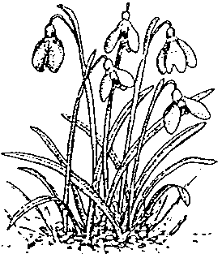
Twelfth meeting of the Plants Committee
Leiden (The Netherlands), 13-17 May 2002
Follow-up of CoP11 Decisions
Harpagophytum spp.
Imports of Harpagophytum in Germany
1. This document has been prepared by the Scientific Authority of Germany.

Introduction
2. CoP11 decided to review the trade in Harpagophytum species and directed two decisions to the Parties (Dec. 11.63) and to the Plants Committee (Decision 11.111), respectively (see box 1).
3. Germany is a major importing country of Harpagophytum crude drugs, but has no trade monitoring system in place for these species. Therefore, no official trade data are available.
4. To implement Decision 11.63, an interview survey among German importers was carried out. Berit Hachfeld was commissioned in January 2002 to carry out this trade review. Seventeen German importers were interviewed and asked to report on their imports for the years 1999, 2000 and 2001. The data were refined during a symposium on Devil’s Claw held in Windhoek 26-28 Feb 2002.

Results
5. Eigth to ten German companies are covering the German Harpagophytum imports. Only two companies reported exports from both Namibia and South Africa. All other traders presently import from Namibia only.
6. Fig. 1 shows the imports as stated by German importers from the last three years. Trade is predominantly reported as being direct from Namibia to Germany. Imports from South Africa are few. It must be kept in mind that the South African imports may partly be re-exported material from Namibia or Botswana.

Conclusion
7. The existing trade information leaves many questions unanswered. More transparency of the trade, its routes and volumes would be desirable for a resource management which aims at long-term sustainable utilization.
8. Germany has, however, no intention to put forward an amendment proposal for Harpagophytum species for CoP12.
Box 1: CoP 11 decisions regarding the biological and trade status of Harpgophytum spp. (Devil’s Claw)
Decision 11.63
Directed to the Parties
In the light of increasing international trade in the roots of Harpagophytum spp. (devil's claw), the range and importing States should submit to the Secretariat all available information concerning the trade, management and biological status of Harpagophytum species and regulatory measures applying to them.

Decision 11.111
Directed to the Plants Committee
The Plants Committee shall:
a) review information submitted to the Secretariat in accordance with Decision 11.63;
b) summarize the biological and trade status of Harpagophytum species subject to international trade; and
c) prepare a report on the biological and trade status of Harpagophytum species, at least six months before the 12th meeting of the Conference of the Parties, for consideration at that meeting.

