PC12 Doc. 3.2
CONVENTION ON INTERNATIONAL TRADE IN ENDANGERED SPECIES
OF WILD FAUNA AND FLORA
____________
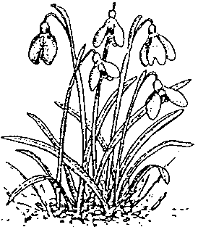
Twelfth meeting of the Plants Committee
Leiden (The Netherlands), 13-17 May 2002
Adoption of the agenda and the Working programme
Working programme

Sunday 12 May
18h00 Welcome reception
Café ‘t Keizertje in the Kaiserstraat, Leiden

Monday 13 May
09h00 – 10h00 Closed session (Committee members and Parties only)
11h00 – 12h00 Official opening of the meeting
Academy building, Rapenburg 73, Leiden
12h00 – 14h00 Lunch at the Leiden Botanic Garden
14h00 – 15h30 Working session
15h30 – 16h00 Tea break
16h00 – 17h30 Working session

Tuesday 14 May
09h00 – 10h30 Working session
10h30 – 11h00 Coffee break
11h00 – 12h30 Working session
12h30 – 14h00 Lunch
14h00 – 15h30 Working session
15h30 – 16h00 Tea break
16h00 – 17h30 Working session
18h00 Reception hosted by the Ministry of Agriculture,
Nature Management and Fisheries

Wednesday 15 May
Excursion: Departure at 06h45 return at 16h00 approx.

Thursday 16 May
09h00 – 10h30 Working session
10h30 – 11h00 Coffee break
11h00 – 12h30 Working session
12h30 – 14h00 Lunch
14h00 – 15h30 Working session
15h30 – 16h00 Tea break
16h00 – 17h30 Working session

Friday 17 May
09h00 – 10h30 Working session
10h30 – 11h00 Coffee break
11h00 – 12h30 Working session
12h30 – 14h00 Lunch
14h00 – 15h30 Working session
15h30 – 16h00 Tea break
16h00- Closing ceremony

