PC11 Inf. 18
(English only/Solamente en inglés/Seulement en anglais)
CONVENTION ON INTERNATIONAL TRADE IN ENDANGERED SPECIES
OF WILD FAUNA AND FLORA
____________
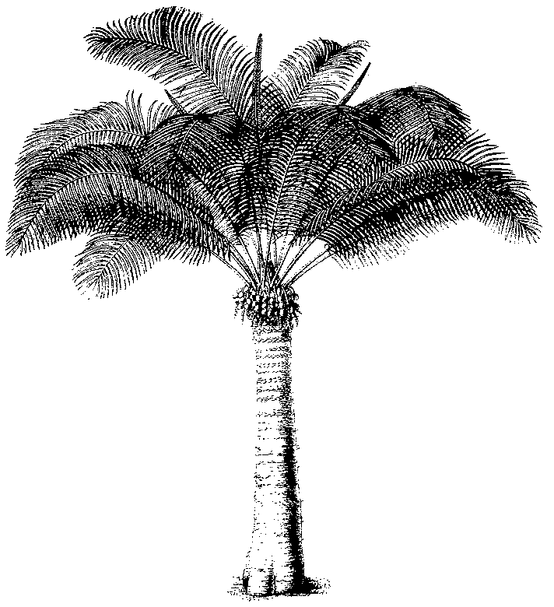
Eleventh meeting of the Plants Committee
Langkawi (Malaysia), 3-7 September 2001
The application of CITES to flora
A preliminary REVIEW OF THE APPLICATION OF THE CONvENTION TO FUNGI
1. This document has been prepared by the Vice-Chairman of the Nomenclature Committee.
2. At its 10th meeting, the Plants Committee briefly discussed the application of the convention to fungi and whether at the time of its negotiation and agreement the term flora was taken to include fungi. The Chairman of the Plants Committee requested that the Vice-Chairman review the situation and report back to PC11.
3. The split between Fungi and Plantae was first suggested in 1909 or earlier, however the move to consensus was much later. The change in consensus viewpoint occurred somewhere between 1961 and 1971. The fungal reference work, Ainsworth & Bisby's Dictionary of the Fungi, now in its 8th edition, is the nearest we have to a standard reference used throughout mycology. Therefore it is the best reference to use as a baseline for our research.
4. The Dictionary of the Fungi, the standard reference, changed from Plantae in the 5th edition (1961) to Fungi in the 6th edition (1971). The change appears to have been based on the five kingdom system proposed by Whittaker (in: New concepts of kingdoms of organisms. Science (New York) 163: 150 - 160 (1969)). This proposal was then rapidly adopted (according to Hawksworth, 1991).
5. It therefore appears that at the time of negotiation and agreement of the Convention the consensus the scientific opinion was that Fungi were separate from Plantae.
6. A selection of scientific definitions is provided on the reverse.
7. It would therefore seem appropriate to request the Conference of the Parties to decide on whether in its opinion, the word ‘flora’ in title of the Convention covers both Fungi and Plantae.
8. The Secretariat and the Nomenclature Committee will prepare a document on the subject for consideration at the next meeting of the Plants Committee.

