PC11 Inf. 13
(English only/Solamente en inglés/Seulement en anglais)
CONVENTION ON INTERNATIONAL TRADE IN ENDANGERED SPECIES
OF WILD FAUNA AND FLORA
____________
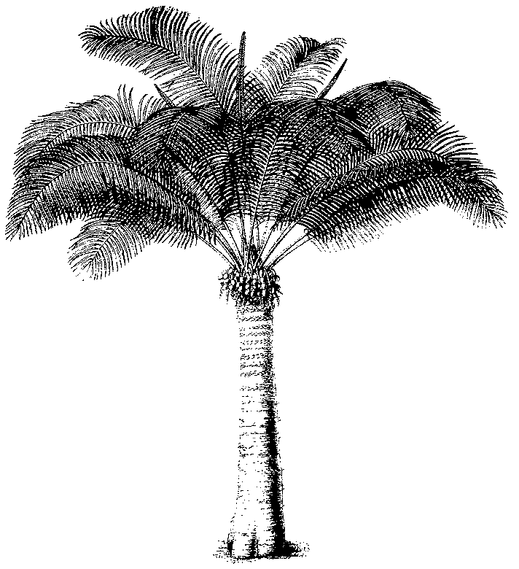
Eleventh meeting of the Plants Committee
Langkawi (Malaysia), 3-7 September 2001
Report of the Animals Committee working group on
Resolution Conf. 8.9 (Rev.), (Agenda item 11.1)

Working Group – Revision of Resolution Conf. 8.9 (Rev.) and Decisions 11.106 – 11.108
Chair: Marco Polo Micheletti, Vice-Chair of Animals Committee and Representative of South and Central America and the Caribbean.
Participants: Regional Representative of Africa (Mike Griffin), Regional Representative of North America, Secretariat, China, Spain, United States of America, Creative Conservation Solutions, IUCN-The World Conservation Union, International Wildlife Coalition, IWMC, Species Survival Network, Traffic Network.
Approach:
- The Working Group agreed on the need to simplify and clarify Resolution Conf. 8.9 (Rev.) and agreed to integrate Dec. 11.106 with the operative part of the resolution eliminating inconsistencies between the two procedures.
- The Working Group reviewed the suggested changes made by the consultant, point by point. A determination was made whether or not there was concensus agreement with the changes. If there was not concensus agreement, then the reasons for each differing point of view is summarized.
- The Working Group summary should be provided to the Plants Committee through the Secretariat, so that it may be used in their review of the same consultant document at the next Plants Committee meeting in Malaysia.
- It is suggested that an Animals Committee/Plants Committee Working Group be established to review the amendment drafted by the Secretariat on the basis of the following comments.
Point-by-point Result of WG Review:

Paragraph 14 - Provisionally agreed with the suggestion.

Secretariat indicated that it may be possible to keep the version of the WCMC list available on the CITES website constantly updated. Therefore, the production of a list after each COP as suggested might not be necessary. WCMC was unable to confirm whether this is the case without consultation with their home office.

Paragraph 15 – Agreed with the suggestion
Paragraph 16 – Deleted the 1st sentence of the suggestion because this is already required under the 2nd Directs in the Resolution. Agreed with the suggestion regarding the database.
Paragraph 17 – Agreed with the suggestion.
Paragraph 18 – The three categories should be described with the same terminology following the model of the earlier definitions and including reference to no-detriment findings and whether its being made appropriately by referencing global populations.
Paragraph 19 – Generally agree with the suggestion. The cautious interim quotas are establsished by the Animals Committee.
It was suggested that there would be value, as a separate exercise, to consider development of standards by which quotas should be set to assist Secretariat, Parties and AC.
Paragraph 20 – Generally agree with the suggestion. But believe that Category II recommednations should include some requirement for Parties to have the ability to monitor the effects of the quotas on the wild populations and have a mechanism available to amend the quotas if need be. As required by the Resolution, cautious interim quotas should be made by Parties in consultation with the Secretaraiat.
Paragraph 21 – Agree with the suggestion.
Paragraph 22 – Agree with the suggestion if something to the effect of “for the Secretariat to make decisions, they may want to consult with a consultant to verify information received”.
Paragraph 23 – Agree with the suggestion.
It was suggested that the AC should have a role in determining whether Parties have satisfied the recommendations.
Paragraph 24 – Agree with the suggestion.
Paragraph 25 – Delete this suggestion – already covered in the Resolution.
Paragraph 26 – Delete Decision 11.109. The significant trade process incorporates species subject to trade in traditional medicines, as well as other uses.
Paragraph 27 – Plant Committee decision, no opinion.

