PC11 Inf. 8
(English only/Solamente en inglés/Seulement en anglais)
CONVENTION ON INTERNATIONAL TRADE IN ENDANGERED SPECIES
OF WILD FAUNA AND FLORA
____________
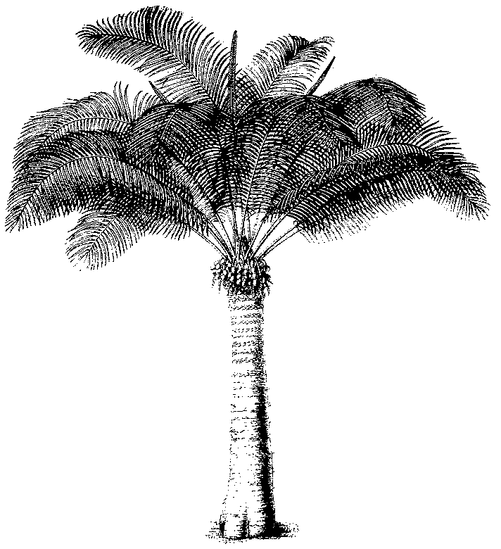
Eleventh meeting of the Plants Committee
Langkawi (Malaysia), 3-7 September 2001
Illegal trade in Paphiopedilum spp. (Agenda item 24.4)
Some Recently described taxa in the genus Paphiopedilum
1. This document has been prepared by the Management Authority of Switzerland.
name | synonyms, comparison | taxonomical history | origin
P. angustatum Z. J. Liu & S. C. Chen | cf. P. malipoense var. hiepii | First description 2000 | China, SE Yunnan
P. anitum Golamco | =P. adductum ssp. anitum, P. x mindanaense | First description 1998 | Philippines: Mindanao, S of Surigao
P. bougainvilleanum var. saskianum Gruss & Roeth | cf. P. bougainvilleanum | Displayed in an Orchid Congress held in Germany 1999, first description 1999 | Solomon Islands
P. cerveranum Braem | cf. P. robinsonii | Type collection 1996, first description 1999 | Vietnam-Cambodia border and central Vietnam
P. caobangense Tich | cf. P. helenae | First description 1999 | Vietnam
P. chaoi Hua | cf. P. henryanum and  P. herrmannii | First description 1999, based on a single specimen | China
P. coccineum Perner & Herrmann | cf. P. helenae and  P. barbigerum | First description 2000 | N Vietnam: Prov. Cao Bang
P. emersonii var. huonglanae Tich | = P. hangianum, cf.  P. emersonii | invalidly published 1998 | Vietnam
P. gigantifolium Braem, Baker & Baker | = P. ayubii (nom. nud.),  P. parnatanum (nom. nud.; non P. parnatanum Cavestro) | Discovery and informal publication 1997 by Parnata as P. ayubii, First description 1999 | Indonesia: Sulawesi, NE Donggala
P. hangianum Perner & Gruss | = P. emersonii var. hangianum, cf.  P. emersonii var. huonglanae | First description 1999 | N Vietnam: Border to China (Prov. Yunnan)
P. helenae Averyanov | incl. P. helenae f. aureum Gruss & Roeth =  P. helenae var. sanderae nom. nud.; cf.  P. barbigerum | Type collection 1995, first description 1996 | N Vietnam: Prov. Cao Bang
P. henryanum Braem | cf. P. chaoi and  P. hermannii | Type collection and first description 1987 | N Vietnam and China
P. herrmannii Fuchs & Reisinger | cf. P. hirsutissimum x barbigerum | First description 1995 | N Vietnam
P. hiepii Averyanov | =P. malipoense var. hiepii | Type collection 1995, first description 1998 | N Vietnam: Prov. Tuyen Quang
P. hilmarii Senghas & Schettle | =P. vietnamense,  P. mirabile | First description 1999 | N. Vietnam: Provinz Kao Bang
P. huonglanae Tich | =P. hangianum, cf.  P. emersonii | invalidly published 1998 | Vietnam
P. intaniae Cavestro | cf. P. randsii and P. stonei | First description 2000 | Indonesia: Sulawesi
P. jackii Hua | =P. malipoense var. jackii | First description 1996 | China: Yunnan
P. lowii var. latifolium nom. nud. | cf. P. lowii | To be published, announced in web | Probably Borneo
P. lynniae A. Garay | =P. lowii var. lynniae | 1993 in Germany, first description 1996 | Borneo
P. malipoense fa. tonnianum Roeth | cf. P. malipoense | First description 2000 | Probably S China / N Vietnam (ex cult. hort. Tonn)
P. mirabile Cavestro & Chiron | =P. vietnamense,  P. hilmari | First description 1999 | N. Vietnam: Provinz Kao Bang
P. ooi Koopowitz | cf. P. glanduliferum and  P. supardii | First flowers in cultivation and first description 1999 | Malaysia
P. parnatanum Cavestro | cf. P. sukhakulii and  P. wardii | First collection and first flowers in cultivation 1998, first description 1999 | S Philippines: District of Tarlac
P. saccopetalum nom. nud. | cf. P. esquirolei | To be published, announced in web | S China
P. singchii Z. J. Liu & J. Y. Zhang | cf. P. emersonii | First description 2000 | China: S Yunnan, border to Vietnam?
P. striatum Clem. & Jones | cf. P. wilhelminae | Type collection 1978, first description 1996 | Papua New Guinea: Southern Highlands
P. sugiyamanum Cavestro | cf.: P. dayanum,  P. javanicum var. virens,  P. hennisianum and  P. lawrenceanum | Discovered 2000, first description 2001 | Malaysia: NE Borneo, Sabah
P. tigrinum Koopowitz & Hasegawa | =P. markianum | First description 1990 | China: W Yunnan
P. tranlienianum Gruss & Perner | cf.: P. hermannii,  P. henryanum and  P. helenae | First description 1998 | N Vietnam: Prov. Bâc Thai
P. usitanum Gruss & Roeth | cf. P. argus | Type collection 1998, first description 1999 | Philippines: Luzon, Prov. Tarlac
P. vietnamense Perner & Gruss | =P. hilmarii, P. mirabile | First description 1999 | N. Vietnam: Provinz Kao Bang
P. viniferum Koopowitz & Hasegawa | cf. P. callosum | First description 2000 | Horticulture

