PC11 Inf. 5
(English only/Solamente en inglés/Seulement en anglais)
CONVENTION ON INTERNATIONAL TRADE IN ENDANGERED SPECIES
OF WILD FAUNA AND FLORA
____________
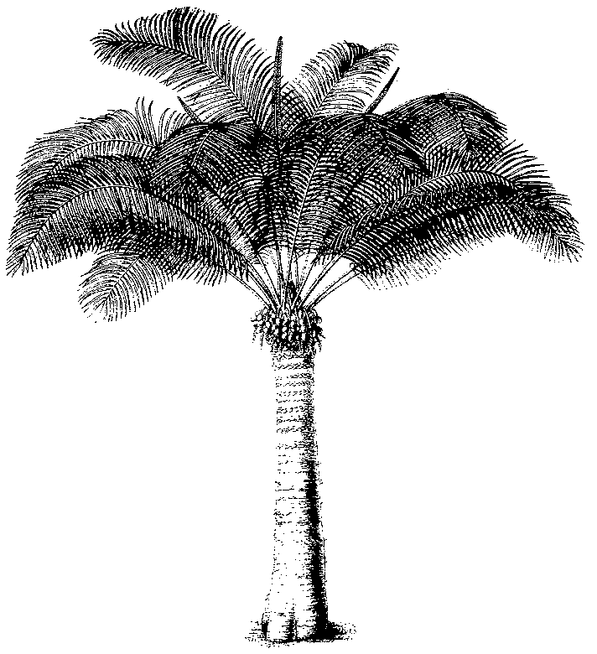
Eleventh meeting of the Plants Committee
Langkawi (Malaysia), 3-7 September 2001
extract federal register (unites states of america)
1. This document has been submitted by the United States of America as an information document.
2. The Annex contains a summary of the plant-related sections of a recent notice in the USA Federal Register requesting input from the public on species the country could consider proposing for amendment at CoP12.

PC11 Inf. 5
Annex
US Federal Register Notice Requesting Information and Recommendations
on Species to Consider for Changes to the CITES Appendices
This document has been prepared by the United States.
Background
On June 12, 2001, the U.S. Fish & Wildlife Service formally requested information and recommendations from the public on species the United States should consider for changes to the CITES Appendices by publishing a notice in our Federal Register (v.66, n.113, pp.31686-31690). The entire notice can be viewed online at http://international.fws.gov/fedregister/fedreg.html. The relevant text regarding the plant and fungus species concerned is reproduced here.
SUMMARY: We have been informed that the twelfth meeting of the Conference of the Parties to CITES (COP12) will be held in November 2002, in Santiago, Chile. We are, therefore, soliciting recommendations for amending Appendices I and II of CITES at COP12. We invite information and comment from the public on animal and plant species that should be considered as candidates for U.S. proposals to amend CITES Appendix I or II. Such amendments may concern the addition of species to Appendix I or II, the transfer of species from one Appendix to another, or the removal of species from Appendix II. We are also seeking information and comment from the public on the biological and trade status of selected species identified at the end of this notice.
DATES: We will consider all information and comments received by August 13, 2001.
ADDRESSES: Send correspondence concerning this request pertaining to species amendments to: Chief, Division of Scientific Authority; U.S. Fish and Wildlife Service; 4401 North Fairfax Drive, Room 750; Arlington, Virginia 22203-1610, or via E-mail to:
FOR FURTHER INFORMATION CONTACT: Dr. Susan Lieberman, Chief, Division of Scientific Authority, phone 703-358-1708, fax 703-358-2276, E-mail:
SUPPLEMENTARY INFORMATION:
Request for Information and Comments
One of the purposes of this first notice is to solicit information that will help us identify species that the United States should propose as candidates for addition, removal, or reclassification in the CITES Appendices, or to identify issues warranting attention by the CITES Nomenclature Committee. This request is not limited to species occurring in the United States. Any Party may submit proposals concerning animal or plant species occurring in the wild anywhere in the world. We encourage the submission of information on species for possible inclusion in the Appendices if these species are subject to international trade that may be detrimentally impacting the status of the species. Complete proposals are not being requested at this time, but are always welcome. Rather, we are asking interested persons to submit convincing information describing: (1) the status of the species, especially trend information; (2) conservation and management programs for the species, including the effectiveness of enforcement efforts; and (3) the level of domestic as well as international trade in the species, especially trend information. Any other relevant information can also be provided. References are appreciated.
What will we do with the information we receive?
There may be species that qualify for CITES listing for which we decide not to submit a proposal to COP12. Our decision will be based on a number of factors, including scientific and trade information, whether or not the species is native to the United States and, for foreign species, whether or not a proposal is supported or co-sponsored by at least one range country for the species. We will consult range countries for foreign species, and for species we share with other countries, subsequent to receiving and analyzing the information provided by the public. The lists that follow includes species that we are considering based on our monitoring efforts since COP11. Including a species here does not mean that we will necessarily submit a proposal for it.
There may be species which meet the criteria for CITES Appendix I or II but do not appear in the lists below because of inadequate or anecdotal information in our records. We will continue to consult with other Federal and State agencies, academia, the public, and other countries to obtain information on additional species that may qualify for CITES listing and will report our findings in subsequent Federal Register notices prior to COP12.
What species are we considering for proposals, and for which species are we requesting additional information?
Plants
We are seeking additional information on the biological and trade status of the following North American cacti, and whether they qualify for transfer to Appendix I due to possible unsustainable trade in individual species or seeds collected from the wild:
SPECIES | GEOGRAPHIC SCOPE | Current Status
Sclerocactus nyensis | U.S.A.  (Nevada) | Appendix II
Sclerocactus parviflorus | U.S.A.  (Arizona, Colorado, New Mexico, Utah) | Appendix II
Sclerocactus sileri | U.S.A.  (Arizona, Nevada) | Appendix II
Sclerocactus spinosior ssp. blainei | U.S.A.  (Nevada, Utah) | Appendix II

At COP11 the following plant species were proposed by Switzerland on behalf of the Plants Committee for transfer from Appendix I to II or for removal from Appendix II. However, these proposals were not adopted due to lack of consensus regarding the proposed actions. We are seeking additional information on the biological and trade status of the following taxa, and whether they qualify for transfer to Appendix II or for removal from Appendix II.
SPECIES | GEOGRAPHIC SCOPE¹ | Current Status
Dudleya traskiae  (Santa Barbara Dudleya) | U.S.A.  (California) | Appendix I
Lewisia maguirei  (Maguire’s bitter-root) | U.S.A.  (Nevada) | Appendix II
Lewisia serrata  (saw-toothed Lewisia) | U.S.A.  (California) | Appendix II
Sclerocactus mariposensis | U.S.A. (Texas), Mexico | Appendix I
Shortia galacifolia  (O’conee-Bells) | U.S.A.  (Appalachian Mountains) | Appendix II

We are seeking additional biological and trade information on the following taxa native to the United States, and whether or not they meet the CITES criteria for listing in Appendix II:
SPECIES or TAXON | GEOGRAPHIC SCOPE¹ | RATIONALE
Cimicifuga (=Actaea) racemosa, C. americana  (black cohosh) | U.S.A. (eastern states), Canada | Suspected over-harvest for export
Echinacea spp.  (coneflower) | U.S.A. (eastern and midwestern states), Canada | Suspected over-harvest for export
Olneya tesota  (ironwood) | U.S.A (Arizona and California), Mexico | Suspected unsustainable harvest in Mexico for import to the United States
Sanguinaria canadensis  (bloodroot) | U.S.A.(eastern states), Canada | Suspected over-harvest for export

We are soliciting additional information on the following species native to the United States and Canada that are used in the floral and horticulture markets. In particular, we solicit information on the biological and trade status of these taxa, and whether or not they meet the CITES criteria for listing in Appendix II:
SPECIES | GEOGRAPHIC SCOPE¹
Antitrichia curtipendula (hanging moss) | U.S.A., Canada, Europe, possibly elsewhere
Eurhynchium oreganum (=Kindbergia oregana) (Oregon beaked moss) | U.S.A., Canada
Hypnum curvifolium, H. imponens  (log moss) | North America, Europe, Africa, Asia
Isothecium myosuroides (cat-tail moss) | U.S.A., Canada, Europe, possibly elsewhere
Metaneckera menziesii (Menzies’ neckera) | U.S.A., Canada, Europe, possibly elsewhere
Neckera douglasii (Douglas’ neckera) | U.S.A., Canada
Rhytidiadelphus loreus (lanky moss), R. triquetrus (cat’s tail moss) | U.S.A., Canada, Europe, possibly elsewhere
Thuidium delicatulum (log moss) | U.S.A., Canada, Europe, Asia, possibly elsewhere

We are soliciting additional information on the following species native to the United States and Canada that are used in the herbal medicinal market. In particular, we solicit information on the biological and trade status of these taxa, and whether or not they meet the CITES criteria for listing in Appendix II.
SPECIES | GEOGRAPHIC SCOPE¹
Caulophyllum thalictroides (blue cohosh) | U.S.A., Canada
Dioscorea villosa (wild yam) | North and Central America
Drosera spp. (sundews) | U.S.A., Canada
Ligusticum porteri (osha) | U.S.A. (western states), Mexico
Rhamnus (=Frangula) purshiana  (cascara sagrada) | U.S.A. (western states), Canada
Tricholoma magnivelare  (American matsutake mushroom) | U.S.A. (California, Oregon, and Washington), Canada
Trillium erectum (beth root) | U.S.A. (eastern states), Canada
Usnea sp. (tree lichen) | cosmopolitan

We are seeking additional information on the following species not native to the United States. In particular, we solicit information on the biological and trade status of these taxa, and whether or not they meet the CITES criteria for listing in Appendix II.
SPECIES | GEOGRAPHIC SCOPE¹
Guaiacum coulteri  (guayacan, used for timber) | Mexico, Central America, Caribbean
Taxus chinensis, Taxus celebica, Taxus cuspidata, Taxus fuana, Taxus yunnanensis  (a tree, used medicinally) | Eurasia
Uncaria guianensis and Uncaria tomentosa (cat’s claw, a medicinal plant) | South America

We also welcome information and comment from the public on tree species. Many trees are traded in large volumes and have high value and may, therefore, be of conservation concern.

Future Actions
After review of any information received, we will make some preliminary decisions and will seek assistance in developing more complete proposals during the summer and fall of 2001.
We plan to publish a Federal Register notice in December 2001 to announce tentative species proposals to be submitted by the United States and to solicit further information and comments on them, as well as to provide summary comments on information provided in response to this notice. In January 2002, we plan to hold a public meeting to allow for additional input. We will consult all CITES Parties within the geographic range of species we are considering proposing for amendments to the Appendices by March 2002, so that final proposals will have the benefit of their consideration and comments. This is consistent with CITES Resolution Conf. 8.21. Another Federal Register notice in July 2002 will announce our final decisions and those species proposals submitted by the United States to the CITES Secretariat.

Some Geographic Scope information published in the Federal Register was incorrect and has been corrected here.
Some species names published in the Federal Register were incorrect and have been corrected here.

