PC11 Inf. 4
(English only/Solamente en inglés/Seulement en anglais)
CONVENTION ON INTERNATIONAL TRADE IN ENDANGERED SPECIES
OF WILD FAUNA AND FLORA
____________
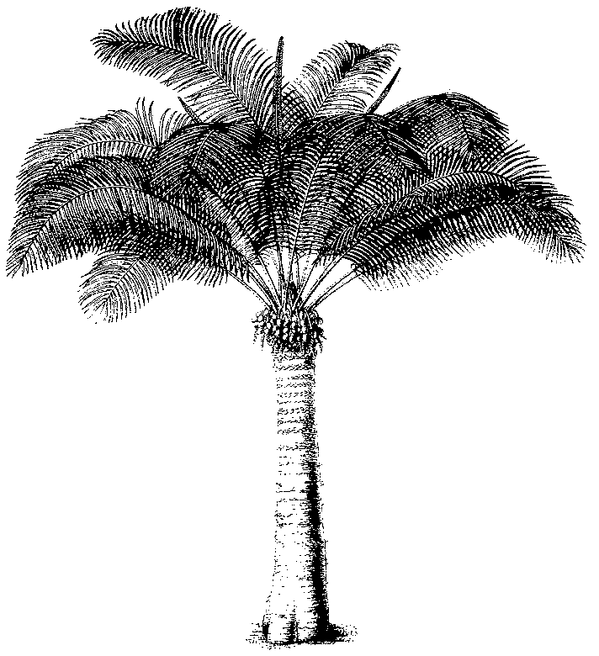
Eleventh meeting of the Plants Committee
Langkawi (Malaysia), 3-7 September 2001
information on plant species for which amendment proposals
were rejected or withdrawn
1. This document has been submitted by the United States of America as an information document.
2. The Annex contains the list of all species for which proposal for inclusion of transfer were rejected or withdrawn.

PC11 Inf. 4
Annex

