PC11 Doc. 5.6
(English only/Solamente en inglés/Seulement en anglais)
CONVENTION ON INTERNATIONAL TRADE IN ENDANGERED SPECIES
OF WILD FAUNA AND FLORA
____________
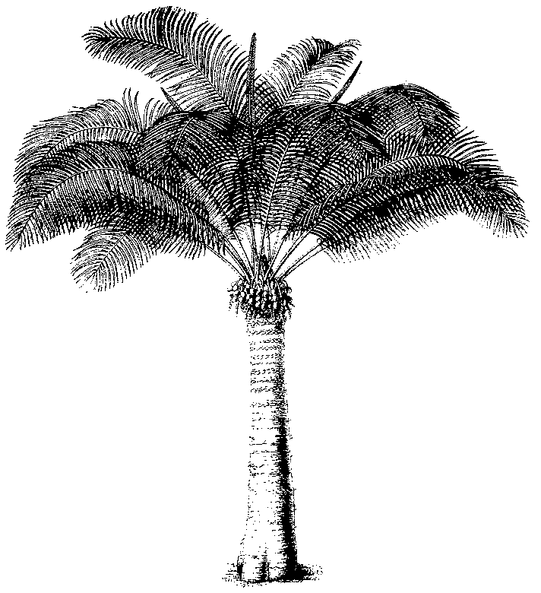
Eleventh meeting of the Plants Committee
Langkawi (Malaysia), 3-7 September 2001
Regional reports and reports on regional meetings
Oceania
A) General Information
• Name of Member (author of report): Greg Leach
• Name of Alternate Member: O. Gideon
• Number of Parties in the Region: 5
• Number of Parties responding to communications: 3
• Names of other institutions or NGO’s contacted for CITES work during the period:
TRAFFIC (Oceania), Council of Heads of Australian Botanic Gardens, Center for Plant Biodiversity, Flora Malesiana Symposium organisers.
B) List of Items

Regional Directory
The Regional Directory has been maintained and a recent circular sent out to update entries since the 10th Plants Committee meeting.

CRITERION WORKING GROUP
The Oceania representatives for Animals (Rod Hay) and Plants committees participated in the continuing work of the Criteria Working Group.

COMMUNICATION WITH PARTIES IN REGION
There have been difficulties in communications with Fiji, Papua New Guinea and Vanuatu. Some of the material presented in the report has been extracted from the Oceania report to Standing committee, particularly where it relates to plants issues.

CAPACITY BUILDING ACTIVITIES
There has been no regional meeting since PC10.
The Oceania representative has accepted an offer to participate in a workshop at the forthcoming Flora Malesiana Symposium. The workshop is on stakeholder needs for taxonomic information and the presentation will identify CITES as a regional stakeholder and provide examples of the need for taxonomic information for implementation of the convention.

Australia

Wildlife law enforcement workshop in Australia
In November 2000 Australia hosted a conference for the purpose of promoting inter-agency cooperation and issues of mutual interest and concern in the area of wildlife enforcement. Wildlife enforcement officers and others from government and non-government organisations from throughout the Australasian region shared information and views on ways to achieve better wildlife protection outcomes. Over 30 government and international agencies were represented, including personnel from New Zealand, Papua New Guinea, Czechoslovakia, Italy and the CITES Secretariat.
The conference:
• provided a forum for discussion of the enforcement of Australasian wildlife legislation;
• enabled discussion on current methods of gathering, analysing and disseminating information on breaches of wildlife legislation;
• enabled discussion on current procedures for investigating and prosecuting breaches of wildlife legislation; and
• formulated, for consideration by participating agencies, proposals to improve enforcement of wildlife legislation, including the further development of inter-agency cooperation and support.
Conference sessions provided information to wildlife officers regarding:
• current trends in wildlife trade;
• evidence handling procedures;
• traditional medicines;
• computer and Internet crime; and
• national investigation strategy.
A sample copy is available at the meeting and those interested can obtain copies from the Australian Management authority.

Fiji
The Fiji CITES Management Authority, the Department of Environment, has been discussing CITES issues with senior officers in Customs and Quarantine since 1997 and has identified the need to further improve levels of awareness and understanding of issues within these agencies. The Department of Environment is endeavouring to secure funding for an awareness workshop for officers at all levels in agencies including Customs and Quarantine. Fiji would greatly appreciate assistance with this project from the CITES Secretariat or any other potential donors.
The Department of Environment plans to undertake a program of training the trainers, who will then train officials of relevant institutions such as Customs and Quarantine. They urgently need assistance with this. Funds are needed to cover the program, including production of relevant materials, venue, transport, accommodation, meals and hiring of trainers/consultants.
Papua New Guinea
Following restructuring of the Office of Environmental Protection in 1999, two new positions have been created within the new organisational structure to ensure that planned national programs and activities for both CITES Management and Scientific Authorities are implemented. Officers will be appointed by June/July of this year.
The CITES Management Authority Technical Officer will be responsible for coordinating CITES related programs and activities within the implementing agency, other government agencies and institutions.
The CITES Scientific Authority Scientific Officer will be responsible for coordinating CITES Scientific Authority related programs in Papua New Guinea.

New Zealand
The last twelve months saw the beginning of a vigorous public relations campaign designed to better inform the public on CITES and the aims of the Convention. The campaign has been based around Auckland International Airport, which deals with around 97% of New Zealand's CITES seizures, but will take on a more national focus over the next year. Public talks and a strong media focus have been adopted, along with additional training for border staff. Fact sheets have been produced to provide information on those CITES species that make up the majority of New Zealand's illegal imports and they are displayed at the Auckland Airport. Recent statistics show that 54% of these seizures were coral, a further 17% were of clams, mainly shells, with some meat also being confiscated. 20% of all seizures originated from Fiji, with a further 20% from Tonga, and 12% from the Cook Islands, the latter 2 being non-CITES countries. Information has been provided to TRAFFIC Oceania to assist in developing a South Pacific CITES Souvenir research project, which will assess the issues involved in this type of trade.
Discussions continue on the possibility of using other fora such as South Pacific Regional Environment Programme (SPREP) meetings to advance a number of CITES-related issues including supporting capacity building within the region (11 countries are currently not Party to CITES within the region). SPREP has recently secured funding to continue a bird conservation and invasive species initiative within the region, providing an enhanced opportunity for advancing CITES in Oceania.
NZ’s Management Authority has recently produced a new brochure to deal with the increase in illegally imported traditional medicines containing CITES listed ingredients. The brochure was written after consultation with the Chinese community and the Register of NZ Traditional Chinese Medicines Practitioners Inc, and was followed up with a series of meetings. A phone "hotline" has also been set up to provide additional information to members of the public on CITES and Traditional Chinese Medicines. Anyone interested in obtaining copies of the brochures can contact the NZ CITES Management Authority (cites@doc.govt.nz)"

Vanuatu
In 1998 Vanuatu produced a brochure and poster on CITES, which were distributed to relevant stakeholders such as Quarantine, airlines, Customs, hotels, restaurants and market vendors. In 1998 a two-day workshop was held with relevant government departments to introduce them to CITES requirements. Vanuatu has expressed a need for funding assistance to follow up these initiatives and generate more awareness of CITES in Vanuatu and in the region.

DIFFICULTIES OF IMPLEMENTATION ENCOUNTERED IN THE REGION

LEGISLATION

Australia
There has been a long-standing issue with Australian legislation, which provided a loophole allowing importers to bring in wild harvested Appendix 1 seed. This seed was then typically germinated and re-exported as artificially propagated. New wildlife legislation was recently enacted under the Environment Protection and Biodiversity Conservation Act 1999 (EPBC Act).
Under the new Act a CITES specimen is a specimen of a species listed in Appendix I, II or III of the Convention.
It is an offense to import or export a Cites specimen unless:
(a) the exporter or importer holds a permit; or
(b) an exemption applies.
Penalties are vastly increased for transgressions. For example importing CITES specimens without a permit is 10 years or 1000 penalty units or both (1 penalty unit is currently Aus$110).
There is also a restructuring of the possession offense so that the evidential burden is on the accused to prove that the specimen is a legal import or is the progeny of legally imported ancestors.

Fiji
The environment legislation which Fiji planned to have enacted by April 2001 and which could have included provisions relating to subsidiary legislation on CITES, has been deferred due to reasons beyond Fiji’s control. Fiji had however envisaged earlier in the year extracting provisions relating to CITES from an earlier Bill and enacting these separately. Enactment of CITES legislation by December 2001 had been included in the Fiji Department of Environment’s corporate plan for 2001, but at this stage the Department does not think that in the present situation anything can be produced by the end of this year. The Department will nevertheless continue with the process and would appreciate technical assistance with this.

Papua New Guinea
A legislative review of Papua New Guinea’s national legislation has been completed, with appropriate instruments submitted to legislators and it is anticipated that the national legislation will be ready to be enacted later this year.

Vanuatu
Although not a plants or legislation issue, the following is included as an example of financial difficulties that can prevent or hamper implementation. Vanuatu recently experienced financial difficulties, which prevented a successful prosecution for illegal importation of elephant tusks from Africa. The prosecution case had to be abandoned because Vanuatu was unable to meet the cost of testing required to prove that the tusks were sourced post-CITES.

OTHER TOPICS
Tree Ferns (New Zealand)
Recent inquires from Great Britain concerning tree fern exports, particularly from Oceania, has highlighted some area of confusion following the partial de-listing after COP 11.
New Zealand has reported difficulty with exports partly due to not knowing whether countries will now accept Dicksonia from NZ without some kind of document of origin. The major importers of Canada, UK, Japan and the Netherlands were asked to clarify their requirements. The Netherlands and UK have replied that no official documentation is required at all (no export permit and no certificate of origin). Canada have replied that the exporter must be able to show where the Dicksonia originated from, and have clear documentation (not necessarily CITES) that shows this.
New Zealand has explained the changes to their main clients, but most are refusing to accept that the government can no longer provide CITES export certificates for Dicksonia, and that they are no longer required. Most clients apparently have had bad experiences with customs officials and so simply want the same documentation as they have always had.
Invasives (New Zealand)
R Hay attended the IUCN SSC Invasive Species Specialist Group Conference on Eradication of Island Invasives and a meeting of the ISSG in Auckland in February 2001. He gained the agreement of ISSG in collaborating on a review of trade in CITES listed species which are actual and potential invasives.
Gaharu wood trade (Papua New Guinea)
Trade in Gaharu wood has emerged as a relatively recent problem in Papua New Guinea as reported previously in PC 11. PNG government authorities initially presumed the species being harvested for Gaharu to be Aquilaria filaria, and hence not covered under CITES. The current CITES listing only includes A. malaccensis. It is thought that the bulk of this trade is illegal movement out of PNG to Indonesia or Singapore. Particular enforcement difficulties are the lack of scientific information for identification purposes, a lack of human resources and a policy vacuum with Gaharu trade.
Visits by Gaharu wood traders from neighbouring Malaysia and Indonesia into Papua New Guinea are having an impact on the trade, creating concerns about the sustainability of this resource and profound socio-economic effects on the lives of some rural village communities.
The Papua New Guinea CITES Management Authority has raised concerns about the sustainability of this trade, and has had consultation with the PNG National Forest Authority, the Internal Revenue Commission and other government agencies to look at control measures for this trade, which included consideration of a temporary trade ban.
Liaison between the Oceania representative, TRAFFIC Oceania, CITES Secretariat and WWF has resulted in recent preliminary work which has aided substantially in clarifying the PNG situation. This work is the basis of the commendable report and recommendations tabled at this PC meeting by TRAFFIC Oceania.
Papua New Guinea is also seeking technical and financial support to be made available to TRAFFIC Oceania for further scientific work to be done on medicinal plant trade in the Oceania region.

