PC11 Doc. 5.4
(English only/Solamente en inglés/Seulement en anglais)
CONVENTION ON INTERNATIONAL TRADE IN ENDANGERED SPECIES
OF WILD FAUNA AND FLORA
____________
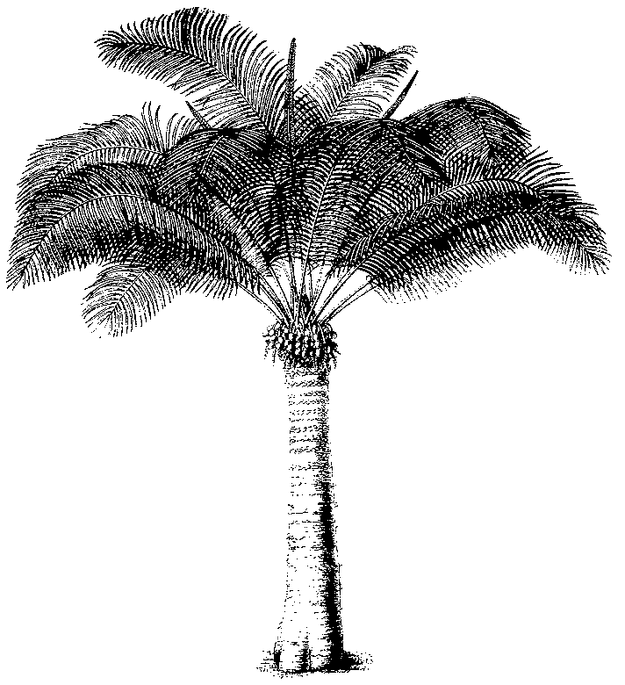
Eleventh meeting of the Plants Committee
Langkawi (Malaysia), 3-7 September 2001
Regional reports and reports on regional meetings
Europe
A) General Information
- Name of the Member (author of the Report): Margarita Clemente Muñoz
- Name of the Members: M. Clemente; J. De Koning
- Name of the Alternate Members: H. Werblan-Jakubiec, D. Supthut
- Number of Parties in the Region: 37 y 10 N. Parties
- Number of Parties responding to communications: 30
- Names of other institutions or NGO’s contacted for CITES work during the period.
- Institutions dealing with conservation and enforcement tasks, amongst which various IUCN/SSC groups, TRAFFIC, amateur societies, environmental police bodies, etc.
- List of the Items
⇒ Regional Directory
The Regional Directory has been continuously updated, and has been included in the WebPages of the University of Cordoba:
http://www.uco.es/organiza/servicios/jardin/ingles/address/marcdirec.htm
The European Representatives will send the information contained in the Directory to the Secretariat in order to be included on the Secretariat Web site
⇒ Regional meeting
Fourth European Regional CITES meeting of Management, Scientific and other authorities involved in CITES plants issues (Menemen, Izmir, Turkey, 24 – 27 April, 2001)
Participants:
European Representatives: M. Clemente, J. De Koning
Alternate Representatives: H. Werblan-Jakubiec, D. Supthut
44 Participants -SAs or MAs- from 14 countries (Austria, Czech Republic, Estonia, Germany, Ireland, Italy, Norway, Poland, Slovenia, Spain, Switzerland, The Netherlands, Turkey, United Kingdom); European Union-Commission; United States of America (invited as observer); CITES Secretariat.
Summary of recommendations from the regional meeting:
1. Regarding Co-operation between CITES Authorities in Europe: Directory
• that the CITES Authorities in the Region provide the European Representatives with any relevant information for the update of the Directory of Management and Scientific Authorities in the European Region;
• that the European Representatives send the information contained in the Directory to the Secretariat in order to be included on the Secretariat Web site.
2. Regarding standardisation of information
• that the European Commission make information available on prices of permits in the various Member States of the European Union and information regarding general stricter measures in the European Union to all non-European Union countries within the Region.
3. Regarding Registration of scientific institutions
• that Parties in the Region provide information and training to registered scientific institutions on how to use the labelling system.
4. Regarding information on confiscations
• at the next European Regional meeting one of the agenda items will be a discussion on confiscations in the various European countries through written presentations by each country.
5. Regarding Rescue centres for plants in Europe
• that national Management and/or Scientific Authorities in the Region prepare a written report on the rescue centres in their country to be presented at the next European Regional meeting. The report should include details on:
- The mechanisms for compensation of costs (material, space, maintenance of staff) for rescue centres.
- Ownership of the confiscated plants.
- Ownership of the artificially propagated offspring of confiscated material.
- Ownership of the right to commercialise confiscated plants and their artificially propagated offspring (e.g. by using them in exhibitions or selling the offspring).
- The regulations which allow the transfer of confiscated plants and/or their offspring to other rescue centres in other countries with better facilities for artificial propagation of the corresponding taxon.
- The solutions for CITES-CBD problems occurring for gardens keeping confiscated post-CBD plants (e.g. regarding property rights and benefit sharing).
6. Regarding Co-operation between Management Authorities and amateur societies
• that the CITES Authorities in the Region inform their amateur societies about CITES related provisions included in their national legislation and/or the EU CITES Regulation.
7. Regarding Training needs in the European region
• that Parties in the Region formulate proposals on capacity building to the Secretariat after needs assessments;
• that Parties in the Region are encouraged to seek funding to support these proposals.
8. Regarding Mechanisms for information exchange
• that the Management and Scientific Authorities in the European Region send the UK Scientific Authority information, articles and suggestions for the CITES News - Plants.
• that the Management and Scientific Authorities in the European Region send CITES Secretariat information, articles and suggestions for CITES World.
9. Regarding checklist of European orchids
• that the UK Scientific Authority and Irish Scientific Authority proceed with the proposal for the preparation of a European Orchid Checklist, to the European Commission and other appropriate institutions in order to obtain funding.
10. Regarding Training Program in CITES medicinal plants
• that all Parties in the Region continue to provide the DE Scientific Authority with information on, and samples of, parts and derivatives of CITES medicinal plants that have been detected in trade;
• that the Parties of the Region consider Notification to the Parties number 1999/26 on ‘Trade in plants for medicinal purposes’ and provide additions and corrections to the checklist to the Secretariat. An updated Notification that will then be transmitted by the CITES Secretariat to the Parties early next year.
11. Regarding Trade in CITES medicinal plants
• that Parties in the Region take note, whenever relevant to their country, the recommendations of the TRAFFIC report on the Conservation, Use and Trade in Europe’s Medicinal and Aromatic plants;
• that Parties to the best extent possible, provide a written report on trade in medicinal plants in their country at the next European Regional meeting.
12. Regarding the monitoring of Non CITES species in Europe
• that Parties in the region inform the European Commission if they have any ideas on Non-CITES species that could require an Annex D listing (Monitoring on entry into the European Union by means of an import declaration).
13. Regarding checklists and nomenclature
• that the Austrian Scientific Authority continues with the preparation of the Bulbophyllum checklist and seeks additional funding from appropriate organisations.
14. Regarding the slide pack project
• that the Management and Scientific Authorities in the European Region send the UK Scientific Authority any suggestions or images that will assist with the development of the slide pack project.
15. Regarding the CITES Strategic Plan
Following discussion of the CITES Strategic Plan it was decided that for:
Objective 1.1: Action Point 1.7.2 – Regional Directories
• that Scientific Authorities of Eastern European countries send contact information regarding botanical experts within the country to Ms Hanna Werblan-Jakubiec (PO-SA) and that the Scientific Authorities of Western European countries send contact information regarding botanical experts within the country to Mr Jan de Koning (E.Rep);
• that the two European Representatives will produce a list of botanical experts for distribution within the Region, subject to the approval of the Parties.
Objective 2.1: Action Points 2.1.2 – Review of the Appendices to ensure that listed taxa satisfy the CITES criteria
• to facilitate the review process, countries preparing proposals are invited to enter into contact with the European Representative. The European Representative will contact the Regional Representative of the Range State concerned if necessary.
Objective 2.4 – Innovative technologies
• Parties should communicate information on any relevant innovative technologies to the Secretariat to assist with better implementation of the Convention.
Objective 4.3: Action Point 4.3.2 – CITES and the Scientific Community
• all Scientific Authorities in the Region should participate actively at scientific meetings and conferences, and encourage participation in CITES issues by the scientific community and report on these activities at the next European Regional meeting.
C) Work in Parties
Several documents - which will be presented at this meeting - show the work accomplished in various Parties. Amongst the topics raised in the documents provided by the various European countries, and amongst the activities undertaken regarding CITES Plants issues, the following may be mentioned:
- Revision of the Appendices
- The Significant Trade process
- Issues dealing with medicinal plants
- Evaluation of tree species
- Courses in several countries addressed to enforcement bodies
- Participation in the Criteria Working Group
- Checklists

