PC11 Doc. 5.2a
(English only/Solamente en inglés/Seulement en anglais)
CONVENTION ON INTERNATIONAL TRADE IN ENDANGERED SPECIES
OF WILD FAUNA AND FLORA
____________
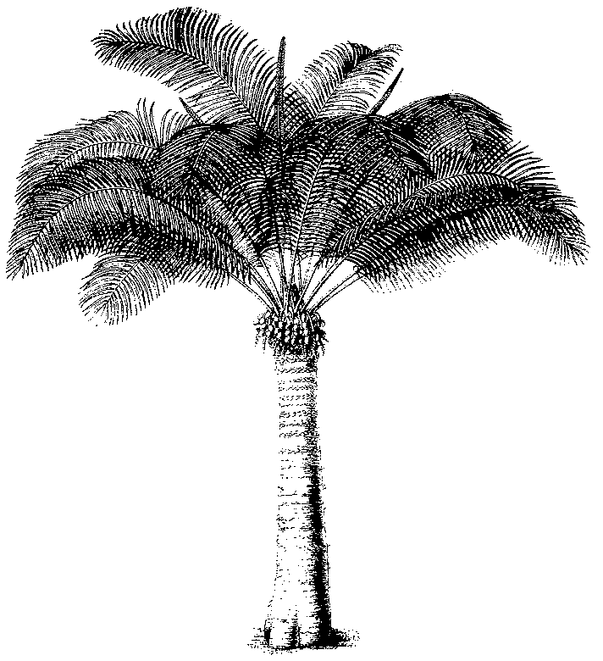
Eleventh meeting of the Plants Committee
Langkawi (Malaysia), 3-7 September 2001
Regional reports and reports on regional meetings
Asia
1. This report has been prepared by Dr N.P. Singh, regional representative for Asia.
2. There are 21 countries in Western Asia of which I could get the names and addresses of only 14 countries and I have informed all these countries about the forthcoming Plants Committee meeting and if they have any agenda to be discussed besides requesting for information on Regional Directory of Plant Experts. The information received will be intimated in the next Committee meeting.
3. Nomenclatural information on Taxus wallichiana has been supplied to Dr. Noel Mc Gough of Kew for discussions in the next meeting.
4. Information on experts of various groups of plants of India has been collected and is being sent to Dr. Shaari separately for the Regional Directory of Asia.
5. A draft of Identification Manual for plants of India included in the CITES has been prepared and will be shown during the next Committee meeting for improvement, If any.

