PC11 Inf. 3
CONVENTION ON INTERNATIONAL TRADE IN ENDANGERED SPECIES
OF WILD FAUNA AND FLORA
____________
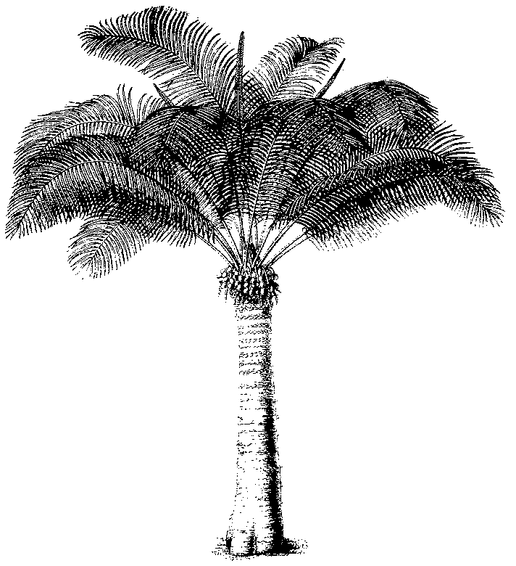
Eleventh meeting of the Plants Committee
Langkawi (Malaysia), 3-7 September 2001
Control of captive breeding, ranching and wild harvest production systems
for Appendix-II species
1. The attached document [AC17 Doc. 14 (Rev. 1)] was presented to the Animals Committee at its 17th meeting, in Hanoi, (Viet Nam), 30 July-3 August 2001.

