PC11 Inf. 1
CONVENTION ON INTERNATIONAL TRADE IN ENDANGERED SPECIES
OF WILD FAUNA AND FLORA
____________
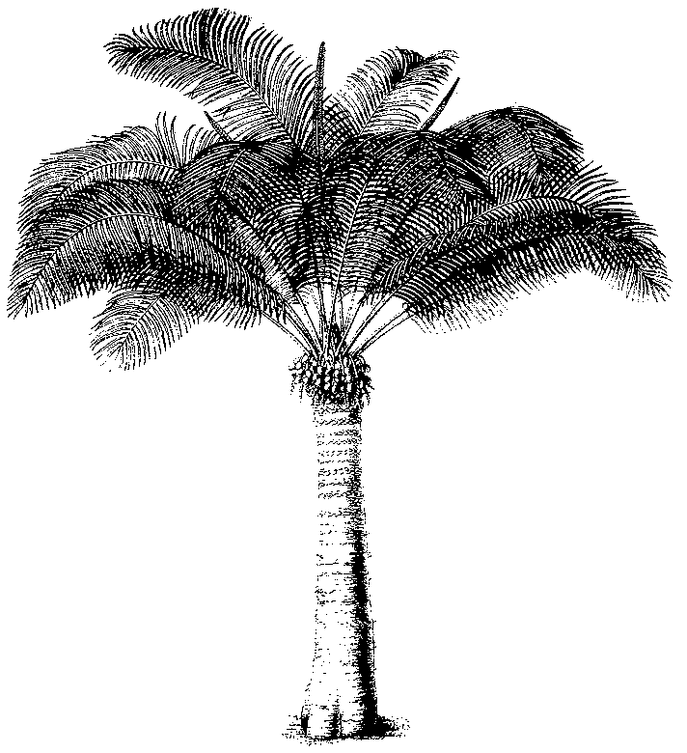
Eleventh meeting of the Plants Committee
Langkawi (Malaysia), 3-7 September 2001
Implementation of Resolution Conf. 8.9 (Rev.)
THE SIGNIFICANT TRADE REVIEW PROCESS
This document has been prepared by the Secretariat.
1. Resolution Conf. 8.9 (Rev.) and Decision 11.117, as the principal references for the Review of Significant Trade, are provided in Annexes 1 and 2 respectively.

PC11 Inf. 1
Annex 1
Resolution Conf. 8.9 (Rev.)
Trade in specimens of Appendix-II species taken from the wild
RECALLING that Article IV, paragraph 2 (a), of the Convention requires, as a condition for granting an export permit, that a Scientific Authority of the State of export has advised that the export will not be detrimental to the survival of the species concerned;
RECALLING that Article IV, paragraph 3, requires a Scientific Authority of each Party to monitor exports of Appendix-II species and to advise the Management Authority of suitable measures to be taken to limit such exports in order to maintain such species throughout their range at a level consistent with their role in the ecosystem;
RECALLING also that Article IV, paragraph 6 (a), requires, as a condition for granting a certificate of introduction from the sea, that a Scientific Authority of the State of introduction from the sea has advised that the introduction will not be detrimental to the survival of the species concerned;
RECALLING further that Resolution Conf. 2.6 (Rev.), adopted at the second meeting of the Conference of the Parties (San José, 1979) and amended at the ninth meeting (Fort Lauderdale, 1994), provides a mechanism by which any Party deeming any Appendix-II or -III species to be traded in a manner detrimental to the survival of that species may consult directly with the Management Authority of the country involved, with the assistance of the Secretariat if required, and take stricter domestic measures where appropriate;
NOTING that some Parties permitting export of Appendix-II species of wildlife are not effectively implementing Article IV, and that all Parties benefit from management of Appendix-II species that ensures the continued availability of these resources;
RECALLING that Resolution Conf. 9.1 (Rev.), adopted at the ninth meeting of the Conference of the Parties (Fort Lauderdale, 1994) and amended at the 10th meeting (Harare, 1997), charges the Animals Committee and the Plants Committee to: establish a list of those animal and plant taxa included in Appendix II that are considered as being significantly affected by trade; review and assess all available biological and trade information including comments by the range States on these taxa; formulate recommendations for remedial measures for those species for which trade is believed to have a detrimental effect; and establish priorities for research projects for species for which information is insufficient to determine whether the level of trade is detrimental;
RECALLING that the Conference of the Parties at its ninth meeting (Fort Lauderdale, 1994) established a work programme for the Plants Committee with regard to the review of trade in plant taxa listed in the Appendices, with special reference to those taxa considered as being specifically affected by trade;
CONCERNED that in many cases, population assessments and monitoring programmes necessary in order to maintain the level of export of Appendix-II species below the level that would be detrimental to the survival of the species are not being undertaken;
RECALLING that, by adopting document Doc. 10.56, the Parties recognized that information on the biological status of many plant species is frequently not available and that the data on trade in plants as included in annual reports are frequently incomplete;
THE CONFERENCE OF THE PARTIES TO THE CONVENTION
DIRECTS the Animals Committee and the Plants Committee:
a) in cooperation with the Secretariat and experts, to continue to review the biological, trade and other relevant information on Appendix-II species, with a view to identifying problems with the aim of ensuring the implementation of Article IV, paragraphs 2 (a), 3 and 6 (a);
b) in relation to those species under review for which sufficient information is available on trade and biological status, to determine possible problems with the implementation of the relevant paragraphs of Article IV, and following consultation with the range States, to make specific recommendations. Such recommendations shall be either primary or secondary recommendations;
i) primary recommendations include, for example, administrative procedures, specific quotas, zero quotas or temporary restrictions on exports of the species concerned; and
ii) secondary recommendations include, for example, field studies or evaluation of threats to populations or other relevant factors, including illegal trade, habitat destruction, internal or other uses, designed to provide the information necessary for a Scientific Authority non-detriment finding;
c) for those species under review for which sufficient information on trade and biological status of the species under review is not available:
i) to recommend taxon-specific status assessments;
ii) to recommend country-specific status assessments;
iii) to recommend to range States the establishment of cautious quotas as an interim measure; and
iv) to make, as appropriate, recommendations as described under paragraph b) above once the assessments referred to in paragraphs c) i) and ii) have been completed; and
d) to report at each meeting of the Conference of the Parties on the progress of this review, and on the measures adopted and those recommended to implement Article IV for Appendix-II species subject to significant trade;
DETERMINES that these reviews shall be carried out in close consultation with all range States concerned, and in accordance with the Decisions of the Conference of the Parties regarding the implementation of this Resolution;
RECOMMENDS that:
a) the above-mentioned recommendations of the Animals Committee and the Plants Committee be communicated by the Secretariat to each Party concerned;
b) for primary recommendations, each Party concerned, within 90 days of receipt, demonstrate to the satisfaction of the Secretariat that is has implemented the recommendations;
c) for secondary recommendations, each Party concerned, within 12 months of receipt, demonstrate to the satisfaction of the Secretariat that it has implemented or taken action to implement the recommendations;
d) for recommendations made pursuant to paragraphs c) i) and ii) under 'DIRECTS' above, each range State concerned, in consultation with the Secretariat and the Chairman of the Animals Committee or Plants Committee, as appropriate, complete a status assessment within two years of receipt of the recommendations of the committee concerned;
e) for recommendations made under the provisions of paragraph c) iii) under 'DIRECTS' above, each Party concerned, within 90 days of receipt of the recommendations of the Animals Committee or the Plants Committee, demonstrate to the satisfaction of the Secretariat that it has implemented the recommendations;
f) upon failure of a concerned Party to satisfy the Secretariat that it has fulfilled the requirements specified in paragraph b), c), d) or e) of this section, the Secretariat recommend to the Standing Committee that all Parties immediately take strict measures, including as appropriate suspension of trade in the affected species with that Party;
g) following acceptance of the Secretariat's recommendation by the Standing Committee, the Secretariat notify the Parties accordingly; and
h) in the case of suspension of trade in accordance with paragraph f) above, trade in the affected species with the Party concerned be reinstated only when that Party demonstrates to the satisfaction of the Standing Committee, through the Secretariat, compliance with the recommendations made by the Animals Committee or Plants Committee with respect to the implementation of Article IV, paragraph 2 (a), 3 or 6 (a);
DIRECTS the Secretariat for the purpose of monitoring and facilitating the implementation of this Resolution and the relevant paragraphs of Article IV of the Convention, and for allowing the reintroduction of a species into the review process in case of concern;
a) to report to each meeting of the Animals Committee and the Plants Committee on the implementation by the countries concerned of the recommendations made by the committee; and
b) to immediately inform the Animals Committee and the Plants Committee about possible concerns regarding trade in species:
i) that had been eliminated from the review process at a time when the committee concerned believed that the trade data available indicated that the trade was not detrimental to the survival of the species concerned; or
ii) for which the Secretariat was satisfied that the primary or secondary recommendations had been fulfilled by the Parties concerned; and
URGES the Parties and all organizations interested in the utilization and conservation of wildlife to provide the necessary financial support and/or technical assistance to those Parties in need of such assistance to ensure that wild populations of species of fauna and flora subject to significant international trade are maintained at a level that will allow international trade that is not detrimental to their survival.

PC11 Inf. 1
Annex 2
Decisions related to the implementation of Resolution Conf. 8.9 (Rev.)
11.117 Resolution Conf. 8.9 (Rev.) shall be implemented in accordance with the following procedure.
a) UNEP-WCMC shall produce a print-out from the CITES database showing the recorded net levels of trade in all Appendix-II species over the five most recent years.
b) In preparing these data, UNEP-WCMC shall analyse the available trade information, and highlight for the Plants Committee any inadequacies and deficiencies in the trade data available, in order to assist the Committee with its review.
c) Species for which the average net trade over this period has exceeded a level determined by the Plants Committee to be ‘safe’ should be selected and a print-out should be produced showing the levels of export and re-export of these species by country. This will constitute the list of taxa that might be subject to significant levels of trade.
d) On the basis of knowledge available in the Plants Committee and information from other relevant experts, species of immediate concern will be selected because of their recorded trade levels.
e) The Secretariat should, within 30 days after the meeting of the Plants Committee at which species are selected, notify range States of the species selected, providing an explanation for this selection and requesting comments and cooperation in providing information on the taxon to assist the review.
f) When necessary, consultants shall be engaged to compile information about the biology and management of the selected species and shall contact the range States and/or relevant experts to obtain information for inclusion in the compilation.
g) The consultants shall summarize their conclusions about the effects of international trade on the selected species and should divide them into three categories:
i) Category 1 shall include species for which the available information indicates that the provisions of Article IV of the Convention are not being implemented;
ii) Category 2 shall include species for which it is not clear whether or not the provisions of Article IV of the Convention are being implemented; and
iii) Category 3 shall include species for which the level of trade is evidently not a problem.
h) Before consideration by the Plants Committee, the Secretariat shall transmit the review documents prepared by the consultants to relevant range States, seeking comments and, where appropriate, additional information. Range States should be given six weeks to respond.
i) The Plants Committee should review the information provided by the consultants and the responses received from the Parties concerned and, if appropriate, revise the categories proposed by the consultants.
j) Species in Category 3 should be eliminated from the review process.
k) With respect to species in Categories 1 and 2, the Secretariat, on behalf of the Plants Committee, shall consult the range States to seek comments regarding possible Article IV implementation problems identified by the Committee. Range States should be given six weeks to respond.
l) If a response satisfactory to the Plants Committee is received, the species shall be eliminated from the review process1 with respect to the State concerned.
m) Otherwise, the Plants Committee shall, in consultation with the Secretariat, formulate recommendations in accordance with the provisions of Resolution Conf. 8.9 (Rev.), relating to species in Categories 1 and 2.
n) These recommendations shall be transmitted to the States concerned by the Secretariat, which shall, in consultation with the Plants Committee, determine whether the recommendations have been implemented and report to the Standing Committee in accordance with Resolution Conf. 8.9 (Rev).

The text regarding stricter measures was eliminated from Resolution Conf. 2.6 (Rev.) by the adoption of consolidated Resolution Conf. 11.3, where this text is now included
Replaced by Resolution Conf. 11.1
The elimination of a species from the review process will be decided on the basis of considerations related to the implementation of Article IV only. Other problems identified in the course of the review process will have to be addressed by other means.
1

