PC11 Doc. 24.5
CONVENTION ON INTERNATIONAL TRADE IN ENDANGERED SPECIES
OF WILD FAUNA AND FLORA
____________
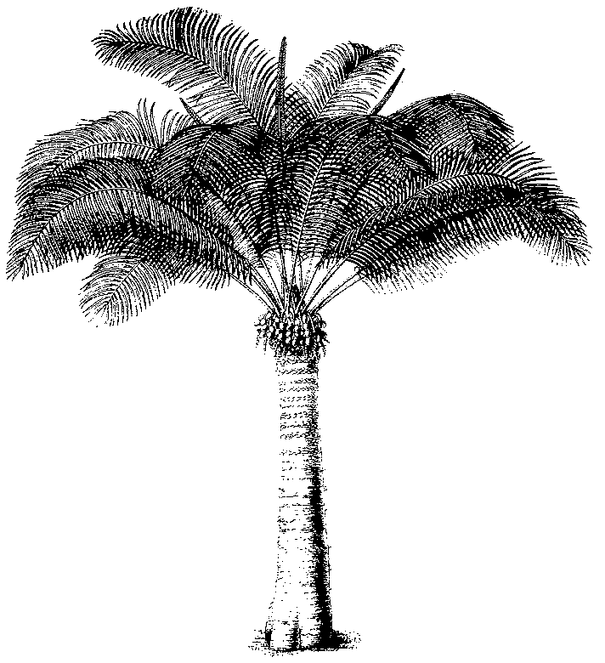
Eleventh meeting of the Plants Committee
Langkawi (Malaysia), 3-7 September 2001
Any other business
Implementation issues related to Appendix-III timber species
1. This document has been prepared by the United States of America.
Background
2. Since the 11th meeting of the Conference of the Parties in April 2000, two new timber species, Cedrella odorata (Spanish cedar) and Gonystylus spp. (ramin) have been listed in CITES Appendix III. These listings demonstrate the important steps that countries are taking to ensure that trade in their native timber resources is sustainable.
3. CITES Resolution Conf. 9.25 (Rev.), Recommendation c), recommends that a Party inform the Management Authorities of other range States, the known major importing countries, the Secretariat and the Animals Committee or the Plants Committee that it is considering the inclusion of the species in Appendix III and seek their opinion on the potential effects of such inclusion.
4. Under Article V of the Convention, an export of specimens of a species included in Appendix III from a country that has listed that species in Appendix III must be accompanied by a CITES export permit. An export of specimens of this species from another country must be accompanied by a certificate of origin.
Implementation issues
5. When Parties list timber species in Appendix III without following the consultations recommended in Resolution Conf. 9.25 (Rev.), Parties may find it difficult to implement the listing in a timely or effective manner.
a) Often the Ministry or agency responsible for issuing export documents for timber species is different from the one normally responsible for CITES implementation for terrestrial wildlife and plants. An Appendix-III listing becomes effective 90 days after the date of the Notification from the Secretariat. Ninety days may not be an adequate amount of time for the Management Authority to coordinate with the other Ministry or agency to ensure that certificates of origin are issued in accordance with Section V of Resolution Conf. 10.2 (Rev.), provide the Secretariat with sample copies of such documents for distribution to the Parties, or coordinate with inspection officials to adequately prepare to implement the listing.
b) It does not provide the Management Authorities of other range States and major importing countries with an opportunity to share information with the listing Party on potential effects of an Appendix-III listing.
6. Inspection officials may encounter difficulties in identifying and inspecting shipments of timber. Additional problems may occur when a timber listing includes parts and derivatives and is not annotated to include only logs, sawn wood, and veneer sheets. For example, the recent listing of Gonystylus spp. includes all parts and derivatives. Therefore, international trade of furniture, moldings, cue sticks, futon beds, picture frames, window blinds, and other wood products of this species requires CITES documents (an export permit, re-export certificate, or certificate of origin). Identifying the Customs tariff codes for these parts and derivatives may be complicated and delay effective implementation of a listing in the country of import.
Recommendations
6. The Plants Committee is requested to:
a) Encourage each Party that is considering the inclusion of a species, particularly a timber species, in Appendix III to consult with range States, known major importing countries, the Secretariat, and the Plants Committee as recommended in Resolution Conf. 9.25 (Rev.);
b) Encourage the Management Authorities of range States to provide the Secretariat with sample copies of any CITES certificates of origin that are different in appearance from CITES documents currently on file with the Secretariat as soon as possible after notification of an Appendix-III listing;
c) Direct the Secretariat to provide the Parties, via Notification, with samples of the export permits and certificates of origin that Parties will use for a new Appendix-III species prior to the effective date of the listing;
d) Direct the Secretariat to provide a status report on the preparation of CITES identification materials for timber species listed since the 11th meeting of the Conference of the Parties and, if identification materials have not yet been prepared, seek means by which they can be prepared in a timely manner and provided to the Parties to utilize at ports of export and import; and
e) Encourage each Party that is considering the inclusion of a timber species in Appendix III to carefully consider how the listing should be annotated to ensure control in parts and derivatives that need to be controlled to ensure that trade is sustainable while allowing for practical, effective implementation of the Convention.

