PC11 Doc. 24.4
CONVENTION ON INTERNATIONAL TRADE IN ENDANGERED SPECIES
OF WILD FAUNA AND FLORA
____________
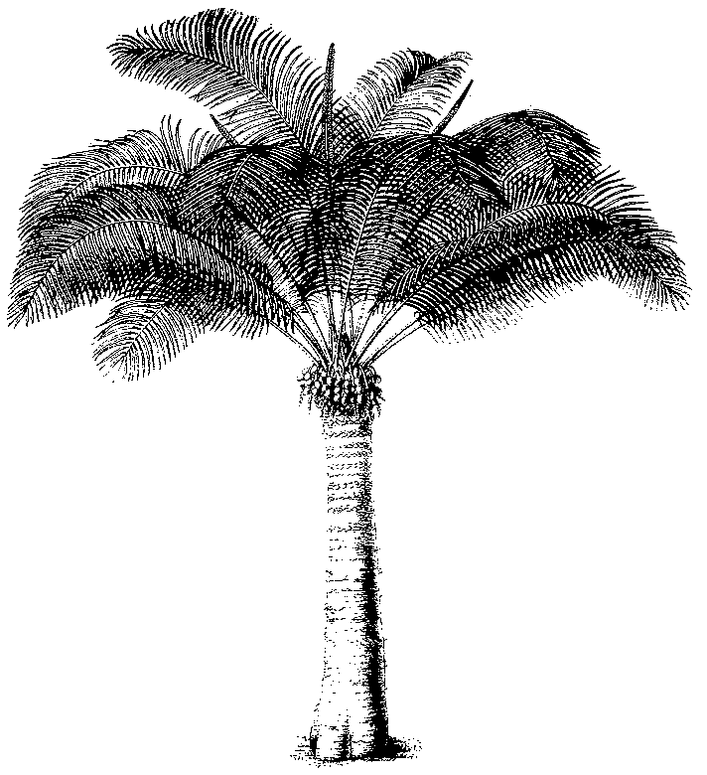
Eleventh meeting of the Plants Committee
Langkawi (Malaysia), 3-7 September 2001
Any other business
Illegal trade in Paphiopedilum spp.
1. This document has been prepared by the United States of America.
Background
2. Since 1995, several previously unknown species in the genus Paphiopedilum have been discovered in Southeast Asia, most notably in Viet Nam. In addition, Paph. delenatii, a showy, pink-flowered species discovered in the early 20th Century and unknown from the wild since that time, was rediscovered in the early 1990s. Some of the newly described species may actually be natural hybrids of well-known taxa, but are being recognized as new discoveries of naturally occurring entities. Several are showy or possess other characteristics that make them highly prized to collectors and for hybridizing for the commercial market. While Paph. delenatii is already known in cultivation and widely available, until its rediscovery all plants in cultivation were believed to have been derived from a single plant. Additional plants from the wild are desirable to improve the genetic composition of cultivated stocks.
3. All species in the genus Paphiopedilum are included in CITES Appendix I and are therefore prohibited from trade for commercial purposes, except as they may qualify for treatment under the exemption of Article VII, paragraph 4, and in accordance with the requirements of Resolution Conf. 11.11 for artificially propagated plants, including flasked seedlings.
4. The generation time for Paphiopedilum species is from a few to several years, and artificially propagated seedlings generally cannot be produced from wild-collected parental stock within a time period of less than 2-3 years, depending on when the plants flower, time required for seedpods to ripen, germination time, growth rate, etc. Yet, specimens of these species are appearing in international trade within a very short time after their discovery, indicating that the specimens involved are not truly artificially propagated.
Implementation and enforcement issues
5. Seedlings of these newly discovered and rediscovered species are also entering trade in sterile flask culture, but are unlikely to meet the requirements for artificially propagated plants, which is the presumptive basis for the flasked seedling exemption contained in Resolution Conf. 11.11. The failure of flasked seedlings to satisfy the requirements for artificially propagated plants are two-fold: First, in at least some cases, range countries have not allowed the legal export of these species, either as wild-collected or artificially propagated specimens, with the possible exception of scientific research specimens. Second, some species have been over-collected and may have been extirpated, or nearly so, such that parental stock was not obtained in a manner not detrimental to the survival of the species in the wild.
6. There appears to be widespread misunderstanding and misapplication of the flasked seedling exemption. This exemption is to be applied “taking into account the provisions of Article VII, paragraph 4,” as stated in Resolution Conf. 11.11. However, in practice, it appears that all seedlings in flask are treated as exempt, with no determination of whether they actually qualify for the exemption. Implementation of the exemption in this manner may be encouraging illegal trade in wild-collected plants for parental stock, which can then be used to produce progeny for commercial trade as flasked seedlings.
7. Plants of recently discovered Paphiopedilum species are widely available and are being offered for sale at orchid exhibitions, on the internet, and through print advertisements and mailings worldwide, including in Europe, Japan, Taiwan, and the United States of America. In some cases, these plants are being advertised to appear artificially propagated and have accompanying documentation that substantiates their legality, but which the sellers state cannot be used for obtaining further CITES permits. These advertisements suggest that trade is occurring with invalid documentation obtained by fraudulent means. It also may indicate that plants are being deliberately mislabeled or otherwise disguised in trade.
8. The U.S. Fish and Wildlife Service is working with the U.S. Geological Survey, Biological Resources Division, to determine if genetic methods can be developed for identifying non-blooming plants of Paphiopedilum species in trade.
Recommendations
9. The Plants Committee is requested to:
- Consider the special problems with trade in Paphiopedilum species, especially recently discovered species, and consider whether the existing framework for conducting trade in these species is resulting in effective control and protection of wild populations from over-exploitation. In particular, the application of the flasked seedling exemption should be evaluated with regard to its misuse and potential impacts on the conservation of these species. Measures should be sought to improve the application of this exemption and restrict its use appropriately, or its use should be reconsidered altogether.
- Consult with range countries of newly described Paphiopedilum species and assess their capacity for artificial propagation of these species, to determine whether they allow any export of these species. Legitimate sources of these plants should be identified and encouraged for supplying the international market in lieu of plants of illegal origin.
- Explore avenues for technical exchanges and capacity development for the production of legitimately artificially propagated Paphiopedilum species in range countries, with appropriate training to ensure that such endeavors are conducted in a manner that will not be detrimental to the survival of the species in the wild.
- Explore how the nursery registration procedures of Resolution Conf. 9.19 might be used more assiduously for these species to achieve greater control over trade in them.
- Work with the Secretariat, through the Standing Committee as necessary, to develop a Notification to the Parties on trade in Paphiopedilum species, focusing on those species that should be prohibited from trade when range countries have advised that their export is prohibited and that no legitimate artificial propagation of the species has been documented.

