PC11 Doc. 24.3
CONVENTION ON INTERNATIONAL TRADE IN ENDANGERED SPECIES
OF WILD FAUNA AND FLORA
____________
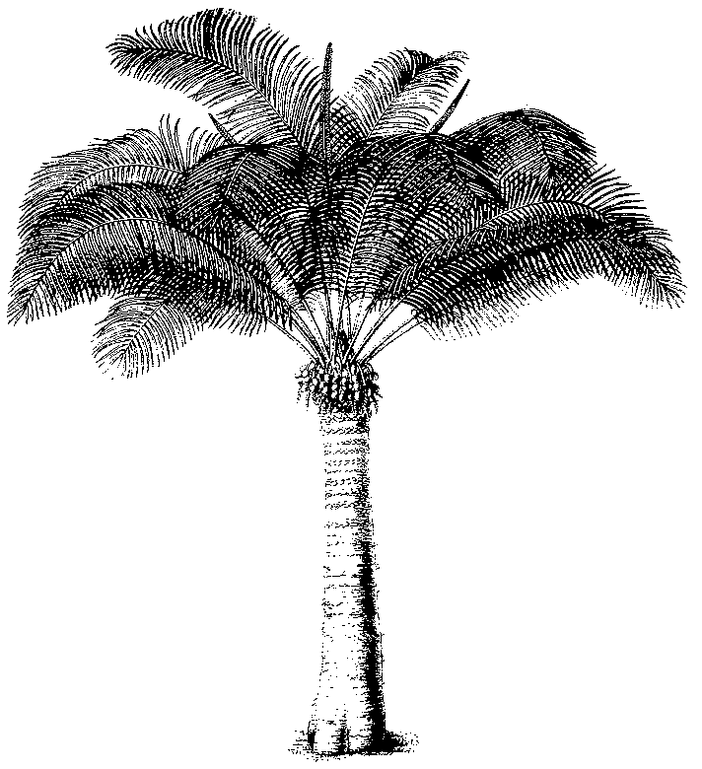
Eleventh meeting of the Plants Committee
Langkawi (Malaysia), 3-7 September 2001
Any other business
Annotation to Cistanche deserticola
1. At its 11th meeting, the Conference of the Parties approved a proposal to include Cistanche deserticola in Appendix II with the annotation “designates whole and sliced roots and parts of roots, excluding manufactured parts or derivatives such as powders, pills, extracts, tonics teas and confectionery”.
2. It was not noted during the meeting, or immediately afterwards, that this annotation was incorrect because Cistanche deserticola is a parasite and does not have roots!
3. The parts that are traded are dried or fresh undeveloped inflorescences, which are harvested when still subterranean, hence the reference to ‘roots’.
4. It is clear that the intention of the proponent was that only the trade in these inflorescences should be regulated and that all manufactured products should be exempt from CITES controls.
5. The Secretariat intends to prepare a Notification to the Parties on the subject, and will cooperate with China in preparing an amendment proposal to correct the current annotation.

