PC11 Doc. 24.1
CONVENTION ON INTERNATIONAL TRADE IN ENDANGERED SPECIES
OF WILD FAUNA AND FLORA
____________
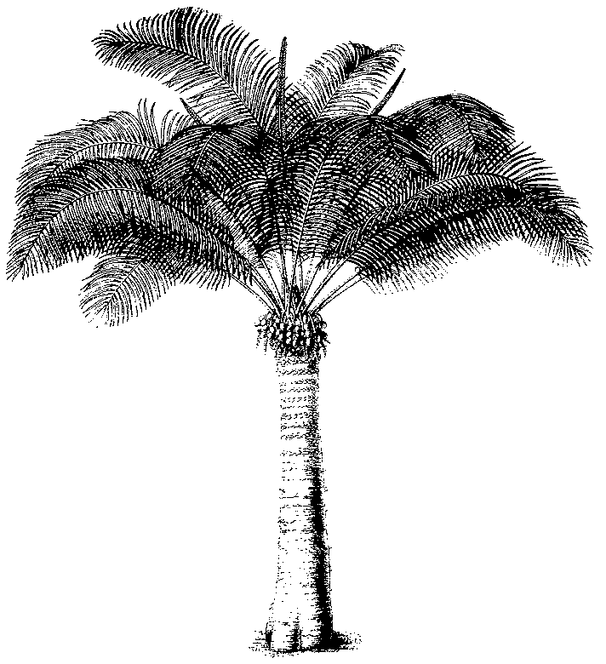
Eleventh meeting of the Plants Committee
Langkawi (Malaysia), 3-7 September 2001
Any other business
Relationship between ex-situ breeding operations and
in-situ conservation programmes (Decision 11.102)
1. The attached document (Doc. AC.16.9.2) was presented to the Animals Committee at its 16th meeting, in Shepherdstown, (United States of America), 11-15 December 2000.

