PC11 Doc. 18
CONVENTION ON INTERNATIONAL TRADE IN ENDANGERED SPECIES
OF WILD FAUNA AND FLORA
____________
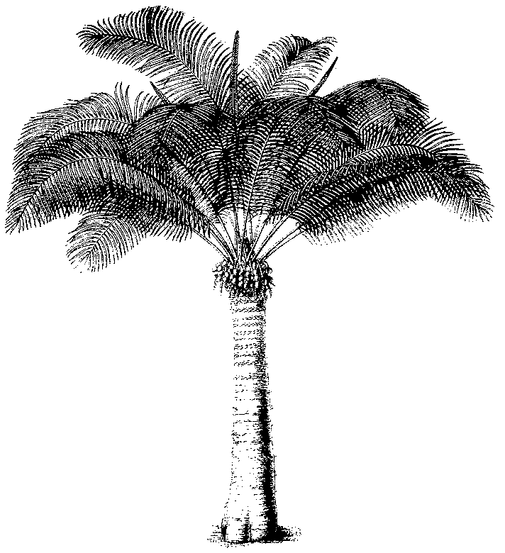
Eleventh meeting of the Plants Committee
Langkawi (Malaysia), 3-7 September 2001
Tree species evaluation: progress report by the Netherlands
1 This document has been submitted by the Scientific Authority of the Netherlands.
2. At the Plants Committee meeting in Darwin the Plants Committee decided that the above-mentioned report is useful in the process of the revision of the appendices, and should be used as such. The PC therefore invited The Netherlands to provide all Parties with copies of the report.
3. The actions taken so far include:
i) copies of the original report (in English) have been sent out to all Management Authorities, accompanied by a Notification to the Parties issued by the CITES Secretariat;
ii) translation into French and Spanish of each sheet, depending upon the language of the range States concerned;
iii) texts in all three languages working languages of the Convention, as requested by the Plants Committee, are available on the web at http://www.unep-wcmc.org with feedback quality; and
iv) a hard copy of the text translated into French and Spanish has been sent out to those countries that the Secretariat have listed as appropriate to receive documents in French or Spanish.
4. In July 2001 two letters have been sent out to the Management Authorities, asking for their comments and inputs.
5. The Scientific Authority of the Netherlands invites any Management Authority to consult with their Scientific Authority for comments regarding the evaluation report, and to provide these comments to the following person, in charge of the collection of observations and data that Parties care to send:
Harriet Gillett
Senior Programme Officer
Species Programme
UNEP World Conservation Monitoring Centre
219 Huntingdon Rd
Cambridge CB3 0DL
United Kingdom

