PC11 Doc. 17
CONVENTION ON INTERNATIONAL TRADE IN ENDANGERED SPECIES
OF WILD FAUNA AND FLORA
____________
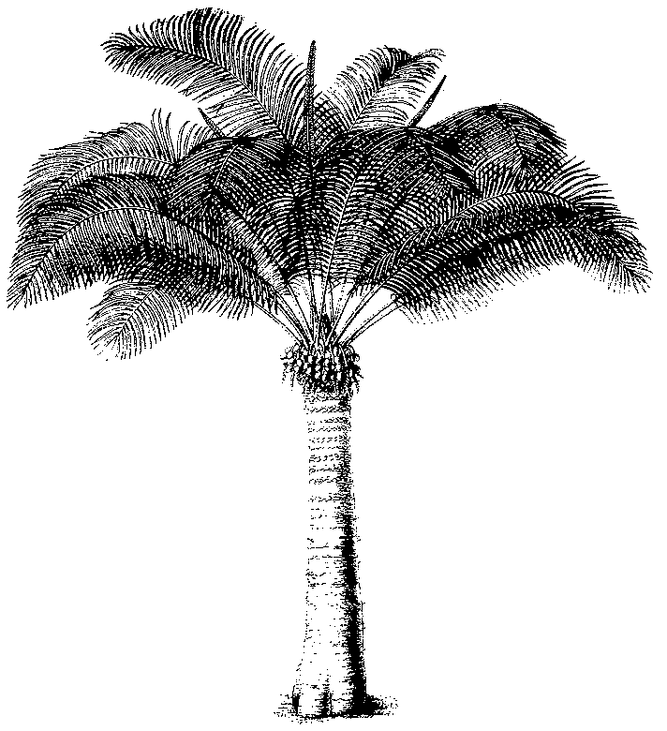
Eleventh meeting of the Plants Committee
Langkawi (Malaysia), 3-7 September 2001
Guidelines for transport of live plants
1. This document has been prepared by the Vice-Chairman of the Plants Committee
2. The new draft (in Annex 2, in English only) is the result of a wide consultation with PC members, the Secretariat and enforcement persons. The various comments have been included (bold = additions; strikethrough = deletions; the paragraph numbers remain from the original document) in the original document provided by Dr Irina Sprotte (Guidelines for animals, two last pages on plants) and reorganised. A clean version is included in Annex 1.
3. Some comments (especially from scientists) questioned the need for such guidelines and this should be discussed first.
4. However, interesting enough, enforcement people were missing precise guidelines not only on how to keep the plants alive, but also on the documentation and labelling of the packages as an absence of proper information is very often a cause of delays which can be fatal to the plants.

PC11 Doc. 17
Annex 1
GUIDELINES FOR TRANSPORTATION OF LIVE PLANT SPECIMENS
Introduction
1. Shipments of live plant material have to comply with applicable international and national phytosanitary and transportation regulations. Theses regulations dictate the way in which plant material shall be transferred from country to country. They not only cover the form in which the plant specimens may be transferred but also the materials and methods which may be used in packaging and any preconditioning necessary to meet environmental conditions to be encountered in transit or at the final destination.
2. To obtain optimum success in propagation and cultivation, live plant material should be transported as rapidly as possible, which usually means by air, using the pressurised compartment of the aircraft. Except for seeds, surface mail should not be used for long-distance transport of plant specimens.
3. All possible precautions should be taken in advance to ensure that shipment containers are kept dry, and not exposed to desiccating conditions, and that they are not left exposed to the sun, extreme heat, or freezing conditions (temperatures). Plants should be stored in such a manner that they have adequate ventilation.
General
4. Shipments of live plant material have to comply with applicable international and national phytosanitary and transportation regulations.
5. Living plant specimens should be given high priority over non living items during all phases of transportation and handling.
6. It is the consignor’s (exporter) responsibility to ensure that adequate advance arrangements are made to care for the plant specimens until the consignee (importer) takes them into his charge (i.e. the estimated time of arrival of the plant specimens should be notified in advance to the consignee, and also the route of the consignment).
7. Plant quarantine import requirements of the country of destination should be consulted before plants are packaged and shipped in order to avoid compulsory fumigation and other treatments what will injure plant specimens. It should be noted that soil and certain other materials used as growing media or packaging material are prohibited entry into many countries, as a potential source of pests or pathogens.
8. In case of storage, plants should be kept in such a manner that they have adequate living conditions.
package
9. Package should be strong enough to withstand handling and shipping.
10. Plant specimens shall be packaged in a manner to minimise desiccation, movement, and damage during transport, and to allow adequate ventilation. Plant specimens normally should not be enclosed in airtight containers; however, propagating material (newly germinated seedlings and tissue cultures) may travel on culture media in tubes or other sealed containers.
11. Indications such as “CITES” ; “urgent” ; “fragile”; LIVE PLANTS – NO EXTREME HEAT OR COLD” and “This way up” or arrows indicating the top on all sides and top should be provided on durable, waterproof labels.
Documentation
12. Durable, waterproof means of containing the following documents and other essential information should be firmly attached to the package.
13. In a shipment with more than one box to more than one importer, each item shall show the appropriate information and carry copies of the original permits.
14. On package and documentation, the following information must appear clearly:
- consignor’s and consignee’s name, full address and telephone number. (Postal box numbers must not be used as the sole address);
- Complete Latin names of all plants contained in package (on a label?);
- Copies of relevant export and import licences. (never list of higher taxa on documentation);
- A phytosanitary certificate is not replacing CITES Permits, unless in accordance with Resolution Conf. 10.2, section VI, and only for those Parties notified by the Secretariat; and
- A clear list of handling recommendations and restrictions should be provided by the consignor and attached to each shipment.

PC11 Doc. 17
Annex 2
(English only/Solamente en inglés/Seulement en anglais)
GUIDELINES FOR TRANSPORTATION OF LIVE PLANT SPECIMENS
1. GENERAL
1.1 Shipments of live plant material have to comply with applicable international and national phytosanitary and transportation (PD) regulations. Theses regulations very often dictate the way in which plant material may be transferred from country to country. They not only cover the form in which the plant specimens may be transferred but also the materials and methods which may be used in packaging and any preconditioning necessary to meet environmental conditions to be encountered in transit or at the final destination (GVV/BVA from 1.3)
1.1a It should be the consignor’s responsibility to ensure that adequate advance arrangements are made to care for the plant specimens until the consignee takes them into his charge. (GVVfrom 2.1) Plants should be stored in such a manner that they have adequate living conditions (BVA: adapted from 2.2)
Package should be strong enough to withstand handling and shipping. (GVV: from 3.1 / GL: truism of no use.)
3.3 Plant specimens normally should be packaged in a filling compound, in a manner to minimise desiccation, movement, and damage during transport, and to allow adequate ventilation.
3.4 Plant specimens normally should not be enclosed in airtight containers; however, propagating material (newly germinated seedlings and tissue cultures) may travel on culture media in tubes or other sealed containers.
1.2 Living (GL) Plant specimens should be given high priority over nonliving items during all phases of transportation and handling.
1.3 Generally, only healthy pest-free plant specimens should be transported. Certain plants may need. (redundant with 1.1 as amended)
1.4 To obtain optimum success in propagation and cultivation, live plant material should be transported as rapidly as possible, which usually means by air, using the pressurised compartment of the aircraft. Except for seeds, surface mail should not be used for long-distance transport of plant specimens. The estimated time of arrival of the plant specimens should be notified in advance to the consignee, and also the route of the consignment (from 2.3)
1.5 Quarantine authorities should not impose fumigation treatments what will injure plant specimens, particularly specimens of taxi included in Appendix I of CITES. (in contradiction with 1.1; GVV)
Plant quarantine import requirements of the country of destination should be consulted before plants are packaged and shipped in order to avoid compulsory fumigation and other treatments what will injure plant specimens. It should be noted that soil and certain other materials used as growing media or packaging material are prohibited entry into many countries, as a potential source of pests or pathogens. (PD/GL: mod from 3.1)
2. ADVANCE ARRANGEMENTS FOR TRANSPORT.
2.2 All possible precautions should be taken in advance to ensure that shipment containers are kept dry, and not exposed to desiccating conditions, and that they are not left exposed to the sun, extreme heat, or freezing conditions (temperatures). Plants should be stored in such a manner that they have adequate ventilation. (BVA: in introduction)
2.3 The estimated time of arrival of the plant specimens should be notified in advance to the consignee, and also the route of the consignment. (BVA: Difficult)
3. PACKAGING
No packaging materials or methods should be used which would be contrary to those requirements or which would make port of entry inspections or treatment difficult. It should be noted that soil and certain other materials used as growing media or packaging material are prohibited entry into many countries, as a potential source of pests or pathogens. (GVV: superfluous as if not conform will not get phytosanitary permit)
4. LABELLING AND DOCUMENTATION
Durable, waterproof labels or tags should be provided as follows.
4.1 Indications such as “CITES” ; “LIVE PLANTS – NO EXTREME HEAT OR COLD” and “This way up” or arrows indicating the top on all slides and top. Label or tag should be completed with appropriate restrictions. (mod bva from 4.1/ 4.2)
4.2 , , should always be used where appropriate.
5. DOCUMENTATION
Durable, waterproof means of containing the following documents and other essential information should be firmly attached to the package
On package and documentation, consignor’s and consignee’s name, full address and telephone number. Postal box numbers should not be used as the sole address. (mod. ex 4.1) and complete Latin names
A clear list of handling recommendations and restriction should be provided by the consignor and attached to each shipment.
4.4 Duplicate of consignor’s and consignee’s name, address and telephone number. Postal box numbers should not be used as the sole address.
Copies of relevant export and import licences (no short list of higher taxa
A phytosanitary certificate is not replacing CITES Permits, unless in accordance with Resolution Conf. 10.2, section VI, and only for those Parties notified by the Secretariat. (GVV)

