PC11 Doc. 14.5
CONVENTION ON INTERNATIONAL TRADE IN ENDANGERED SPECIES
OF WILD FAUNA AND FLORA
____________
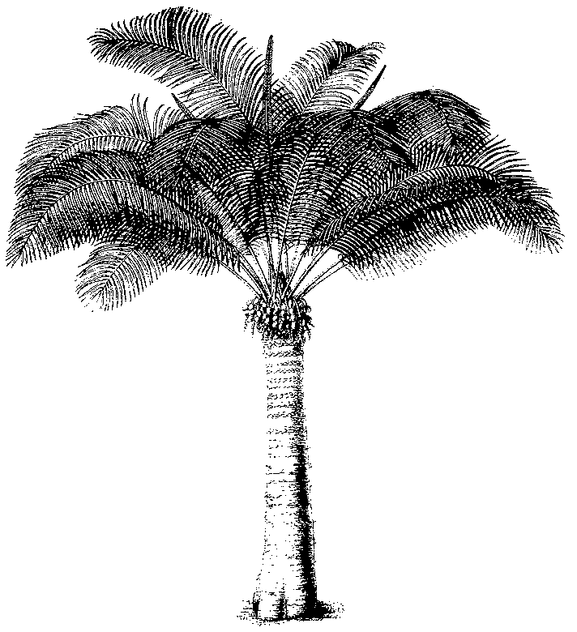
Eleventh meeting of the Plants Committee
Langkawi (Malaysia), 3-7 September 2001
Checklists and Nomenclature
nomenclature of cedrela odorata
1. This document has been prepared by the Vice-Chairman of the Nomenclature Committee.
2. This subject has been included in the agenda at the request of the Management Authority of Argentina because it felt that the taxonomy of the genus was not clear. There was neither agreement on whether the species Cedrela odorata occurred in Argentina, or whether it might be another species (C. angiustifolia). They also provided the information contained in the paragraphs 3. – 6. below.
3. Zuloaga and Morrone (Catálogo de plantas vasculares de la República Argentina 1999), following the classification by Penington, Styles & Taylor (1981 Meliaceae. Flora Neotropica Monograph No 28, 459 pp) indicate that C. lilloi, C. fissilis and C. odorata occur in northeast Argentina. This revision, probably the most complete one, is for the distribution of Cedrela, exclusively based on herbarium material from this region (Bolivia, Argentina, Paraguay and the south of Brasil).
4. Pennington et al. noted that C. angustifolia is a not very well known entity, and that previous authors considered it as being close to C. odorata or C. fissilis.
5. Digilio and Legname (1966. Los árboles indígenas de la provincia de Tucumán. Opera Lilloana XV) recognize only the entity C. lilloi as occurring in Tucumán, and consider C. angustifolia and C. lilloi to occur in the northern part of ‘las yungas’ (hot valleys).
6. Smith (1960. A Revison of Cedrela, Meliacea) and the Commonwealth Forestry Institute (CFI) (Progress with provenance exploration and seed collection of Cedrela spp. 1980. C.E. Chaplin) regard C. angustifolia as a separate species.
7. The Vice-Chairman of the Nomenclature Committee has consulted Mr Pennington on the subject.
8. He mentioned that, as far as he was aware, only 3 species occur in Argentina, C.odorata, C. fissilis, and C. lilloi, the latter confined to altitudes above 1000m. He also indicated that the name C. angustifolia could be safely ignored, because it refers to something described from Mexico. In the unlikely event that it can be proved distinct from C. odorata, it will be some local north Mexico taxon.

