PC11 Doc. 14.2
CONVENTION ON INTERNATIONAL TRADE IN ENDANGERED SPECIES
OF WILD FAUNA AND FLORA
____________
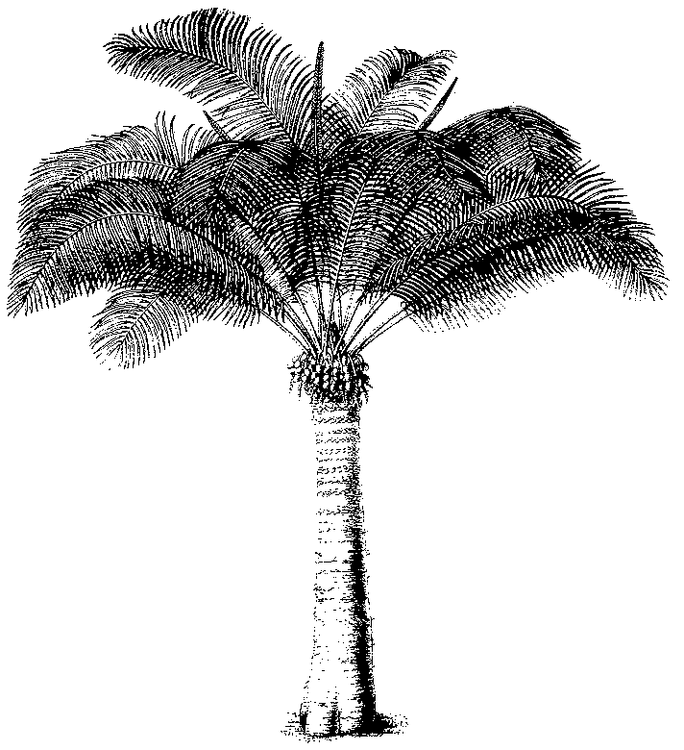
Eleventh meeting of the Plants Committee
Langkawi (Malaysia), 3-7 September 2001
Checklists and nomenclature
ISSUES REFERRED TO THE NOMENCLATURE COMMITTEE
1. This document has been prepared by the Vice-Chairman of the Nomenclature Committee.
Cactaceae
2. During recent years, an increase in the trade of Nopal as well as several other preparations made from parts and derivatives of Opuntia spp. have been noticed.
3. Two species of Opuntia spp. namely O. streptacantha and O. ficus-indica- are mainly used.
4. In the Interpretation of Appendix I and II, annotation #4 e) stipulates that ‘separate stem joints (pads) and parts and derivatives thereof of naturalised or artificially propagated plants of the genus Opuntia subgenus Opuntia’ are exempted.
5. However, there is no clear definition of which species are actually listed in the subgenus Opuntia. There are over 300 Opuntia species and more than 900 names can be found in the literature. Different taxonomic opinions are found in the literature.
Action:
6. The Plants Committee Representative for North America and the Alternate Representative have co-operated to review the present lists available for the Subgenus Opuntia. It is hoped that draft list will be available for this meeting. The list will be further reviewed and if necessary a final list will be prepared in time for the next meeting of the Conference of the Parties.
Thymeleaceae (Aquilariaceae): Aquilaria spp.
7. Aquilaria malaccensis was included in CITES Appendix II in 1995. The proposal by India included only one synonym - A. agallocha. The genus is considered to contain some 15 species.
8. There are conflicting views with regard to the species which are included in the entity known as A. malaccensis as indeed there is with the number of species included in the genus. For example, A. malaccensis may include A. sinensis and some consider A. agallocha to be a separate species.
9. The eleventh Meeting of the Conference of the Parties directed the Plants Committee to continue its review of the genus Aquilaria to consider inter alia how species might be distinguished from each other when traded as Agarwood.
Action:
10. The review of the genus Aquilaria requested by the last meeting of the Conference of the Parties will include a full review of the present taxonomic status of the species. This will be carried out in association with the Nomenclature Committee.
Valerianceae: Nardostachys grandiflora
11. This species was included in CITES Appendix II in 1997. The proposal put forward by India included the synonyms, Valeriana jatamans sensu D.Don, Patrinia jatamanis D. Don, Fedia grandiflora Wall., Nardostachys jatamansi DC. and Nardostachys gracilis Kitamura.
12. The inclusion of the homonym Valeriana jatamans sensu D. Don has caused some confusion as regard to what is included in N. grandiflora. This is just a misapplied name. There is no indication in the proposal that the intent was to control Valaeriana jatamasi Jones, which is mentioned in the proposal but only a similar species.
Decision and action:
13. The original intent of the proposal was to control Nardostachys grandiflora and its accepted synonyms which does not include Valeriana. This will be clarified with a note in paragraph 10 of the Interpretation of Appendices I and II.
Scrophulariaceae: Picrorhiza kurrooa
14. Picrorhiza kurrooa was included in CITES Appendix II in 1997. The proposal put forward by India included no synonyms.
15. Picrorhiza scrophulariiflora is considered to be a synonym of this species in Nepal and China. Some authors however consider Picrorhiza scrophulariiflora to be a separate species.
Decision and action:
16. The original intent of the proposal was to control Picrorhiza kurrooa. In fact the original proposal treated Picrorhiza scrophulariiflora as a similar species and noted characters by which the two could be distinguished. This will be clarified with a note in paragraph10 of the Interpretation of Appendices I and II.
17. However Picrorhiza scrophulariiflora (present accepted name Neopicrorhiza scropulariiflora) is a component of the Kutki material in trade which is mostly a mixture of both taxa. This obviously gives rise to major problems of implementation and the effectiveness of the present listing needs to be further reviewed.
Taxaceae: Taxus wallichiana
18. India proposed this species for Appendix II at the ninth meeting of the Conference of the Parties in Fort Lauderdale USA in 1994. The proposal included as scientific synonyms 'Taxus baccata sensu Hook. F. 1888. Auct non L.: Taxus baccata L. ssp. wallichiana (Zucc.) Pilger'.
19. The taxonomy and nomenclature of the genus is subject to some confusion and gives rise to problems in the interpretation of the listing. The problems relating to Taxus are under review at present by a number of experts.
20. To assist in implementing the listing it is important to clarify what was the original intent of the listing proposal.
21. To assist Parties in the implementation of the listing until a critical review is available a standard reference should be chosen which meets with the original intent of the listing.
Recommendation
22. There is no taxonomic consensus with regard to the validity of Taxus wallichiana. Reference to the original proposal does not clarify the full intent of the listing. The information in the proposal and a review of the literature available at the time suggest that the intent of the proposal is nearest to the conservative approach adopted in the World Checklist and Bibliography of Conifers by Farjon (1998). A new edition is at present in press, however the treatment of Taxus remains unchanged. Farjon does include T. yunnanensis as a synonym and it is not clear whether this was the intent of the original listing. Based on available information it is recommended that Farjon (1998) and its updates be used as the standard reference for CITES.
- 23. In practical terms it is impossible to effectively implement the present listing. There is no reliable means for an enforcement officer to identify material in trade as that which is controlled by CITES. The present listing needs to be reviewed to ascertain whether the present listing should be deleted, amended or expanded to provide adequate protection for any taxa within the genus which may require monitoring to ensure that trade is sustainable.

