PC11 Doc. 13.2
(English and Spanish only/Solamente en inglés y español/Seulement en anglais et espagnol)
CONVENTION ON INTERNATIONAL TRADE IN ENDANGERED SPECIES
OF WILD FAUNA AND FLORA
____________
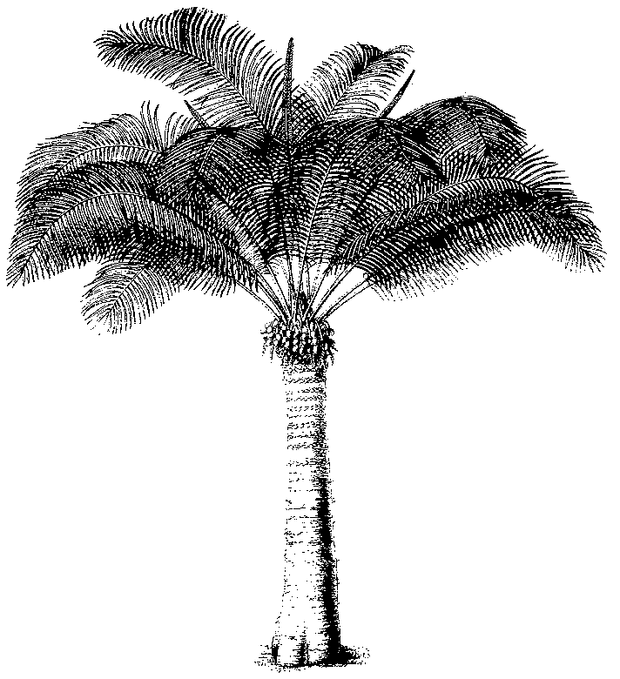
Eleventh meeting of the Plants Committee
Langkawi (Malaysia), 3-7 September 2001
Review of the Appendices
Appendix–I Cactaceae
1. The attached document has been prepared by the Management Authority of Switzerland.

