PC11 Doc. 11.2.3
CONVENTION ON INTERNATIONAL TRADE IN ENDANGERED SPECIES
OF WILD FAUNA AND FLORA
____________
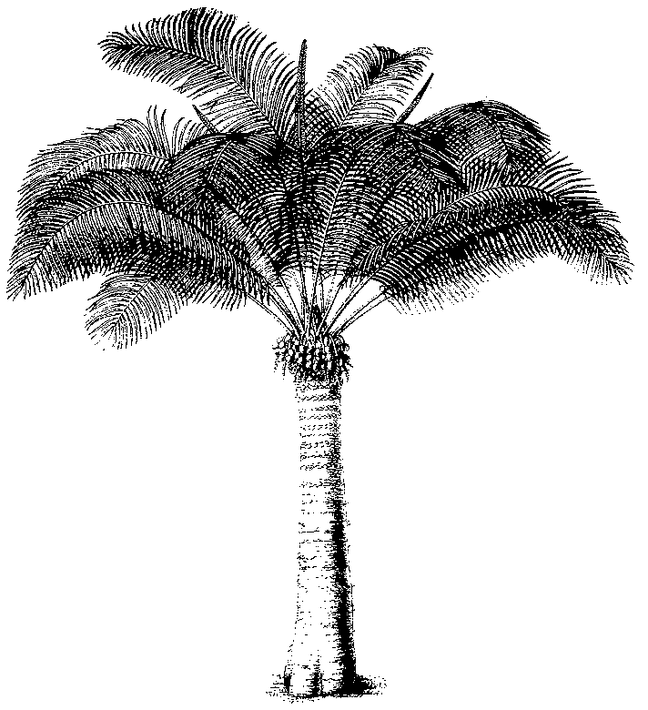
Eleventh meeting of the Plants Committee
Langkawi (Malaysia), 3-7 September 2001
Significant trade in plants
Implementation of Resolution Conf. 8.9 (Rev.) (cf. decision 11.117)
Selection of taxa for review
1. This document has been prepared by UNEP-WCMC at the request of the Secretariat.

SIGNIFICANT TRADE IN PLANTS

Net Trade Outputs

Produced by UNEP - WCMC in accordance with

DECISION 11.117 OF THE CONFERENCE OF THE PARTIES

Directed to the Plants Committee

Regarding the implementation of
Resolution Conf. 8.9 (Rev.)

July 2001

Prepared and produced by: UNEP World Conservation Monitoring Centre, Cambridge, UK

The UNEP World Conservation Monitoring Centre was established in 2000 as the world biodiversity information and assessment 5rgani of the United Nations Environment Programme. The roots of the 5rganization go back to 1979, when it was founded as the IUCN Conservation Monitoring Centre. In 1988 the World Conservation Monitoring Centre was created jointly by IUCN, WWF-International and UNEP. The financial support and guidance of these 5rganizations in the Centre’s formative years is gratefully acknowledged.

Prepared for: The CITES Secretariat

A contribution to UNEP - The United Nations Environment Programme

Printed by: UNEP World Conservation Monitoring Centre
219 Huntingdon Road, Cambridge CB3 0DL, UK

© Copyright: UNEP World Conservation Monitoring Centre/CITES Secretariat

The contents of this report do not necessarily reflect the views or policies of UNEP or contributory organisations. The designations employed and the presentations do not imply the expressions of any opinion whatsoever on the part of UNEP or contributory organisations concerning the legal status of any country, territory, city or area or its authority, or concerning the delimitation of its frontiers or boundaries.

Contents

Introduction |  | I
Cactaceae
1. | Total net trade in wild-Appendix-II Cactaceae by taxon, 1995-1999, highlighting taxa in significant trade¹ | 1
1a. | Net exports of significantly-traded¹-wild-Appendix-II Cactaceae taxa, by country of export or re-export, for 1995-1999 | 13
Cycadaceae
2. | Total net trade in wild-Appendix-II Cycadaceae by taxon, 1995-1999, highlighting taxa in significant trade¹ | 17
2a. | Net exports of significantly-traded¹-wild-Appendix-II Cycadaceae taxa, by country of export or re-export, for 1995-1999 | 18
 | Note: Zamiaceae are under ‘Other plants’
Other plants
3. | Total net trade in wild-Appendix-II plants other than Cactaceae, Cycadaceae and Orchidaceae by taxon, 1995-1999, highlighting taxa in significant trade¹ | 19
3a. | Net exports of significantly-traded¹-wild-Appendix-II plants other than Cactaceae, Cycadaceae and Orchidaceae, by country of export or re-export, for 1995-1999 | 37

¹ Significant trade has been defined as ≥ 100 units per annum (see introduction)

Introduction
The following outputs, produced for review by the CITES Plants Committee, have been prepared by the UNEP World Conservation Monitoring Centre in accordance with Decision 11.117 of the Conference of the Parties.
There are two types of output per section, the first gives the total net trade in each taxa for the years 1995-1999. On the left of the species name an asterisk has been generated where the annual average trade of the species is greater than or equal to the "safe" level decided by the Plants Committee. In this instance, an annual average trade of 100 was chosen as the "safe" level.
The second output contains a breakdown of the countries of export/re-export, and net export figures, for species where the average annual net trade was ≥ 100.
The programme that highlights species where the trade is greater than or equal to a specified number is user-defined, i.e., the ‘critical’ number selected for these outputs was 100, but any number can be used.
The queries created on the UNEP-WCMC CITES Trade Database to produce the outputs for this review specified that only the species where the reported origin was wild, unknown or unrecorded would be selected.
For each section the most representative commodities were chosen. These are as follows.

CACTACEAE live, seeds, timber¹
CYCADACEAE dried plants, leaves, live, roots, seeds, stems
Other plants bark, carvings, chips, derivatives, dried plants, extract, fibres, flower pots, leaves, live, logs, oil, powder, roots, sawn wood, seeds, stems, timber², timber pieces, veneer

- The commodity defined as timber for Cactaceae includes trade reported as carvings, dried plants, stems, timber carvings, timber pieces and timber.
- The commodity defined as timber for other plants includes only trade reported as timber.

Trade reported in pounds, tons or grammes has been converted to kilogrammes; similarly trade reported in centimetres or feet has been converted to metres and trade reported in square feet or square decimetres to square metres. Trade reported in bags, bottles, cartons or cases has been converted to boxes.
The main report has been limited to Appendix-II species. For trade reported at higher taxonomic levels where there is a split listing only trade in Appendix-II specimens has been included.
Taxa listed on Appendix II during part or all of the relevant period, 1995-1999, but no longer listed on Appendix II have not been included in the analysis. Where taxa moved from Appendix I or III to Appendix II during the period 1995-1999, all trade that was reported during the entire period has been included. Where taxa were introduced to CITES during this period the average annual trade has been calculated using only those years for which the taxa were listed.

