PC11 Doc. 11.2.2
CONVENTION ON INTERNATIONAL TRADE IN ENDANGERED SPECIES
OF WILD FAUNA AND FLORA
____________
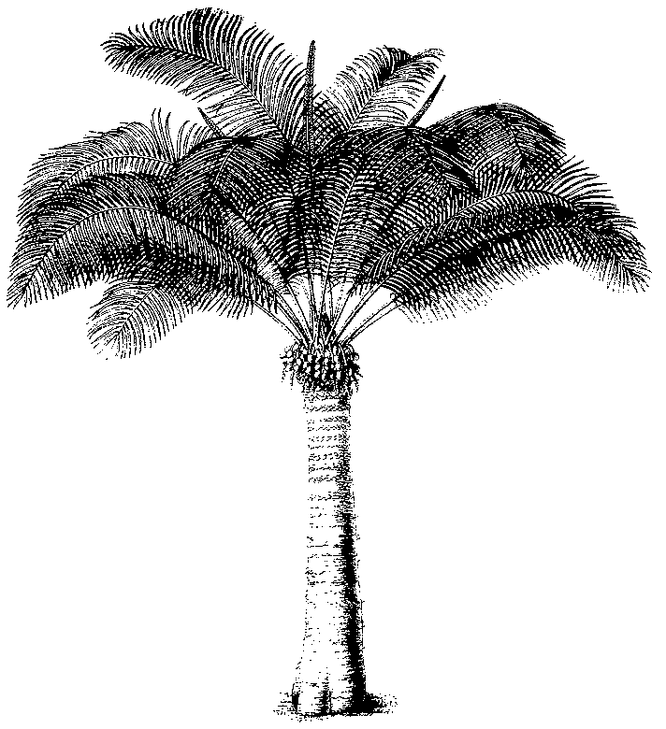
Eleventh meeting of the Plants Committee
Langkawi (Malaysia), 3-7 September 2001
Significant trade in plants
Implementation of Resolution Conf. 8.9 (Rev.) (c.f. Decision 11.117)
Cycads
1. This document has been prepared by the Secretariat.
2. At its 10th meeting, the Plants Committee agreed that a review of trade in cycads (Cycadaceae, Stangeriaceae and Zamiaceae) should be initiated as soon as possible. This document provides an outline of the various elements of that trade that need to be analysed.
3. A printout of trade data on cycads will be available for consultation at the 11th meeting of the Plants Committee. On the basis of this information, the Plants Committee should select species of immediate concern (cf. Decision 11.117 in document PC 11 Inf. 2).
4. When analysing the trade data, the Committee should take account of the following:
i) All cycads have been included in the CITES Appendices since 1977, although some species were transferred from Appendix II to Appendix I after that date. The taxa from this group are particularly popular for landscaping projects in appropriate climatological regions. There is furthermore a large group of cycad enthusiasts who are particularly interested in the rarer and newly described species. Consequently there is a substantial trade, not only at the national level but also at the international level. There is also a growing trade in very old, high-value plants, which is another unique aspect of the trade in this group.
ii) Concern has been expressed about the trade in artificially propagated material. It is possible that a significant proportion of the material traded as ‘artificially propagated’ does not fulfil the definition of ‘artificially propagated’ contained in Resolution Conf. 11.11, because they are of wild origin. No review or analysis of such trade has been carried out and such analysis is required to allow the identification of possible detrimental trade.
iii) Another point of concern is the trade in seedlings of Appendix-I species. Although the seedlings themselves may seem to be artificially propagated, the source of the seeds from which these are grown is not necessarily legal. This trade in seeds may have an impact on wild populations.
5. The Secretariat proposes the following programme of work to be implemented for this review, to be carried out if funding is available:
i) analysis of all data available on international trade in selected cycad species, including re-exports and trade in artificially propagated specimens;
ii) analysis of the trade in artificially propagated specimens of species included in Appendix I and of the possibility that the seeds from which these are grown are of illegal origin;
iii) review of trade in seeds and other parts and derivatives with respect to utilization for horticultural or medicinal purposes;
iv) review of the conservation status of the species subject to international trade; and
v) collection of information on internal trade in selected range States and evaluation of this trade in relation to international trade in the same species.
6. With regard to 8. iv) above, the Secretariat intends to cooperate closely with the IUCN/SSC Cycad Specialist Group.
7. On the basis of the information available once the review has been completed, the Plants Committee would be able to make recommendations, as appropriate, under the provisions of Resolution Conf. 8.9 (Rev.).
8. As a follow-up to the analysis, the Plants Committee could consider to:
i) prepare a list of commonly artificially propagated species;
ii) review the current listing in the CITES appendices of the species identified in trade by applying the relevant criteria included in Resolution Conf. 9.24; and
iii) what is in demand and what is available from artificial propagation.
9. The Plants Committee is requested to agree to this programme of work, and to provide suggestions with regard to the countries whose trade should be evaluated as indicated in paragraph 8. v) above.

