PC11 Doc. 11.2.1
CONVENTION ON INTERNATIONAL TRADE IN ENDANGERED SPECIES
OF WILD FAUNA AND FLORA
____________
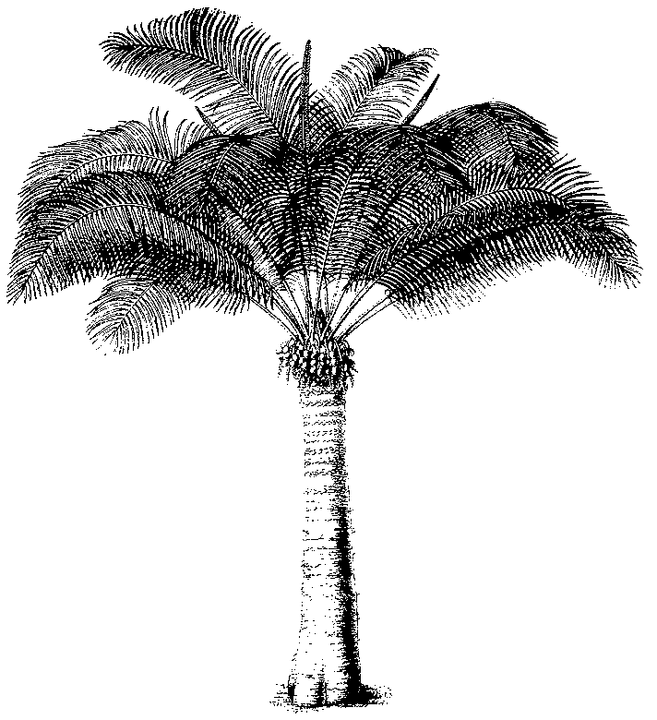
Eleventh meeting of the Plants Committee
Langkawi (Malaysia), 3-7 September 2001
Significant trade in plants
Implementation of Resolution Conf. 8.9 (Rev.) (c.f. Decision 11.117)
trade in plants from madagascar
1. This document has been prepared by the Secretariat.
2. At its 10th meeting (Shepherdstown, December 2000), the Plants Committee decided to review the trade in plants from Madagascar under the provisions of Resolution Conf. 8.9 (Rev.).
3. Madagascar is an important country of export of orchids and succulents for international trade. Commercial production, however, is not well established within the country, and most of the trade is therefore in wild-collected specimens, without it being confirmed that the export is not detrimental to the survival of the species concerned.
4. The review of trade in plants from Madagascar should therefore assist the Management Authority and Scientific Authority of this country by providing recommendations on the appropriate levels of trade in wild-collected plants to ensure compliance with Article IV, and recommendations on commercial propagation of species of horticultural interest, through an analysis of the structure of the trade, a preliminary survey of the conservation status of Malagasy orchid and succulent species reported in trade, and a review of the level of cultivation and artificial propagation outside Madagascar.
5. The Secretariat proposes the following programme of work, to be implemented in close cooperation with the Management and Scientific Authorities of Madagascar, depending on the availability of funds:
Phase 1:
i) Review the trade data available in the trade data base at UNEP-WCMC, in order to determine the quantities of specimens of Malagasy orchid and succulent species in trade;
ii) Collect information on nurseries that are artificially propagating or cultivating orchids or succulents for national and international trade, including details of their annual production, the techniques of propagation used and sources of material; and
iii) Review the distribution in Madagascar of orchid and succulent species common in international trade and conduct a preliminary survey of their conservation status.
Phase 2:
i) Organize a workshop to review the results of the activities of Phase 1 above and to determine the specific activities to be conducted in Phase 3; and
ii) Organize training, as appropriate, based on the results of Phase 1 in order to achieve adequate implementation of Phase 3.
Phase 3:
i) conduct field surveys, as appropriate;
ii) establish a database on Malagasy orchids and succulents in trade, including information on distribution within protected areas and on conservation status, to be maintained by Madagascar;
iii) develop specific identification materials in cooperation with the Secretariat; and
iv) assess the potential for further development of nursery production.
6. The Secretariat has informed the Management Authority of Madagascar of the intention of the Plants Committee to review its plant trade, but has not yet received a response.
7. Once the Plants Committee has approved the proposed programme of work, the Secretariat will ensure its implementation in close consultation with the Management Authority of Madagascar.
8. It should be noted that through this review, it would be possible to collate information on the trade in a number of plant species that are endemic to Madagascar, but are not yet included in the Appendices (see point 2.1.4 of the Action Plan).

